Progress Probe #1663347: 5th Grade TCAP Coach Chapter 4 Lesson 35 and 36 (Grade 05 RE)
Teacher Key with Answers
Ques | Answer | Level | Skill | Subskill | Item #
1 | A | Moderate | Literature | SPI 0501.8.7 Similes, Metaphors, Personification, and Hyperbole [69251] | U47733
2 | D | Hard | Literature | SPI 0501.8.7 Similes, Metaphors, Personification, and Hyperbole [69251] | D102558
3 | B | Moderate | Literature | SPI 0501.8.7 Similes, Metaphors, Personification, and Hyperbole [69251] | U47573
4 | A | Hard | Literature | SPI 0501.8.8 Effect of Sound [69253] | D102863
5 | C | Hard | Literature | SPI 0501.8.8 Effect of Sound [69253] | D103940
6 | A | Hard | Literature | SPI 0501.8.8 Effect of Sound [69253] | D104512
7 | D | Hard | Literature | SPI 0501.8.7 Similes, Metaphors, Personification, and Hyperbole [69251] | D17973

Name: Date:
5th Grade TCAP Coach Chapter 4 Lesson 35 and 36
Question 1 of 7
Mrs. Hansen's Mystery
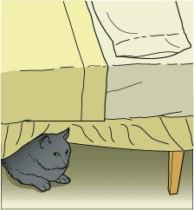
1 Carmen and I have stopped by Mrs. Hansen's house several times a week for several months. She lived alone since her daughter was married, and she enjoyed our company. We, on the other hand, enjoyed the muffins and carrot cake that she baked for us. We also enjoyed petting Mrs. Hansen's cat, Slick, who curled around our ankles, purring loudly, as we ate. Mrs. Hansen also had a dog she named Slim because it was very slender when she got it at the animal shelter. Slim ended up being a quite round black-and-white terrier that liked to get into everything.
2 One day Mrs. Hansen looked a bit worried. 'I'm so glad you're here,' she said anxiously. 'Yesterday I wrote a list for groceries, as usual, and put it on the counter, but now I can't find it. My grocery list just walked away. My favorite pen is missing, too, and I have no idea where it is. My daughter gave me that pen before she left for college. It's very special to me.'
3 'We'll be glad to help,' I told Mrs. Hansen. As soon as we finished our muffins, my sister and I started looking. We searched the kitchen drawers and looked on the counters and on the table, but we could not find the list or the pen. We looked in drawers, in closets, behind the sofa, and around chair cushions. Our search was slightly delayed by Slick curling around our ankles and playing with our shoelaces. Finally, we had to admit that the items were simply nowhere to be found.
4 'I'm sorry, Mrs. Hansen,' I told her. 'We couldn't find your list or your pen, but we can come back tomorrow and look again.'
5 'Oh, please do,' she said. 'I really miss that pen. I can remember what's on the list, but still, I don't know why it just disappeared. I am totally bewildered.'
6 The next day we hurried over to Mrs. Hansen's house after school, and she looked even more upset. 'More things are missing!' she cried. 'You know I go to the community center for physical fitness classes, but today I was late because one of my socks I needed for class was gone. As if that weren't bad enough, my niece made me a bookmark from some beautiful beads. I know I put it in the book I was reading, but this afternoon it was gone, and one of my favorite earrings has also disappeared.'
7 'This mystery has to be solved!' I said with determination. We sat down on the couch to work out a plan. As we talked, Slick crawled up into Carmen's lap and started batting at her necklace. Finally, Carmen said, 'Let's set a trap for the thief. Tomorrow is Saturday, and we can put out something valuable and then hide all day if we need to. Mrs. Hansen can go work in her garden, and it will seem like no one is home!'
8 Mrs. Hansen agreed to the plan, and the next morning we arrived at her house at 9 a.m. Mrs. Hansen led us into the living room. 'I'll just leave my bracelet on the table while I go weed the garden,' she said. She walked outside toward her garden.
9 Carmen and I hid behind the couch, waiting like two cats outside a mouse's home. After awhile, Slick strolled into the room and, noticing that we were there, came over and began batting at our shoelaces. 'Not now, Slick,' I whispered. 'Shoo, go away.' With a flick of its tail, Slick leaped onto the back of the couch and then down to the arm, before settling comfortably. After a moment, the cat got up and walked across the couch to the table where Mrs. Hansen had left her bracelet.
10 'Go away, Slick!' Carmen said angrily. 'You'll spoil everything!' Slick ignored her, began batting at the bracelet, and then leaped down and walked away.
11 'Thank heavens,' Carmen sighed, 'that cat could have ruined the plan. I wonder why…' she stopped in mid-sentence. 'Stephanie, the bracelet is gone!' We both stared at the table in disbelief. We hadn't left the room, and no one had entered—except 'SLICK!' we shouted together. We rushed into the hallway just as Slick scooted into the bedroom. As we turned the corner, we saw a black tail disappear under the bed. Scrambling to the floor, we peered under the bed. In a pile were the list, an earring, a beaded bookmark, the bracelet, and the missing pen.
12 'We've solved the mystery,' Carmen said happily.
13 'No, we haven't,' I replied. 'I don't see Mrs. Hansen's gym sock there, do you?'
14 Just then, I felt a cold nose on my ankle and looked around to see Slim, tail wagging happily. Carmen and I looked at each other. 'You don't suppose,' she began, 'not Slim!'
15 'Show us your toys, Slim!' she said loudly. The dog bounded over to a basket. Carmen and I began looking, and sure enough, in the middle of the basket was Mrs. Hansen's sock.
16 'NOW we've solved the mystery,' Carmen said, and she was right.

Which sentence from the story includes personification?
 |  | A. | 'My grocery list just walked away.'
 |  | B. | 'I really miss that pen.'
 |  | C. | Carmen and I looked at each other.
 |  | D. | … we saw a black tail disappear under the bed.

Question 2 of 7
On Monday it was raining cats and dogs, but I still had to walk to school. I felt like a drowned rat by the time I walked in the building, and everyone laughed at me. After a while I dried out and was able to finish my math before lunch, which didn't come a moment too soon. I could eat a horse! It was spaghetti day too--my favorite. Maybe this day didn't turn out so bad after all.
Identify the hyperbole used in the paragraph above.
 |  | A. | It was raining cats and dogs.
 |  | B. | I felt like a drowned rat.
 |  | C. | After a while I dried out.
 |  | D. | I could eat a horse!

Question 3 of 7
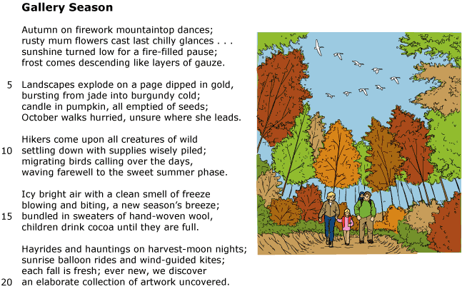

Read lines 19 and 20 from the poem.
each fall is fresh; ever new, we discover an elaborate collection of artwork uncovered.
Which of the following did the author use in the sentence?
 |  | A. | Personification
 |  | B. | Metaphor
 |  | C. | Simile
 |  | D. | Onomatopoeia

Question 4 of 7
Slowly slithering
Down the lawn
Kids playing
Unharmed
Slither
Slither
Slithering faster
Keep out of sight
Want to go on
Not stand and fight
Slither
Slither
On its belly
No feet to walk
The snake slithers
As if to stalk
Slither
Slither
What effect does the repetition of "Slither, Slither" have on the meaning of the poem?
 |  | A. | The word slither means a certain sound associated with a snake, so you imagine it is about a snake even though that is not revealed until the last stanza.
 |  | B. | The word slither being repeated denotes time passing and placed between the stanzas lets you know that time has moved on.
 |  | C. | The word slither repeated between the stanzas denotes a sequence and places the events in chronological order.
 |  | D. | The word slither repeated makes a sound like children playing, and you are able to visualize them playing in the background.

Question 5 of 7
I want you to take
Into consideration
The fact that we
Had a formation
Of people in
A confederation
Who were great
At communication
And never had
An altercation
They waved hello
In salutation
Always eager for
Peer cooperation
This class had
The best reputation
How does the repetition of sound affect the meaning of the poem above?
 |  | A. | The repeated sound makes it easier for the reader to decode the bigger words.
 |  | B. | The repeated sound dominates the meaning and the reader has to concentrate harder for comprehension.
 |  | C. | The reader is able to concentrate more on the meaning of the poem and not on the rhyme because the sound is constant.
 |  | D. | The reader has difficulty deriving meaning from the text because the author only paid attention to linking sounds.

Question 6 of 7
The witch! The witch!
Watch out
Turn and twist
Scowl and pout
Swoop and loop
Dip and list
Scoop and droop
Zig zag
Smack, pow
The witch is here
To take a bow
How does the rhythm of the poem above effect its meaning?
 |  | A. | The poem was written with a fast rhythm, which gives the reader a sense of how fast the witch was flying.
 |  | B. | The poem was written with a moderate rhythm, which gives the reader a sense of calm, even though a witch was flying overhead.
 |  | C. | The poem was written with a slow rhythm, which tells the audience the witch was very lethargic and old.
 |  | D. | The poem was written with an inconsistent rhythm, that varies back and forth between fast and slow to mimic the speed of the action.

Question 7 of 7
The car engine sputtered and gasped as José tried to bring it to life.
What type of figurative language is used in the sentence?
 |  | A. | simile
 |  | B. | metaphor
 |  | C. | alliteration
 |  | D. | personification

Copyright © Discovery Education Assessment 2012. Proprietary Information. All rights reserved.
Discovery Education Page

