Progress Probe #1663140: 5th Grade TCAP Coach Chapter 3 Lesson 30 and 31 (Grade 05 RE)
Teacher Key with Answers
Ques | Answer | Level | Skill | Subskill | Item #
1 | B | Hard | Writing & Research | SPI 0501.3.4 Irrelevant Sentences [69167] | D59799
2 | D | Hard | Informational Text | SPI 0501.6.5 Summary of a Text [69229] | D65167
3 | D | Hard | Writing & Research | SPI 0501.3.4 Irrelevant Sentences [69167] | D51876
4 | D | Hard | Informational Text | SPI 0501.6.6 Sequential Order [69231] | D104644
5 | B | Hard | Writing & Research | SPI 0501.3.12 Appropriate Title [69177] | D52293
6 | D | Hard | Logic | SPI 0501.5.3 Fact/Opinion and Reality/Fantasy [69212] | D68158
7 | C | Hard | Logic | SPI 0501.5.7 Sequence of Events [69219] | D52331
8 | D | Moderate | Informational Text | SPI 0501.6.5 Summary of a Text [69229] | D51219
9 | A | Hard | Informational Text | SPI 0501.6.6 Sequential Order [69231] | D71618
10 | D | Hard | Writing & Research | SPI 0501.3.12 Appropriate Title [69177] | D52631
11 | A | Moderate | Logic | SPI 0501.5.7 Sequence of Events [69219] | U47708
12 | B | Moderate | Logic | SPI 0501.5.3 Fact/Opinion and Reality/Fantasy [69212] | U48525
13 | B | Moderate | Writing & Research | SPI 0501.3.4 Irrelevant Sentences [69167] | U47838
14 | C | Moderate | Informational Text | SPI 0501.6.5 Summary of a Text [69229] | U46877
15 | B | Moderate | Writing & Research | SPI 0501.3.12 Appropriate Title [69177] | U47879
16 | C | Moderate | Logic | SPI 0501.5.7 Sequence of Events [69219] | U48274
17 | A | Moderate | Informational Text | SPI 0501.6.6 Sequential Order [69231] | D103914
18 | D | Hard | Informational Text | SPI 0501.6.5 Summary of a Text [69229] | D57946
19 | A | Moderate | Logic | SPI 0501.5.3 Fact/Opinion and Reality/Fantasy [69212] | U48422

Name: Date:
5th Grade TCAP Coach Chapter 3 Lesson 30 and 31
Question 1 of 19
Which sentence is not relevant to the paragraph?
My grandfather told my class about his hobby of beekeeping. He is really my step-grandfather. People have been keeping bees for their honey for thousands of years. The worker bees collect the nectar from flowers and turn it into honey.
 |  | A. | My grandfather told my class about his hobby of beekeeping.
 |  | B. | He is really my step-grandfather.
 |  | C. | People have been keeping bees for their honey for thousands of years.
 |  | D. | The worker bees collect the nectar from flowers and turn it into honey.

Question 2 of 19
The largest and deepest body of water in the world is the Pacific Ocean. It covers approximately one third of the earth's surface and touches the shore of every continent except Europe and Africa.
Choose the best summary of this selection.
 |  | A. | The Pacific Ocean is larger than all continents except Europe and Africa, which cover about one third of the earth's surface.
 |  | B. | The Pacific Ocean is the deepest body of water on all continents except Europe and Africa. It is larger than one third of the world.
 |  | C. | As deep as nearly one third of the earth's surface, the Pacific Ocean surrounds every continent except Europe and Africa.
 |  | D. | The world's largest body of water is the Pacific Ocean, which takes up a third of the earth's surface. All continents except Europe and Africa touch the Pacific Ocean.

Question 3 of 19
Which sentence is irrelevant in the paragraph below?
There are many things that you can do to help our environment. Ask your parents to start recycling things like glass and newspaper. You can also turn off lights when you leave a room. My brother saves cereal labels to collect prizes.
 |  | A. | There are many things that you can do to help our environment.
 |  | B. | Ask your parents to start recycling things like glass and newspaper.
 |  | C. | Turn off lights when you leave a room.
 |  | D. | My brother saves cereal labels to collect prizes.

Question 4 of 19
Division Steps
Dad - Divide
Mom - Multiply
Sister - Subtract
Brother - Bring down
Dog - Do it again
What is the function of the informational text above?
 |  | A. | to follow directions
 |  | B. | to solve a problem
 |  | C. | to perform a procedure
 |  | D. | to answer a question

Question 5 of 19
Christopher Columbus probably found America by mistake. He was looking for a shorter way to get to the Indies. He hoped to bring back lots of expensive spices. When he saw land, he thought he was there. He was wrong. He had landed in the New World.
Choose a title for this paragraph.
 |  | A. | Sailing Around the World
 |  | B. | A Mistake That Changed History
 |  | C. | Spices in the Kitchen
 |  | D. | The Childhood of Columbus

Question 6 of 19
Sean fished the key out of his pocket and let himself in the front door. "Hello?" he called. Nobody was home; his dad was probably still at work, and who knew where Ellen was. He dropped his backpack on the couch and went into the kitchen to fix himself an after-school snack. The refrigerator was almost empty. All Sean saw on the shelves were jars and bottles of condiments, a sorry-looking tomato, leftover Chinese food containers, and a carton of yogurt that had expired the week before. Shutting the door in disgust, he headed for his room.
He put a CD in his stereo, put on the headphones, and lay down on his bed. This CD was a special one. He had made it for his mother last year, before all the tests, the hospital, and everything else had happened. The first song was one of her favorites. It was an oldie but a goodie, as she used to say, and Sean knew that his parents had danced to it on their first date years ago. As he closed his eyes and listened to the familiar tune, he could see his mother in his mind: laughing with his father, helping him and Ellen paint their bedrooms, tying her shoes to go for a run. But in his memories, his mother's face wasn't as clear as it used to be. Blinking back tears, Sean rolled over to face the wall. He didn't see his father as he entered the room.
Based on the events in the story, what is least likely to happen next?
 |  | A. | Sean's father will try to make him feel better.
 |  | B. | Sean will ask his father to go to the grocery store.
 |  | C. | Sean's sister will come home and talk with Sean about their mother.
 |  | D. | Sean's mother will come into the room and surprise him.

Question 7 of 19
Choose a good beginning sentence for this paragraph.
Suddenly, she jumped down from her chair. She started running and jumped into the water. Soon she reached a little girl and helped her back to shore.
 |  | A. | Everyone clapped because she was brave.
 |  | B. | The little girls parents were frightened.
 |  | C. | The lifeguard looked out into the ocean.
 |  | D. | After that a newspaper reporter came.

Question 8 of 19
The Great Depression
The Great Depression hit the U.S. in the 1930s. It was a hard time for all. People lost their jobs. They lost their savings and their homes. Many lost everything they had. Even those who were once rich were now starving. They stood for hours in bread lines hoping to get free food. Hundreds picked through garbage dumps looking for food.
In New York, thousands were homeless. Some built shelters out of scrap wood or stone. Shantytowns sprang up all over the city. Some people lived on the streets, in the parks, or under bridges. Since people blamed President Hoover, they nicknamed these crude neighborhoods Hoovervilles. People were angry, scared, and desperate.
What caused this to happen? First, factories made lots of goods, but people did not make enough money to buy what was being made. Supply outweighed demand. On Black Tuesday in October 1929, the stock market crashed. On that one day, America lost over 14 billion dollars. Businesses and factories closed. Banks went broke.
The Dust Bowl also led to the Depression in the West. The plains states received little rain for seven years. This drought along with poor farming techniques turned the soil to dust. Dust storms killed the crops and destroyed the land. One storm in May 1934 carried about 350 million tons of dirt across the country. The Dust Bowl left farmers bankrupt.
These and other events hit the country all at once, leaving thousands and thousands with nothing. It would take years, a war, and a new President for the country to bounce back from this great crisis.
Choose the best summary of this passage.
 |  | A. | The Great Depression left thousands homeless.
 |  | B. | People were very sad because Hoover was the president.
 |  | C. | The Great Depression was easier on Americans than people in Europe.
 |  | D. | The Great Depression caused many different types of hardships for people all across the US.

Question 9 of 19
Many laws are made in Washington, D.C. Read the following steps that explain this process.
How a Bill Becomes a Law
1. A bill is sent to a committee in the House.
2. _________________________.
3. The committee votes on whether or not to send the bill to the entire House.
4. The House votes to either approve or reject the bill.
5. If the House approves the bill, it goes to the Senate.
6. The Senate votes to either approve or reject the bill.
7. If the Senate approves the bill, the final bill is sent to the President.
8. If the President signs the bill, it becomes law.
What is the missing step?
 |  | A. | The committee lets people speak for or against the bill.
 |  | B. | The House debates whether or not to vote for the bill.
 |  | C. | The Senate debates whether or not to vote for the bill.
 |  | D. | The Vice-President signs the bill into law.

Question 10 of 19
Which is the best title for the following selection?
Athletes can get hurt while playing sports. Basketball players can sprain their ankles by jumping up and landing on their feet wrong. Football players can also hurt their knees and bones. The most common sports injuries are broken bones and sprains. These problems can become serious if athletes do not see a doctor.
 |  | A. | Football and Its Rules
 |  | B. | The Most Common Sprains
 |  | C. | Athletes and their Sports
 |  | D. | Athletes and Injuries

Question 11 of 19
Where Are Grandma and Grandpa?
A Native American Tale
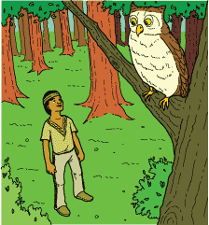
1 Nooshenh took a walk one fine day to try to find his grandparents. He knew what they would be doing. At this time of the year, during the hot summer months, they would be walking through the woods, collecting blueberries to make blueberry bannock. Nooshenh loved eating that warm, delicious bread when it had just been taken out of the fire. Nooshenh thought his grandma made the best blueberry bannock around.
2 As Nooshenh started his journey through the woods among the tall trees and along the grassy paths, he came upon Gaag the porcupine. 'Have you seen my grandma and grandpa?' Nooshenh asked. Gaag, in his prickly porcupine manner, replied, 'Sorry, little one, I have not,' and ambled off into some tall grass.
3 Nooshenh continued through the woods among the tall trees and along the grassy paths. He came upon Amik the beaver and asked, 'Have you seen my grandma and grandpa?' Amik, in his busy-beaver manner, replied, 'Sorry, little one, I have not,' and proceeded to gnaw on a piece of bark.
4 Nooshenh continued his journey through the woods among the tall trees and along the grassy paths. He was getting tired looking for his grandma and grandpa, so he decided to have a rest under the biggest shade tree he could find.
5 There Nooshenh sat, speculating where his grandma and grandpa could be. All of a sudden, he heard KoKo the owl calling out to the woods with his usual greeting, 'Hoo, hoo, hoo.'
6 Nooshenh stood up and looked up into the big shade tree. He asked KoKo the owl, 'Have you seen my grandma and grandpa?' KoKo, in his knowing owl manner, replied, 'Yes, little one, I can see them from here. They are picking blueberries just behind this big shade tree. Hoo, hoo, hoo.'
7 Nooshenh then started walking among the tall trees and along the grassy paths, and there were his grandma and grandpa picking blueberries.
8 'Hello, Grandma and Grandpa! Do you need some help picking berries?' Nooshenh asked.
9 'Nooshenh,' said Grandma, 'we are so glad you have come to join us. We are finished picking berries, but you may help us to take the baskets home, for they are heavy with all the blueberries.'
10 Grandma, Grandpa, and Nooshenh started their journey home among the tall trees and along the grassy paths with their baskets full of blueberries.
11 Nooshenh smiled. He didn't mind carrying the baskets. His grandma made the best blueberry bannock around.

Whom did Nooshenh see right after he saw the beaver?
 |  | A. | The owl
 |  | B. | His grandparents
 |  | C. | The porcupine
 |  | D. | The beaver

Question 12 of 19
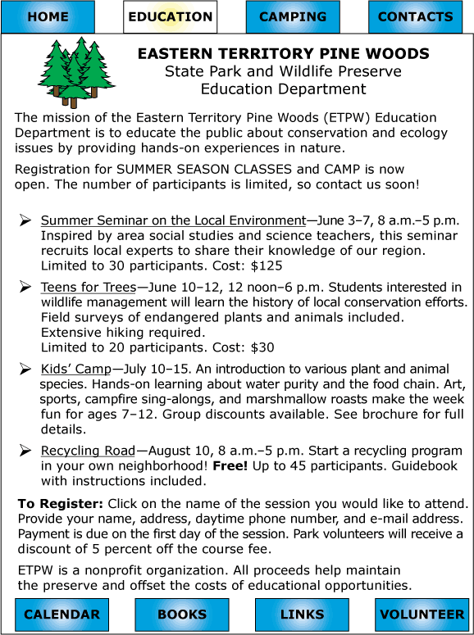

Which sentence from the webpage is an opinion?
 |  | A. | Students interested in wildlife management will learn the history of local conservation efforts.
 |  | B. | Art, sports, campfire sing-alongs, and marshmallow roasts make the week fun for ages 7–12.
 |  | C. | Park volunteers will receive a discount of 5 percent off the course fee.
 |  | D. | All proceeds help maintain the preserve and offset the costs of educational opportunities.

Question 13 of 19
Ted Rhodes
1Still, Rhodes practiced his golf skills as much as he could. He used old balls and clubs he had found. He would sneak onto the golf course at night. Around this time, he met Joe Louis, a famous boxer. Louis was very interested in golf he asked Rhodes to help him learn to be a better player. Soon Rhodes and Louis were playing together in private matches. Rhodes continued to improve as a golfer. Louis offered to sponsor Rhodes in tournaments. Rhodes quitting his job as a caddy to focus on golf.
2In 1948, Rhodes entered an important golf tournament. He finished high enough in the rankings to become the first African American golf pro. Even with this major accomplishment, Rhodes was unable to join the professional golfers’ group of his choice. Rhodes and other golfers brought a lawsuit against the group. After many years, they won the lawsuit. In 1961, the rules were changed and all African American golfers who qualified were allowed to play on the tour.
3Ted Rhodes was born in Nashville Tennessee in 1913. At the age of 12, he worked as a caddy at a local country club. As a caddy, Rhodes' main job was to manage the player’s equipment and provide information about the course. However, like many such clubs in 1939, this club restricted its membership. Rhodes was allowed to work at the club, but he could not play on the golf course.
4Rhodes wanted to become a member of a professional golfers’ group. However, he was not allowed to join the one he preferred. Instead, he joined another golfing association.
5He quickly became a champion in this group. He gained a lot of attention as a top golfer. Rhodes enjoyed a long and successful career. Some people called him “Rags” because of the flashy way he dressed.

Which is the best thesis statement for this passage?
 |  | A. | Ted Rhodes enjoyed many other interests in addition to golf.
 |  | B. | Ted Rhodes was a leader for African Americans in the game of golf.
 |  | C. | Ted Rhodes was a good friend to Joe Louis for many years.
 |  | D. | Ted Rhodes worked as both a caddy and a professional golfer in his career.

Question 14 of 19
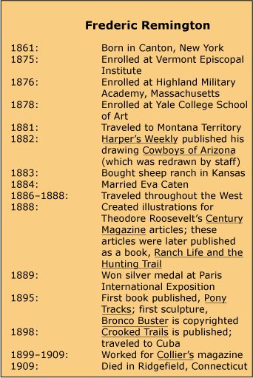

Frederic Remington, Artist of the West
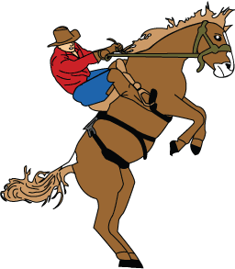
1 What do you think about when someone mentions the Wild West? What pictures are created in your mind? Maybe you picture the pounding hooves of wild horses racing across the plains. Where did you get these ideas about the Wild West? Perhaps you have seen a painting done by Frederic Remington.
2 Remington was born in 1861 and grew up in Canton, New York. As a boy, he was not a good student. He liked playing sports, but the thing he enjoyed doing most was drawing. Remington filled his notebooks with pictures. The pictures contained lots of action. Horses were one of the animals he frequently sketched. Since one of his favorite pursuits was riding horses, he was familiar with the way they looked and moved. He tried to capture those sights and feelings in his drawings.
3 When he was a teenager, Remington decided to enroll as a student in an art school. Later he traveled out West, where he did many of his drawings. He sent some of his work to New York, asking people whether they would be interested in publishing his work. In 1882, a magazine used one of those drawings. The drawing was called Cowboys of Arizona. However, the magazine hired another artist to make changes to Remington's work. The magazine then put Remington's name on the drawing even though it had been retouched. Imagine how Remington felt about that!
4 Remington visited many places in the West and tried different jobs. He attempted to raise sheep in Kansas, but he found that he did not like it. He tried being a soldier and discovered that he enjoyed this type of work. However, he still liked art most of all and often drew pictures of cowboys and soldiers. He also drew Native Americans and other images that he felt portrayed the West. He wanted people to understand the true West. His pictures made life on the frontier look exciting.
5 In 1885, Remington took his art to New York. Many people there praised both his ink drawings and his oil paintings. He was able to sell some of his pieces to important magazines. The pictures that they printed were truly his this time. He also drew illustrations for a book written by a man named Theodore Roosevelt, who later became President of the United States.
6 Remington kept drawing and continued to paint. He also began writing. He wrote about the West and then drew pictures for his books. His first book was called Pony Tracks.
7 In 1895, Remington created his first statue, Bronco Buster, which was in the same style as his drawings and paintings. All of his art was meant to reveal the way the people in the West lived.
8 Frederic Remington died in 1909. He enjoyed fame during his lifetime. Today, he still is the most famous artist of the West.

Which best states the purpose for reading this article?
 |  | A. | To learn who purchased Remington's work
 |  | B. | To learn about life in the American West
 |  | C. | To learn about the life and work of an artist
 |  | D. | To learn why creating art is important

Question 15 of 19
First American Guide Dog
1 Dorothy and Elliot Eustis bred and trained German shepherds in Switzerland for border patrol work. Mrs. Eustis wrote an article for an American magazine describing how smart her dogs were. She included the fact that some of her dogs helped guide war veterans who had lost their sight.
2 When Morris Frank heard about the article, he contacted Mrs. Eustis. He asked her to help him too. Mrs. Eustis invited Morris to come to Switzerland. Morris traveled all the way from Nashville in the 1920s to visit her. While he was there, he was trained to work with a dog named Buddy.
3 Morris and Buddy returned to the United States. Buddy was the first guide dog in the country. Morris was impressed with Buddy. He wrote to Mrs. Eustis to tell her this. Mrs. Eustis was very happy and decided to start a school for guide dogs in the United States.

What would be the best alternate title for this passage?
 |  | A. | German Shepherds
 |  | B. | A Dog Named Buddy
 |  | C. | A New School Opens
 |  | D. | A Visit to Switzerland

Question 16 of 19
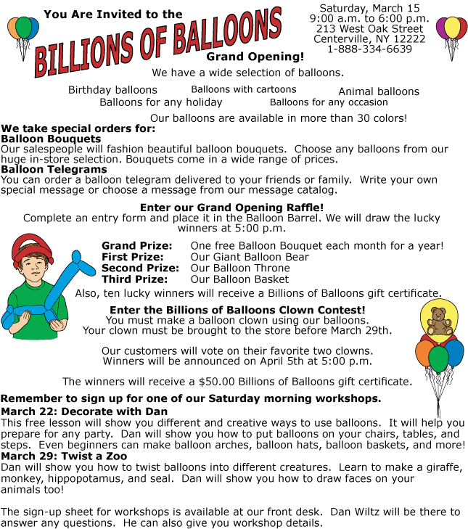

What is the first thing a person must do in order to learn to make balloon creatures?
 |  | A. | Buy a balloon
 |  | B. | Complete an entry form
 |  | C. | Sign up at the front desk
 |  | D. | Be at the store on March 22

Question 17 of 19
Instructions for Building a Derby Car
Materials:
wooden derby car
2 axle rods
4 wheels
dremel tool (optional)
sand paper
10 mm drill bit
lead weights
wood putty
wood primer
paint
decals
Instructions
1. Use sand paper to smooth out the pre-cut wooden derby car. (A dremel tool may be used to modify the shape if desired.)
2. With the 10 mm drill bit, drill through the front and back of the derby car near the bottom for the axle rods.(The farther apart they are, the faster the car will go.)
3. Sand around the drilled holes.
4. Push axle rods through the holes and attach the 4 wheels to the ends of each rod.
5. Check for balance and height.
6. Drill several holes to add lead weights to the car. (The back and sides are optimal sites.)
7. Once weights have been added, weigh the derby car. (It can only weigh a maximum of 5 ounces.)
8. Add or remove lead weights as needed.
9. Fill in holes for the weights with wood putty and allow to dry.
10. Remove the wheels and axles for painting.
11. Paint derby car with wood primer and allow to dry.
12. Paint derby car as desired.
13. Once the paint is dry, reinstall the axles and wheels.
14. Add decals to make the car unique.
In the instructions above, why is it necessary to remove the axles and wheels once they have already been installed?
 |  | A. | to paint the car
 |  | B. | to weigh the car
 |  | C. | to add the weights
 |  | D. | to sand the car

Question 18 of 19
The Circus
We walked up to the giant circus tent known as the Big Top. Once the show started, I patiently waited for the elephants to come out. They are some of the smartest animals in the world. They can be taught lots of tricks like picking up peanuts and sitting on a stool.
Which of the following would correctly summarize the passage?
 |  | A. | The giant tent is known as the Big Top.
 |  | B. | The circus is an exciting place to go.
 |  | C. | Circus elephants move very slowly.
 |  | D. | Elephants are very intelligent circus animals.

Question 19 of 19
Interesting Birds
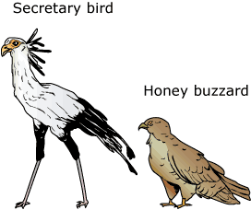
1 Birds, like people, often have interesting names and habits. The secretary bird and the honey buzzard are two examples.
2 The secretary bird is an African bird that is found south of the Sahara Desert. The name 'secretary' is unusual for a bird. Many people wonder how the bird got its name. Certainly, early bird-watchers didn't see it dashing about typing memos, sending fax messages, or attending meetings!
3 This bird's misleading name might have come from the crest of feathers on its head. The crest might have reminded people of the quill pens that 19th-century clerks stuck behind their ears for safekeeping.
4 Another thought is that the name came from the Arab people who lived in the region. The phrase 'saqu ettair' in Arabic means 'hunter bird.' Early visitors from Europe might have heard the name and turned it into either French (secretaire) or English (secretary).
5 The secretary bird has an unusual appearance. The bird is about three feet tall and has a wingspan of more than six feet. It has two very long and distinct tail feathers. From a distance, the bird looks as if it is wearing bicycle shorts because its legs are two different colors. The upper part of the bird's long legs is covered in black feathers. The lower part of the legs has no feathers but is covered with a tough, pinkish skin. This protects the bird against snakebites. All in all, the bird is quite unattractive.
6 Snakes are one of the secretary bird's favorite foods. In fact, farmers in Africa are always glad to see a secretary bird around since they know it will help keep the dangerous snakes under control. The secretary bird also eats lizards and rats. The bird hunts on foot, walking across the land like a chicken and sometimes stomping on prey too big to be speared by its bill. Secretary birds sometimes walk more than 18 miles in a day looking for food. They can travel about three miles an hour.
7 Although they hunt on foot, these birds can fly, but their takeoffs and landings are often clumsy. Secretary birds soar once they are airborne. They generally build their nests off the ground in thorny trees. Once a nest has been built, it can be added to and extended year after year with dry grass and sticks. Sometimes these nests grow to be more than seven feet across.
8 Secretary birds are unlikely to win any honors for their singing ability. They are generally silent, making only an occasional coughing grunt. The sound is quite annoying!
9 Unlike the secretary bird, which stays in Africa for its whole life, the honey buzzard commutes between Africa and the British Isles. It spends its winters in Africa and its summers in northern Europe. The name 'honey buzzard' is a little confusing. The bird does not eat honey, and it is not a buzzard. At one time, the bird was known as the bee hawk. That name is more accurate.
10 The honey buzzard is a shy bird that prefers the deep forest. Like the secretary bird, it spends a lot of time on the ground, mostly looking for food. It likes to eat bumblebees and wasps. The bird has strong, powerful feet and sharp claws. These are especially good for digging up insect nests. The bird also has a thick layer of feathers to help protect it from stings.
11 The honey buzzard is slightly more than two feet tall with a wingspan of nearly five feet. The way that its head pushes forward as it walks reminds some people of a pheasant.
12 Honey buzzards build small nests for themselves, often building their nests upon old crow nests. The nests aren't permanent like those of the secretary bird because the honey buzzard travels so much.
13 When honey buzzards travel back to Africa, they do not travel in groups like many other migrating birds do. Individual birds will set off and meet others along the way. Adult birds tend to choose the quickest route back. Younger birds often act like tourists and take a more scenic route. Sometimes the younger birds even cross the Mediterranean Sea at its widest parts. They would be better off following the example of the adult birds!
14 Like the secretary bird, the honey buzzard is usually silent. In the air, it sometimes gives a jingling-sounding call. When the bird is frightened, it gives off a sound like the rattling of a piece of cardboard in the spokes of a bicycle.
15 To find out more about these interesting birds, consult an encyclopedia or the Internet.

Which of the following sentences from the selection is an opinion?
 |  | A. | Birds, like people, often have interesting names and habits.
 |  | B. | The phrase 'saqu ettair' in Arabic means 'hunter bird.'
 |  | C. | They are generally silent, making only an occasional coughing grunt.
 |  | D. | Adult birds tend to choose the quickest route back.

Copyright © Discovery Education Assessment 2012. Proprietary Information. All rights reserved.
Discovery Education Page

