Progress Probe #1662934: 5th Grade TCAP Coach Chapter 3 Lesson 23, 24 and 25 (Grade 05 RE)
Teacher Key with Answers
Ques | Answer | Level | Skill | Subskill | Item #
1 | B | Moderate | Communications & Media | SPI 0501.7.1 Appropriate Medium/Media [100102] | D108382
2 | C | Moderate | Communications & Media | SPI 0501.7.1 Appropriate Medium/Media [100102] | D105298
3 | D | Hard | Communications & Media | SPI 0501.7.1 Appropriate Medium/Media [100102] | D108345
4 | D | Hard | Communications & Media | SPI 0501.7.1 Appropriate Medium/Media [100102] | D108383
5 | B | Moderate | Communications & Media | SPI 0501.7.2 Main Idea [100103] | D107774
6 | C | Moderate | Communications & Media | SPI 0501.7.2 Main Idea [100103] | D107779
7 | D | Hard | Communications & Media | SPI 0501.7.2 Main Idea [100103] | D107775
8 | D | Hard | Communications & Media | SPI 0501.7.2 Main Idea [100103] | D107777
9 | B | Hard | Communications & Media | SPI 0501.7.2 Main Idea [100103] | D107776
10 | A | Moderate | Communications & Media | SPI 0501.7.3 Mood of Visual Image [100104] | D107781
11 | B | Moderate | Communications & Media | SPI 0501.7.3 Mood of Visual Image [100104] | D107786
12 | A | Hard | Communications & Media | SPI 0501.7.3 Mood of Visual Image [100104] | D107782
13 | B | Hard | Communications & Media | SPI 0501.7.3 Mood of Visual Image [100104] | D107784
14 | C | Hard | Communications & Media | SPI 0501.7.3 Mood of Visual Image [100104] | D107785
15 | A | Moderate | Communications & Media | SPI 0501.7.4 Functions of Media [100105] | D107528
16 | A | Moderate | Communications & Media | SPI 0501.7.4 Functions of Media [100105] | D106521
17 | B | Hard | Communications & Media | SPI 0501.7.4 Functions of Media [100105] | D107529
18 | B | Moderate | Writing & Research | SPI 0501.4.1 Reliable Information Sources [100106] | U48588
19 | A | Hard | Writing & Research | SPI 0501.4.1 Reliable Information Sources [100106] | D69620
20 | B | Hard | Writing & Research | SPI 0501.4.1 Reliable Information Sources [100106] | D16890
21 | C | Hard | Writing & Research | SPI 0501.4.1 Reliable Information Sources [100106] | D1868
22 | D | Moderate | Writing & Research | SPI 0501.4.2 Citations [100107] | D60895
23 | A | Moderate | Writing & Research | SPI 0501.4.2 Citations [100107] | D104069
24 | D | Hard | Writing & Research | SPI 0501.4.2 Citations [100107] | D17748
25 | B | Hard | Writing & Research | SPI 0501.4.2 Citations [100107] | D17788
26 | C | Hard | Writing & Research | SPI 0501.4.2 Citations [100107] | D103728

Name: Date:
5th Grade TCAP Coach Chapter 3 Lesson 23, 24 and 25
Question 1 of 26
Which of the following would support a presentation about how the purpose of horseback riding has changed over the years?
 |  | A. | a PowerPoint slide show of the kinds of horses
 |  | B. | a video clip of horseback riding now and then
 |  | C. | an audio clip of horse sounds
 |  | D. | a fact sheet on how to care for a horse

Question 2 of 26
Which of the following graphics would be the best choice to include in a story about pioneers?
 |  | A. | a rocket
 |  | B. | a map
 |  | C. | a wagon
 |  | D. | a ship

Question 3 of 26
To write a report, which of the following would you use to find information about why people enjoy listening to music?
 |  | A. | an Internet article about music stations
 |  | B. | a newspaper article about different types of music
 |  | C. | an Internet article about The Jonas Brothers
 |  | D. | a magazine article about how music affects moods

Question 4 of 26
Where could you find information for a presentation on the purpose of lighthouses?
 |  | A. | a book about all of the beaches in the northeast area of the United States
 |  | B. | a magazine article about the size of ships on the sea
 |  | C. | a newspaper article about the President of the United States' favorite lighthouse
 |  | D. | an Internet article about guiding ships through the night

Question 5 of 26
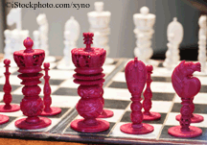
What is the main idea of this picture?
 |  | A. | chess game showing people playing
 |  | B. | chess game ready to be played
 |  | C. | chess game no one knows how to play
 |  | D. | chess game showing someone has won

Question 6 of 26
What is the main idea of this picture?
 |  | A. | a fence at the beach
 |  | B. | someone looking for a ship
 |  | C. | a beach sunset
 |  | D. | two trees growing out of the ground

Question 7 of 26
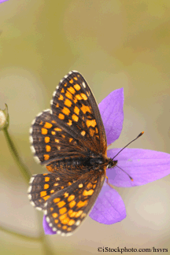
What is the main idea of this picture?
 |  | A. | a butterfly waiting to be photographed
 |  | B. | a butterfly fighting with another butterfly
 |  | C. | a butterfly trying to to find another butterfly
 |  | D. | a butterfly resting on a flower

Question 8 of 26
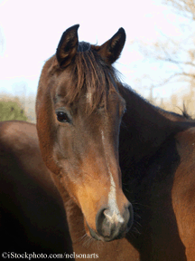
What is the main idea of this picture?
 |  | A. | to show the age of the horse
 |  | B. | to show how out of shape the horse is getting
 |  | C. | to show how many races the horse has won
 |  | D. | to show the beauty of the horse's profile

Question 9 of 26
What is the main idea of this picture?
 |  | A. | to show how much water is in the moat
 |  | B. | to show the beauty and largeness of the castle
 |  | C. | to show how much grass is in front of the castle
 |  | D. | to show why castles are hard to clean

Question 10 of 26
What feeling is given by this picture?
 |  | A. | freedom
 |  | B. | difficulty
 |  | C. | confusion
 |  | D. | excitement

Question 11 of 26
What mood does this picture create?
 |  | A. | awesome
 |  | B. | concentration
 |  | C. | freedom
 |  | D. | sadness

Question 12 of 26
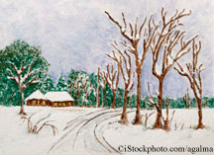
What feeling is given by this picture?
 |  | A. | calmness
 |  | B. | adversity
 |  | C. | aggression
 |  | D. | sadness

Question 13 of 26
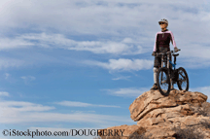
What is the mood of this picture?
 |  | A. | defeated
 |  | B. | accomplished
 |  | C. | confused
 |  | D. | aggressive

Question 14 of 26
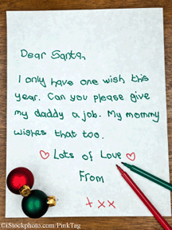
What mood does this picture create?
 |  | A. | happiness
 |  | B. | guilt
 |  | C. | sadness
 |  | D. | confidence

Question 15 of 26
Animals Should Not Be used as Fur Coats
After reading the title of this speech, which is not a goal of the writer?
 |  | A. | to entertain the audience
 |  | B. | to persuade the audience
 |  | C. | to inform the audience
 |  | D. | to communicate to the audience

Question 16 of 26
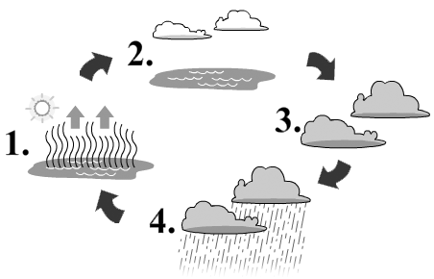
Use the graph.
1. Evaporation
2. Transpiration
3. Accumulation
4. Precipitation
What is precipitation?
 |  | A. | rain or snow
 |  | B. | dangerous winds
 |  | C. | lake water moving
 |  | D. | thunder and lightening

Question 17 of 26
How Do You Ride a Unicycle?
The title of this speech leads us to believe that the author wrote it to______________________.
 |  | A. | persuade an audience
 |  | B. | teach an audience
 |  | C. | bore an audience
 |  | D. | entertain an audience

Question 18 of 26
The Warm Inventor
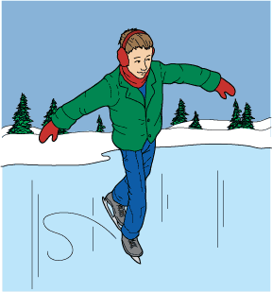
1 Most people outside of Farmington, Maine, have never heard of Chester Greenwood—but endless numbers of children have a fun way to play outside in cold winter weather because of his invention.
2 Chester Greenwood was born in 1858 in Farmington, Maine. One of six children, he grew up on a farm. The family raised chickens and sold eggs. Greenwood walked an eight-mile route to deliver eggs to customers. Some of them also bought the peppermints he made.
3 As a teenager, Greenwood loved skating. During the winter of 1873, he was given a new pair of ice skates. The 15-year-old headed for the local pond to try them out. The winter of 1873 was bitterly cold, and soon Greenwood's ears were stinging. He wrapped a wool scarf around his head, but it was both itchy and bulky. It was hard to see, much less skate, with a scarf tied around his head.
4 Most people would have given up and waited for the weather to improve, but Greenwood was unwavering in his determination to find a way to protect his ears so he could skate. He took some wire and bent it into a pair of loops. Hurrying home, he persuaded his grandmother to sew material over the loops. Greenwood chose fur for the outside and velvet for the inside, which would be next to his sensitive ears. In no time, his grandmother had finished the first earmuffs ever made. With his new invention, Greenwood could keep his ears warm while skating.
5 As he glided around the ice, fellow skaters noticed the strange invention on Greenwood's head. When asked, he called them 'ear mufflers.' Soon everyone wanted the ear mufflers. Greenwood's mother and grandmother helped by covering the wire frames with fur. Ear mufflers were extremely successful, and in 1877, Greenwood patented a model with a steel band. He was only 18 at the time. His 'one-size-fits-all' model had ear covers that could be folded to store in a pocket. Greenwood called them his 'Champion Ear Protectors.'
6 Soon, his mother and grandmother could not keep up with the orders. Greenwood moved his business into a factory in Farmington. By the early 1880s, more than 30,000 ear mufflers were being purchased every year. By 1936, the number was near 400,000. Farmington became the 'Earmuff Capital of the World.'
7 Greenwood did not stop inventing, though. He applied for more than 100 patents. He invented 15 machines to help make and assemble parts for the earmuffs. He also invented a steel-tooth rake, shock absorbers, a whistling teakettle, and a washing machine. Other inventions included a new type of spark plug and a folding bed. While it is a joke among inventors that each is trying to invent a better mousetrap, Greenwood actually did come up with a mechanical mousetrap. The Smithsonian Institution has named him one of this country's 15 outstanding inventors.
8 In 1977, Maine's legislature passed a law declaring December 21 as Chester Greenwood Day. Farmington residents and thousands of visitors celebrate Chester Greenwood's invention on the first Saturday of December. The day features events such as an earmuff fashion show and a cold-ear contest. Best of all, there is a Chester Greenwood Day parade with its own flag: red earmuffs on a white background. Everything from police cars to cows wears earmuffs. Even the dogs wear earmuffs!
9 Chester Greenwood proved that a person can be a successful inventor at any age. All Greenwood wanted to do was find a way to keep his ears warm. In doing so, he started a million-dollar industry.

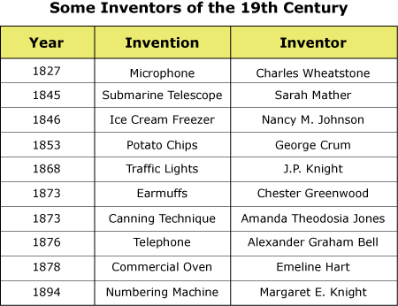

Which of the following would be most helpful in finding out more about the life of Chester Greenwood?
 |  | A. | Searching the Internet using the key words 'Winters in Maine'
 |  | B. | Reading a book about inventors of the late 1800s
 |  | C. | Writing a letter to a citizen of Farmington, Maine
 |  | D. | Asking a professional skater about the best earmuffs to wear

Question 19 of 26
Which of the following questions would tell you the least about the accuracy of a source?
 |  | A. | Can the source be found in the library?
 |  | B. | Was the source reviewed by others?
 |  | C. | Was the source published recently, or years ago?
 |  | D. | Is the author is an expert on the topic?

Question 20 of 26
Imagine you have just finished reading a book about space exploration. Where in the book would you look to find other books about the same topic?
 |  | A. | the introduction
 |  | B. | the bibliography
 |  | C. | the table of contents
 |  | D. | the glossary

Question 21 of 26
Abraham Lincoln was born in a little log cabin in the year 1809. The Lincoln family was very poor. Everyone in the family had to work very hard, even the children. When there was farm work to be done, young Abraham had to stay home and work. That meant he did not get to go to school. Abraham did not mind working hard to help the family but he did mind missing school.
Abraham had only a few books, and about the only time he had to read them was at night. Then he did not have good light. Often, he would have to sit on the floor, in front of the open fireplace of the cabin, and read by the flickering blaze. But Lincoln did not give up. He kept working hard for his father and studying on his own.
Many people believe that Abraham Lincoln was one of our best presidents. How does this passage support the belief that Abraham Lincoln was a man of good character?
 |  | A. | The story lets the reader know how much Lincoln loved to read.
 |  | B. | The passage tells the story of Lincoln's early life.
 |  | C. | The passage shows that Lincoln did not give up when times were hard.
 |  | D. | The passage tells how hard children had to work many years ago.

Question 22 of 26
Use the sample bibliography entries to answer this question.
Collingsworth, Kristin H. The Sixth Planet. Chicago: Milton Press, Inc., 1972.
Havier, Juan F. The Gas Giants. New York: Medal Books, 1984.
Masterson, Bernard A. and Porter, Glen B. Saturn. Boston: Massachusetts Press, 1979.
The Sixth Planet was published by
 |  | A. | Medal Books
 |  | B. | Massachusetts Press
 |  | C. | Collingsworth, Kristin H
 |  | D. | Milton Press, Inc.

Question 23 of 26
Bibliographys are important because they give credit to the people who wrote the information you used in your research paper.
What is the correct way to write a bibliography for a book with two authors?
 |  | A. | Hall, Susan, and Bob Bowman. How to Teach Children to Ride a Bicycle. New York, New York: 2002.
 |  | B. | Hall, Susan, and Bowman, Bob. How to Teach Children to Ride a Bicycle. New York, New York.
 |  | C. | Hall, Susan, and Bob Bowman. How to Teach Children to Ride a Bicycle, New York, New York, 2002.
 |  | D. | Hall, Susan, and Bowman, Bob. How to Teach Children to Ride a Bicycle, New York, New York, 2002.

Question 24 of 26
A bibliography will include all but which of the following information about a book?
 |  | A. | author's name
 |  | B. | title
 |  | C. | year of publication
 |  | D. | number of pages

Question 25 of 26
Which bibliography entry includes all the necessary information?
 |  | A. | Smith, Emily. The Life and Times of Martha Jefferson. Wilkington Press, 2002.
 |  | B. | Bradford, James H. The Third Eye. San Francisco: Vision Press, 1999.
 |  | C. | Howard, Kevin, and Maria North. Do-it-yourself Auto Care. Houston: Cuniculus Publishers.
 |  | D. | Garza, Elena. A Guide to North American Rodents. 2005.

Question 26 of 26
Bell, Tracy. The Civil Rights Movement. Pennsylvania: Westinghouse, 2000.
Dickinson, Fred, ed. March to Washington. New York: Schocken, 2002.
Zimmerman, Lisa. Segregation Has No Place. Los Angeles: Rodale, 2003.
In the bibliography above, how are the resources cited?
 |  | A. | alphabetical by book title
 |  | B. | alphabetical by author's first name
 |  | C. | alphabetical by author's last name
 |  | D. | alphabetical by publishing company

Copyright © Discovery Education Assessment 2012. Proprietary Information. All rights reserved.
Discovery Education Page

