Progress Probe #1662917: 5th Grade TCAP Coach Chapter 3 Lesson 22 (Grade 05 RE)
Teacher Key with Answers
Ques | Answer | Level | Skill | Subskill | Item #
1 | C | Hard | Informational Text | SPI 0501.6.3 Locate Information [69226] | D100014
2 | D | Moderate | Informational Text | SPI 0501.6.2 Meaning from Text [69224] | U46903
3 | C | Moderate | Informational Text | SPI 0501.6.2 Meaning from Text [69224] | U46935
4 | B | Hard | Informational Text | SPI 0501.6.2 Meaning from Text [69224] | D71518
5 | C | Moderate | Informational Text | SPI 0501.6.3 Locate Information [69226] | U48319
6 | C | Hard | Informational Text | SPI 0501.6.2 Meaning from Text [69224] | D59900
7 | D | Hard | Informational Text | SPI 0501.6.2 Meaning from Text [69224] | D67410

Name: Date:
5th Grade TCAP Coach Chapter 3 Lesson 22
Question 1 of 7
Use the Table of Contents below to answer the question.
On what page would you find information about teaching your dog a trick?
Table of Contents
Picking Your Dog 1
Grooming Your Dog 6
Feeding Your Dog 11
Training Your Dog 14
Playing with Your Dog 21
 |  | A. | 1
 |  | B. | 11
 |  | C. | 14
 |  | D. | 21

Question 2 of 7
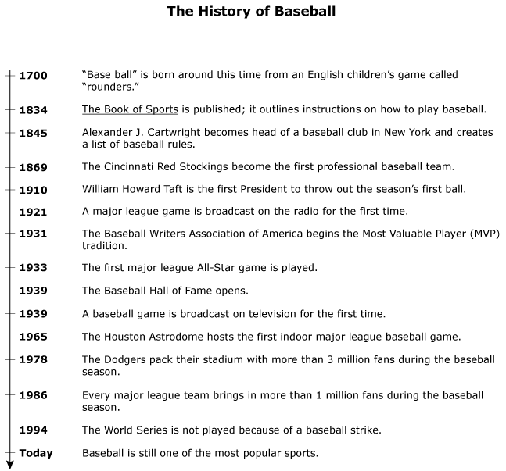

Why does the diagram include details about the number of fans who attended baseball games during a season?
 |  | A. | To explain the history of baseball
 |  | B. | To honor those who watch the sport
 |  | C. | To show that people like the sport
 |  | D. | To emphasize the rising popularity of baseball

Question 3 of 7

Which phrase best explains why the author uses a bulleted list in this flyer?
 |  | A. | To avoid having to write in complete paragraphs
 |  | B. | To make the information easier to locate
 |  | C. | To emphasize specific pieces of information
 |  | D. | To separate the sentences from the pictures

Question 4 of 7
A biography does not include _____________.
 |  | A. | major events in the person's life
 |  | B. | research which explains the solar system
 |  | C. | events arranged in chronological order
 |  | D. | information about how the person thinks or feels

Question 5 of 7
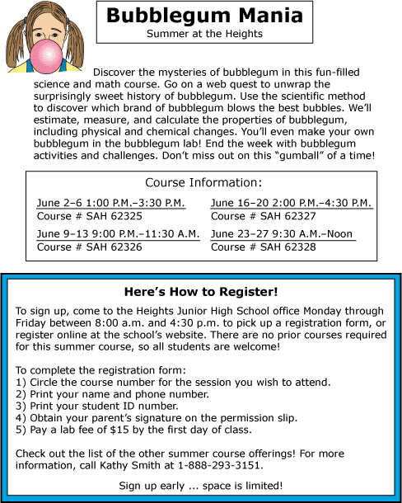

According to the course information, which session will be most appropriate for a student who wants to take the course as late in the day as possible?
 |  | A. | SAH 62325
 |  | B. | SAH 62326
 |  | C. | SAH 62327
 |  | D. | SAH 62328

Question 6 of 7
Look at the map. Which of the following is located at 38 N, 121 W?
 |  | A. | Bakersfield
 |  | B. | San Jose
 |  | C. | Stockton
 |  | D. | Redding

Question 7 of 7
Slavery in America
Many famous people, ideas, and events came from the era of slavery in the United States. For instance, Harriet Tubman was a very important person in the fight against slavery. She was born a slave in 1820 in Maryland. She worked on a plantation in Maryland from the time that she was a little girl. Then, in 1844, she married a freed slave named John Tubman. Five years later they escaped to the North. Before the American Civil War started in 1861, Harriet Tubman made nineteen trips back to the South to lead slaves to freedom. Their path was known as the Underground Railroad.
The Underground Railroad was a network, or group, of northerners who were against slavery. They helped slaves reach safety in the free states or Canada. Harriet Tubman guided over 300 slaves to Canada. They used the North Star for guidance and almost always fled at night. There were "stations" along the way, which were often farms where sympathetic free blacks would hide the runaway slaves. Some of the stations were located in Cincinnati, Ohio, Wilmington, Delaware, Detroit, Michigan, and Buffalo, New York.
An estimated 50,000 people were freed from slavery. Family escapes were very rare since they were not as safe. Most of the runaways were young males who were unattached. Among the 300 slaves that Harriet Tubman led to freedom were her parents. She was linked with other great abolitionists of her time like Frederick Douglass and John Brown. She was sometimes called the "Moses of her People" because, like Moses, she led so many people to freedom.
From Cincinnati, Ohio, slaves would most likely have traveled to __________.
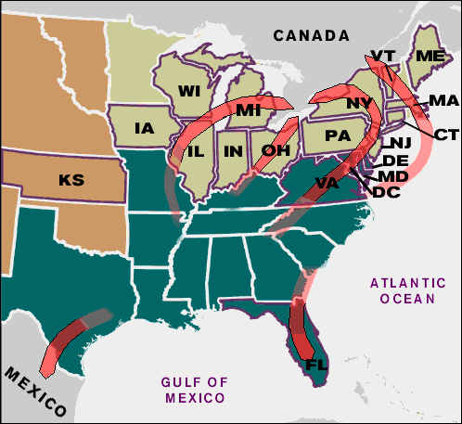
 |  | A. | New York
 |  | B. | Michigan
 |  | C. | Pennsylvania
 |  | D. | Canada

Copyright © Discovery Education Assessment 2012. Proprietary Information. All rights reserved.
Discovery Education Page

