Progress Probe #1662882: 5th Grade TCAP Coach Chapter 2 Lesson 19 and 20 (Grade 05 RE)
Teacher Key with Answers
Ques | Answer | Level | Skill | Subskill | Item #
1 | A | Moderate | Communications & Media | SPI 0501.2.2 Group Leader Criteria [69161] | D107517
2 | C | Hard | Communications & Media | SPI 0501.2.2 Group Leader Criteria [69161] | D107515
3 | A | Hard | Communications & Media | SPI 0501.2.2 Group Leader Criteria [69161] | D107518
4 | D | Moderate | Communications & Media | SPI 0501.2.4 Organize Ideas [69163] | D107717
5 | A | Hard | Communications & Media | SPI 0501.2.4 Organize Ideas [69163] | D107734
6 | D | Hard | Communications & Media | SPI 0501.2.4 Organize Ideas [69163] | D107714
7 | B | Moderate | Logic | SPI 0501.5.2 Cause and Effect Relationships [69210] | U44124
8 | B | Moderate | Logic | SPI 0501.5.2 Cause and Effect Relationships [69210] | U45123
9 | A | Hard | Logic | SPI 0501.5.2 Cause and Effect Relationships [69210] | D102764
10 | A | Hard | Logic | SPI 0501.5.2 Cause and Effect Relationships [69210] | D66685

Name: Date:
5th Grade TCAP Coach Chapter 2 Lesson 19 and 20
Question 1 of 10
Which of the following would be a good comment for a group leader to make during a discussion?
 |  | A. | "Let's give everyone a chance to talk."
 |  | B. | "I will do all of the talking today."
 |  | C. | "That is not a smart comment."
 |  | D. | "Everyone be quiet and listen to me."

Question 2 of 10
Which of the following kind of person would be a good group leader?
 |  | A. | someone who is mean
 |  | B. | someone who pushes people around
 |  | C. | someone who works well with others
 |  | D. | someone who talks very loudly

Question 3 of 10
Group leaders should encourage __________________ when involved in a group discussion.
 |  | A. | everyone to participate
 |  | B. | everyone to yell
 |  | C. | everyone to stay quiet
 |  | D. | everyone to be friends

Question 4 of 10
Presentations need to be organized for an audience to stay interested.
Which of the following is the correct order for a speech about how to train a dog?
1. Reward the dog after he/she has done what you need him/her to do.
2. Buy treats to reward the dog.
3. Decide on the command to use for the trick you would like to teach the dog.
4. Work for 10 minutes on the trick you would like for the dog to learn.
 |  | A. | 1, 2, 3, 4
 |  | B. | 4, 3, 2, 1
 |  | C. | 2, 4, 3, 1
 |  | D. | 2, 3, 4, 1

Question 5 of 10
Susie has to do a presentation on how bats eat at night.
Which of the following is the best way to organize these ideas for the presentation?
1. Bats come out at night to eat insects.
2. What are bats?
3. What do bats eat?
4. Bats are flying mammals.
5. Bats are amazing animals.
 |  | A. | 5, 2, 4, 3, 1
 |  | B. | 1, 2, 3, 4, 5
 |  | C. | 5, 4, 3, 2, 1
 |  | D. | 5, 3, 4, 2, 1

Question 6 of 10
Molly has to organize her ideas for a speech about ballet dancing.
1. Ballet is a great way to get in shape and become graceful.
2. What is ballet?
3. Ballet is a performance kind of dance.
4. What are the benefits of ballet?
5. Ballerinas need tights, a leotard and ballet shoes.
6. What does a dancer need?
 |  | A. | 6, 5, 4, 3, 2, 1
 |  | B. | 1, 2, 3, 4, 5, 6
 |  | C. | 2, 3, 4,1, 5, 6
 |  | D. | 2, 3, 4, 1, 6, 5

Question 7 of 10
Sybil Ludington
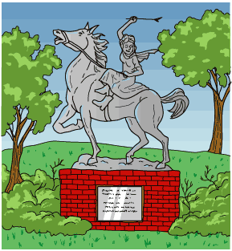
1 Imagine you are riding a horse. You are alone on a dirt road on a stormy night. Then imagine that your country is under attack. You are out on a secret mission. As you ride, you listen carefully for anyone who could be hiding in the dark. Back in 1777, a brave teenager named Sybil Ludington really had this experience.
2 From 1775 to 1783, the Revolutionary War was fought in America. The new settlers in America did not feel they were being treated justly by the British king. They wanted to start their own country. Many people who felt this way joined in the fight. The troops were made up of local groups of soldiers. Sybil's father was Colonel Henry Ludington. He was in charge of a group of soldiers in New York. A messenger showed up at the Ludington farm on the night of April 26, 1777. He told the colonel that the British had attacked nearby Danbury, Connecticut. They were burning houses and supplies.
3 Colonel Ludington knew that his soldiers were the closest. They could help save Danbury. He had let them go home to their farms, though. They had needed to plant the spring crops. Who could call his men back together? Because the messenger was suffering from fatigue, he was too weak to spread the alarm. The colonel had to stay home to give orders when his men arrived. Colonel Ludington let Sybil go and call in his troops so he could unite them. At 16, she was the oldest of the eight children he had at that time. Sybil was a good rider. Her parents must have been concerned as she rode off that cold, rainy April night.
4 Sybil rode from their farm through the towns of Carmel and Mahopac. She warned each farmhouse by shouting, 'The British are burning Danbury! Gather goods and ride out to Ludington's!' On she went, north through Kent Cliffs and up through Stormville. Finally, she headed home. When she returned to the farm at daybreak, the troops were already preparing to leave.
5 Colonel Ludington's soldiers marched 25 miles to fight in Danbury. The Americans caught up to the British and drove them back to their ships. If you go to Carmel, New York, you can see a statue of Sybil. She is sitting on her horse, Star.

Why was Sybil chosen to call in the troops?
 |  | A. | She volunteered to do it.
 |  | B. | She was a very good rider.
 |  | C. | She was the daughter of the army commander.
 |  | D. | She had a horse named Star.

Question 8 of 10
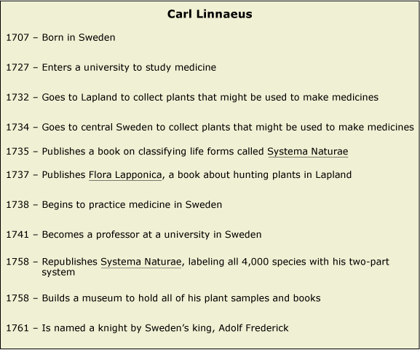

The Man Who Named Plants
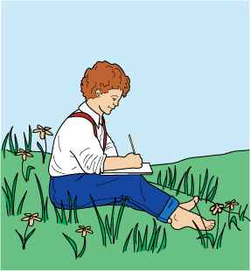
1 Carl Linnaeus was born about 300 years ago. He grew up in Sweden, which is a country on the continent of Europe. As a boy, Carl was fascinated with flowers. He studied them closely. Then he wrote notes about what he learned.
2 People gave Carl a nickname when he was very young. They called him 'the little botanist.' A botanist is a scientist who studies plants. When he became an adult, Carl took his love of plants to a university in his country. While in school, he studied medicine. Back then, doctors made their own cures from plants. By studying medicine, Carl was able to learn even more about his beloved flowers.
3 While still a student, Carl was chosen to explore an area called Lapland. He spent five months walking across this cold and beautiful land near the North Pole. His hike covered 1000 miles. As he walked, Carl studied and collected rare plants.
4 After he returned, Carl wrote a book about what he found. His book described his system of organizing plants. He wanted everyone to know how he grouped the new plants. The book made him famous. He continued to research plants and medicine.
5 Before Carl Linnaeus, plant names were confusing. Many plant names had several parts and were difficult to remember. Some plants even had different names given by different people. If a person did not like the name, he or she would change it.
6 Linnaeus's system was an orderly way to classify and name plants. He decided to give every plant a two-part name, just as people in his country had two-part names. For example, Linnaeus was Carl's family name. It meant that he was one member of a family, or a related group. Carl was his given name. It helped tell him apart from other family members. However, the names Carl gave to plants would be in Latin, the language of the ancient Romans.
7 'Why not shorten plant names?' Carl thought. One part would be the genus, or the group name, just as Linnaeus was his family's group name. For example, one large group of related trees such as maples would have one Latin name. Another group of trees such as oaks would have a different Latin name.
8 The second part of the name would be the species. The species helps tell one member of a group from other members of that group. This worked the same way Carl's first name helped tell him apart from his cousin. For example, the tree commonly known as a sugar maple is one kind of tree in the maple group. A red maple is another member of the maple group. In Carl's two-part naming system, they would share the same Latin genus name but have different Latin species names.
9 Carl studied every plant he could find. He gave them all two-part names. He continued to write about plants. The first book he wrote grew from one small book to several books. People can study his writings today to learn even more about his ideas. People everywhere began to use Carl's plan to name plants. Plant names now are easier to remember because everyone uses the same name. Carl is famous even now because of his great idea!

Where did Carl Linnaeus grow up?
 |  | A. | Lapland
 |  | B. | Sweden
 |  | C. | The North Pole
 |  | D. | North America

Question 9 of 10
In 1519, the King of Spain sent Ferdinand Magellan, a Portuguese explorer, to find a water route to Asia. He set sail with five ships and 237 crewmen. Their goal was to sail west from Europe to find Asia, which was rich with silk, gold, and spices that the King wanted to trade resources for. This exploration was important because the land route had been cut off by the Turks in Central Europe.
The first roadblock Magellan and his crew encountered was the east coast of South America. Time and again they tried to sail upriver, hoping it would lead them through to the other side of the continent. Unfortunately, each time the river ended and the crew had to turn back to the Atlantic Ocean. Magellan and his crew bumped all the way down the east coast of South America this way until they finally found a narrow waterway across the southern tip of South America. Here they were able to cross from the Atlantic to the Pacific Ocean. This waterway was later named the Strait of Magellan after Ferdinand.
Three years later one of Magellan's ships returned to Spain, having successfully sailed around the world. The news they brought with them was that Magellan did reach Asia. He had found the water route to Asia that so many explorers before him had searched for. Unfortunately, Ferdinand Magellan died shortly before reaching Asia. He was struck by a poison dart during a battle in the Philippines with the natives of that island. In the end only one out of five of his ships and 18 out of 237 crewmen survived to return to Spain. History will always remember that Ferdinand Magellan was the first explorer to sail around the world, and he proved that Christopher Columbus had found a new continent in 1492.
Interpreting the passage above, what lasting historical effect could Magellan's expedition have led to?
 |  | A. | Maps were rewritten to include North and South America.
 |  | B. | The Turks allowed access to the land route to Asia.
 |  | C. | Spain retaliated and attacked the Philippine Islands.
 |  | D. | Magellan received the credit for discovering the Americas.

Question 10 of 10
Read the following sentences.
Tara is a fifth grade student. She rides the bus to school because school is far from her house. She was late getting up one morning. She missed the bus to school.
Which sentence is the effect?
 |  | A. | She missed the bus.
 |  | B. | She got up late.
 |  | C. | She was a fifth grade student.
 |  | D. | She lives far from school.

Copyright © Discovery Education Assessment 2012. Proprietary Information. All rights reserved.
Discovery Education Page

