Progress Probe #1662850: 5th Grade TCAP Coach Chapter 2 Lesson 16, 17, and 18 (Grade 05 RE)
Teacher Key with Answers
Ques | Answer | Level | Skill | Subskill | Item #
1 | B | Moderate | Literature | SPI 0501.8.2 Predictions of Future Events [69242] | D57149
2 | C | Moderate | Logic | SPI 0501.5.1 Support Information [69209] | U46925
3 | B | Moderate | Logic | SPI 0501.5.3 Fact/Opinion and Reality/Fantasy [69212] | U47058
4 | B | Moderate | Logic | SPI 0501.5.3 Fact/Opinion and Reality/Fantasy [69212] | U47196
5 | A | Hard | Logic | SPI 0501.5.6 Inferences and Conclusions [69217] | D16711
6 | C | Hard | Logic | SPI 0501.5.1 Support Information [69209] | D2567
7 | D | Hard | Literature | SPI 0501.8.2 Predictions of Future Events [69242] | D66829
8 | B | Moderate | Logic | SPI 0501.5.1 Support Information [69209] | U46917
9 | A | Hard | Logic | SPI 0501.5.3 Fact/Opinion and Reality/Fantasy [69212] | D57787
10 | C | Moderate | Logic | SPI 0501.5.6 Inferences and Conclusions [69217] | U47139

Name: Date:
5th Grade TCAP Coach Chapter 2 Lesson 16, 17, and 18
Question 1 of 10
"The Hare and the Tortoise"
One day a Hare ridiculed the short feet and slow pace of the Tortoise, who replied, "Though you be swift as the wind, I will beat you in a race." The Hare, believing this to be simply impossible, agreed to the race. They agreed that the Fox should choose the course and fix the goal. On the day appointed for the race, the two started together. The Tortoise never for a moment stopped, but went on with a slow but steady pace straight to the end of the course. The Hare, lying down by the wayside, fell fast asleep. At last waking up, and moving as fast as he could, he saw the Tortoise had reached the goal and was comfortably sleeping.
Hare believed he could stop and sleep
 |  | A. | because he thought the Tortoise would sleep, too.
 |  | B. | because he thought he was so much faster than the Tortoise.
 |  | C. | because he thought the Fox would catch him.
 |  | D. | because he thought the Tortoise would give up.

Question 2 of 10
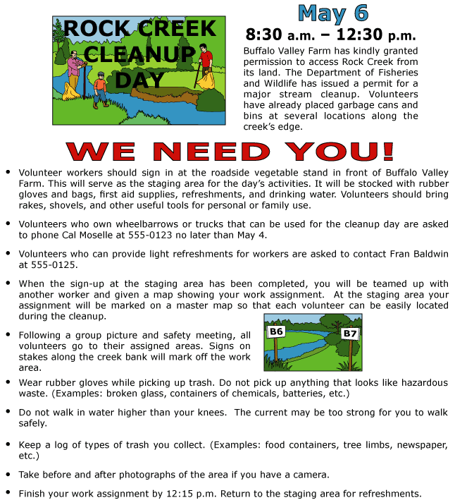

Which best explains why the assigned areas will be marked on a map?
 |  | A. | The signs need to be placed at the correct locations.
 |  | B. | Workers want to know where to find one another.
 |  | C. | The staging area needs to record the location of each worker.
 |  | D. | The picture shows only two of the areas scheduled for clean up.

Question 3 of 10
Vince and Larry
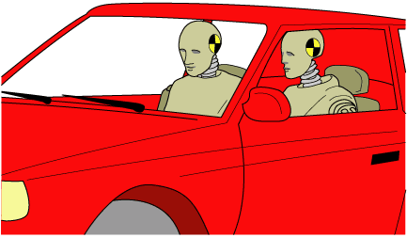
1 Have you met Vince and Larry? Vince and Larry appear at county fairs and schools across America. They have a page on the Internet. They even visited with First Lady Laura Bush at the White House. You may have seen them on television. If you have, you will recall the message on the screen saying that you can learn a lot from them. How? Vince and Larry are crash-test dummies.
2 Crash-test dummies are very important. They are used in tests intended to improve automobile safety features. The use of crash-test dummies did not begin with the automobile industry.
3 The first crash-test dummy was named Sierra Sam. He was used to test ejection seats for the U.S. Air Force. Pilots of military aircraft sit in ejection seats. These special seats allow a pilot, in an emergency, to push a lever on the seat and be hurled from the plane. Then a parachute connected to the ejection seat opens. The pilot floats safely to earth. Test dummies like Sam have also been used in underwater-escape tests and space flights. However, Sierra Sam was not useful to the automobile industry. His body did not function enough like a real person's body does during a car crash.
4 Vince and Larry are 'humanlike' dummies. They first appeared in 1985. The Highway Traffic Safety Administration began the Seat Belt Education campaign during that year. This program was established to advocate the use of automobile seat belts. Vince and Larry appeared on television to show what could happen to someone not wearing a seat belt. One year after the campaign, surveys in nineteen cities showed that more people were using seat belts than ever before.
5 'Hybrid III' models are newer crash-test dummies. They imitate the human body more closely than earlier dummies. A Hybrid III has knees like human knees. It has vinyl skin. A Hybrid III has built-in electronic tools called sensors. These sensors measure pressure on various body parts during an accident.
6 Now four new members have joined the crash-test dummy family. They include a small adult woman and three children of varying ages. Each model costs $200,000 or more to build. Scientists and engineers constantly work to improve crash-test dummies. They are being designed with more human characteristics.
7 Between 1985 and 1994, estimates show that 65,290 lives were saved as a result of using seat belts. Vince and Larry are now in part-time retirement. However, they will continue to appear at schools, fairs, and other gatherings to promote seat belt safety.
'Vince and Larry' is a registered trademark of the National Highway Traffic Safety Administration/Dept. of Transportation.

Which of these sentences from the passage is based the most in opinion?
 |  | A. | Vince and Larry are ''humanlike'' dummies.
 |  | B. | Crash-test dummies are very important.
 |  | C. | Test dummies like Sam have also been used in underwater-escape tests and space flights.
 |  | D. | They imitate the human body more closely than earlier dummies.

Question 4 of 10
The Kingdom of Thailand
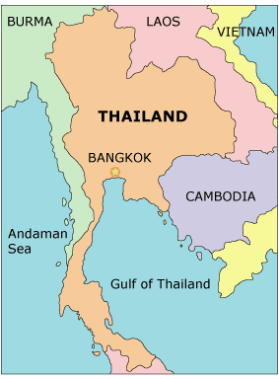
A Land of Contrasts
1 The Kingdom of Thailand, commonly known simply as Thailand, is a beautiful and exciting country in Southeast Asia. It is a land of contrasts, where tall, modern buildings and ancient structures stand side by side. Speedboats filled with noisy tourists occupy the same waterways as Thai-style canoes laden with produce. It is a country in which the modern and the traditional seem to exist together comfortably.
2 Thailand is slightly more than twice the size of Wyoming. Though relatively small in size, some areas of the country are heavily populated. Bangkok, the capital of Thailand, is a busy city of about ten million people.
3 Much of northern Thailand is mountainous, while other areas of the country are quite flat. Lush rain forests in the south are home to colorful birds and tropical plants. Thailand is surrounded by small islands, some of which are prized for their beautiful white-sand beaches. These islands are wonderful places to soak up the sun and enjoy the scenery.
Delights and Surprises Await Visitors
4 Trying new types of food is a pastime enjoyed by many of Thailand's visitors. Thai kitchens offer tantalizing dishes such as Pad Thai (stir fried noodles with fish or chicken) and Tom Kha Gai (chicken soup with coconut milk and lime juice). These and other dishes are seasoned with herbs and spices, giving Thai food its unique taste. The Thai people have a long history of using herbs as medicines as well. So Thai meals are not only appetizing, they are healthful too.
5 Visitors to Thailand are often surprised to learn that the Thai people use two different methods of telling time. 'Formal time' is told by using a 24-hour clock. This way of telling the time is used for radio and television and when conducting business. 'Informal time' is told by using four 6-hour cycles. This method for telling time is used in casual situations, such as when making plans with family and friends.
6 A variety of sports and outdoor activities are popular in Thailand. One form of recreation favored by both residents and tourists is swimming in Thailand's rivers and seas. Thailand's numerous islands provide visitors with opportunities to enjoy soft sand and sparkling blue water.
A Tropical Destination
7 Thailand's climate is warm because of its location near the equator. From February to May, the average temperature is 93 degrees Fahrenheit. The monsoons, or heavy rains, start in June and last until October. From November to January, the temperature ranges from a high of 90 degrees to a low of 82 degrees; it is no wonder that some travelers believe this is the best time to visit Thailand!
Experience Thailand
8 Many people agree that Thailand is one of the best and most popular places to visit in all of Asia. With its abundance of interesting sites and opportunities for relaxation and play, this exotic land is sure to provide first-time visitors with an unforgettable experience.

Which of these statements from the passage is an example of opinion?
 |  | A. | Speedboats filled with noisy tourists occupy the same waterways as Thai-style canoes laden with produce.
 |  | B. | These islands are wonderful places to soak up the sun and enjoy the scenery.
 |  | C. | Trying new types of food is a pastime enjoyed by many of Thailand's visitors.
 |  | D. | Thailand's climate is warm because of its location near the equator.

Question 5 of 10
from Just So Stories by Rudyard Kipling
"How the Whale Got His Throat"
In the sea, once upon a time, O my Best Beloved, there was a Whale, and he ate fishes. He ate the starfish and the garfish, and the crab and the dab, and the plaice and the dace, and the skate and his mate, and the mackereel and the pickereel, and the really truly twirly-whirly eel. All the fishes he could find in all the sea he ate with his mouth -- so! Till at last there was only one small fish left in all the sea, and he was a small 'Stute Fish, and he swam a little behind the Whale's right ear, so as to be out of harm's way. Then the Whale stood up on his tail and said, 'I'm hungry.' And the small 'Stute Fish said in a small 'stute voice, 'Noble and generous Cetacean, have you ever tasted Man?'
Based on the excerpt above, what can you infer about the story?
 |  | A. | It is a children's story.
 |  | B. | It is based on true events.
 |  | C. | It offers scientific information about whales and fish.
 |  | D. | It is meant to be realistic.

Question 6 of 10
from the "I Have a Dream" speech, delivered August 28, 1963, by Rev. Martin Luther King, Jr.
… Let us not wallow in the valley of despair, I say to you today, my friends.
And so even though we face the difficulties of today and tomorrow, I still have a dream. It is a dream deeply rooted in the American dream.
I have a dream that one day this nation will rise up and live out the true meaning of its creed: "We hold these truths to be self-evident, that all men are created equal."
I have a dream that one day on the red hills of Georgia, the sons of former slaves and the sons of former slave owners will be able to sit down together at the table of brotherhood.
I have a dream that one day even the state of Mississippi, a state sweltering with the heat of injustice, sweltering with the heat of oppression, will be transformed into an oasis of freedom and justice.
I have a dream that my four little children will one day live in a nation where they will not be judged by the color of their skin but by the content of their character.
I have a dream today!
How does Dr. King make the problem of racism seem real to his audience?
 |  | A. | by quoting an earlier speech
 |  | B. | by calling the audience "my friends"
 |  | C. | by referring to places where it is a problem
 |  | D. | by repeating the phrase "I have a dream"

Question 7 of 10
Don had a gray dog named Bowser and a black cat named Mabel. The three of them lived in a green house on the edge of town. Every day Don got into his sporty blue car and drove off to his job. When Don came home in the evening, Bowser would be waiting for him by the front gate. The dog would bark happily as Don opened the gate; then it would leap into his arms, overcome with love. "Down, Bowser," Don would always command. "Sit, Bowser," Don would say, and Bowser would sit on the ground, his tail wagging madly.
The cat always watched this performance from the front window. She couldn't believe how silly Bowser was.
One day, Don had to take Bowser and Mabel to the vet for their shots. He asked Bowser, "Do you want to go for a ride?" and Bowser leaped into the car as soon as Don opened the door. Mabel, meanwhile, was nowhere to be found. Don looked everywhere for her and finally gave up. As he was leaving, he reached into his coat closet and grabbed his warm black fur hat. Imagine his surprise when the hat sunk its claws into his forehead and sprang to the other side of the room!
Based upon what you've read about Don, Bowser, and Mabel, how might Don approach the training of each pet?
 |  | A. | Expect the same results from Bowser and Mabel.
 |  | B. | Expect more from Mabel than Bowser.
 |  | C. | Have more patience with Bowser than Mabel.
 |  | D. | Have more patience with Mabel than Bowser.

Question 8 of 10
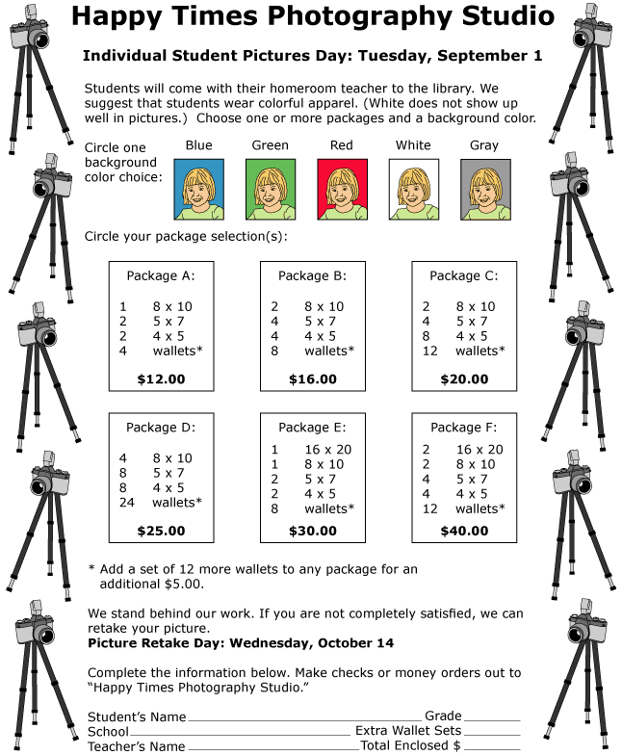

Which of the following best indicates that the photography studio wants to maintain a good reputation with its customers?
 |  | A. | The studio speaks directly with the customer.
 |  | B. | The studio states that it stands behind its work.
 |  | C. | The studio advises students about which clothes to wear.
 |  | D. | The studio schedules two days for taking pictures.

Question 9 of 10
Taste Buds
Taste buds are found in different proportions on each tongue. Some people have more sweet receptors than others do. People with more sweet receptors think that desserts are too rich, or grapefruit tastes better without sugar on it. People who have more bitter receptors than usual tend not to like cooked vegetables or red meats.
Which might be a personal opinion expressed after reading this selection?
 |  | A. | "I must have fewer sweet receptors since I like sugar on grapefruit."
 |  | B. | "My taste receptors are located on my tongue."
 |  | C. | "Some people have more sweet receptors than other people."
 |  | D. | "I had a sweet dessert at the wedding reception."

Question 10 of 10
Our Proud American Symbols
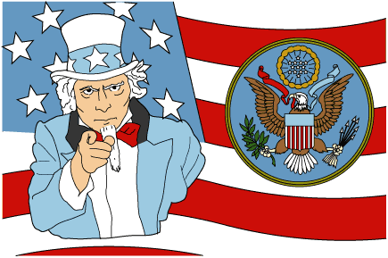
1 A symbol represents a person, object, or idea. A heart represents love, while a dove represents peace. Symbols are also used to represent countries. The following symbols represent the United States of America.
The Red, White, and Blue
2 Every country has its own flag. Parts of the American flag have different meanings.
3 The first United States flag had 13 stripes and 13 stars, which represented the original 13 states. Each time a new state joined the union, another star and another stripe were added. Before long, the growing flag became too large! It was decided to go back to 13 stripes and to add only a star to represent each new state.
4 The colors of the flag also carry meanings. Red represents courage and strength. We want others to see our country as strong. White stands for honesty and purity. It is a color often used to represent honor and goodness. Blue represents determination and justice. This color on the flag means that the United States is faithful, or 'true blue,' to its people.
A Seal for Documents
5 In addition to a flag, our country also has a special seal that is used on official documents. The Great Seal is a metal circle with engraved designs. Even if people have never seen an official United States document, they have probably seen the design of the seal many times, for it is printed on the backs of one-dollar bills.
6 The seal shows an eagle with olive branches in one claw and arrows in the other. The olive branches represent peace, while the arrows signify strength. This means that our country is strong, but it also desires peace. In its beak, the eagle holds a ribbon with some Latin words meaning, 'From many, one.' This stands for the many states that make up one nation. In front of the eagle is a shield. The shield has 13 red and white stripes to represent the original 13 colonies, and a blue stripe, which stands for our country's Congress.
7 Only the front of the Great Seal is used on official documents. There is also a design on the back. This design shows a pyramid with 13 rows, each standing for one of the original 13 colonies. The stones of the pyramid represent strength. There is an eye above the pyramid. This is thought to represent watchfulness.
A Noble Bird
8 The bald eagle, which is used on the front of the Great Seal, is our national bird. The bald eagle was chosen because the species lives almost entirely within North America. The bald eagle is a proud, majestic bird. It has a wingspan of 6 to 8 feet and stands about 3 feet tall. Because the bird is powerful and fierce looking, it represents a country that is strong.
9 Bald eagles used to be numerous, but over time their numbers decreased. The United States did not want to see its national bird disappear, so laws were passed to protect the bird. Now, there are many bald eagles, and they can be seen across our great land. The symbol of the eagle can be seen on coins, paper money, and postage stamps.
One Uncle for All
10 Another symbol for the United States is a character designed by artists and named 'Uncle Sam.' Uncle Sam's initials—U.S.—stand for the United States. He is usually drawn as a tall, white-haired man with a beard, wearing red-striped pants, a long blue coat, and a tall hat with stars and stripes.
11 The symbol of Uncle Sam was made famous when his picture appeared on posters in 1916. He was drawn with his finger pointing outward and the words 'I Want You!' This meant that the United States government was looking for men to serve in the armed forces.
12 There are many symbols for the United States, and we see them wherever we go—in government buildings, in airports, in schools, in offices, and in parades. We fly our American flag, often with an eagle perched on top of the flagpole. These symbols help us feel proud of the country in which we live.

Which would most likely change in our American symbols if another state joined the United States?
 |  | A. | The number of stripes on the shield of the Great Seal
 |  | B. | The number of stripes on the flag
 |  | C. | The number of stars on the flag
 |  | D. | The number of states in the United States

Copyright © Discovery Education Assessment 2012. Proprietary Information. All rights reserved.
Discovery Education Page

