Progress Probe #1662519: 5th Grade TCAP Coach Chapter 1 Lesson 5, 6, and 7 (Grade 05 RE)
Teacher Key with Answers
Ques | Answer | Level | Skill | Subskill | Item #
1 | D | Moderate | Language & Vocabulary | SPI 0501.1.16 Multiple Meaning Words [69159] | D68309
2 | D | Moderate | Language & Vocabulary | SPI 0501.1.4 Usage Errors [69147] | D1286
3 | D | Hard | Language & Vocabulary | SPI 0501.1.11 Word Meanings [69154] | D2560
4 | A | Hard | Language & Vocabulary | SPI 0501.1.4 Usage Errors [69147] | D1290
5 | A | Hard | Language & Vocabulary | SPI 0501.1.4 Usage Errors [69147] | D52931
6 | B | Moderate | Language & Vocabulary | SPI 0501.1.11 Word Meanings [69154] | U47590
7 | D | Moderate | Language & Vocabulary | SPI 0501.1.4 Usage Errors [69147] | D1333
8 | A | Moderate | Logic | SPI 0501.5.5 Analogies [69216] | D50558
9 | C | Hard | Language & Vocabulary | SPI 0501.1.16 Multiple Meaning Words [69159] | D68116
10 | B | Moderate | Language & Vocabulary | SPI 0501.1.16 Multiple Meaning Words [69159] | D17113
11 | B | Hard | Logic | SPI 0501.5.5 Analogies [69216] | D55900
12 | D | Hard | Language & Vocabulary | SPI 0501.1.13 Synonyms, Antonyms, and Homonyms [69156] | D102329
13 | D | Moderate | Language & Vocabulary | SPI 0501.1.15 Grade Appropriate Vocabulary [69158] | D80554
14 | D | Moderate | Logic | SPI 0501.5.5 Analogies [69216] | D18546
15 | D | Moderate | Logic | SPI 0501.5.5 Analogies [69216] | D17120
16 | A | Moderate | Language & Vocabulary | SPI 0501.1.15 Grade Appropriate Vocabulary [69158] | D98217
17 | B | Hard | Logic | SPI 0501.5.5 Analogies [69216] | D68387
18 | A | Moderate | Language & Vocabulary | SPI 0501.1.13 Synonyms, Antonyms, and Homonyms [69156] | U46941
19 | D | Hard | Language & Vocabulary | SPI 0501.1.15 Grade Appropriate Vocabulary [69158] | D102347
20 | B | Hard | Language & Vocabulary | SPI 0501.1.11 Word Meanings [69154] | D2541
21 | A | Hard | Language & Vocabulary | SPI 0501.1.13 Synonyms, Antonyms, and Homonyms [69156] | D102516
22 | C | Hard | Language & Vocabulary | SPI 0501.1.15 Grade Appropriate Vocabulary [69158] | D98181
23 | D | Moderate | Logic | SPI 0501.5.5 Analogies [69216] | U47401
24 | B | Hard | Logic | SPI 0501.5.5 Analogies [69216] | D68148
25 | D | Hard | Language & Vocabulary | SPI 0501.1.13 Synonyms, Antonyms, and Homonyms [69156] | D102330

Name: Date:
5th Grade TCAP Coach Chapter 1 Lesson 5, 6, and 7
Question 1 of 25
Our cat is so smart that she figured out how to open the door to her food cupboard.
Which sentence gives smart the same meaning as it has in the given sentence?
 |  | A. | The jockey gave the horse a smart slap on the rump to make it run faster.
 |  | B. | Isabel looked smart in her new black dress with leopard-print shoes.
 |  | C. | I dropped the book on my big toe, causing a smart pain.
 |  | D. | Daniel is too smart to have flunked his math test.

Question 2 of 25
Michael wanted to go for a run outside, but it was __________ hot.
Which word correctly completes the sentence?
 |  | A. | to
 |  | B. | two
 |  | C. | tough
 |  | D. | too

Question 3 of 25
Randy loves to play football, but during the last game he __________ his shoulder. Randy will be out for the rest of the season.
Which word best completes the sentence?
 |  | A. | located
 |  | B. | allocated
 |  | C. | relocated
 |  | D. | dislocated

Question 4 of 25
Which sentence correctly uses the pronoun "their"?
 |  | A. | Strutting along the gravel path, the peacocks fanned their tails.
 |  | B. | I'm not sure if their is any way to solve this problem.
 |  | C. | The truck drivers declared that their on strike until management offers a pay raise.
 |  | D. | I invited Josh and Zach, but their too busy to come with us.

Question 5 of 25
What is wrong with the following sentence using a coordinating conjunction?
Jake ran through the woods but not John.
 |  | A. | The conjunction does not join two complete and related thoughts.
 |  | B. | One sentence is long and one sentence is short.
 |  | C. | Jake is plural and John is singular.
 |  | D. | "Not" should come after the word "John".

Question 6 of 25
Hammer and Nail
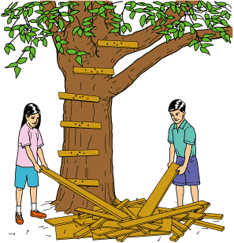
1 Leah sat across from Paul and tried to eat her breakfast, with 'tried' being the key word. It had been only a week since both of them had arrived at their grandparents' home, and already it seemed as if every little thing he did bugged her. Breakfast was the worst. His bowl had to be exactly in the middle of the placemat, and his napkin had to be folded just so on his lap. Then, when he finally got a spoonful of cereal into his mouth, he chewed it 20 times! If all of that was not bad enough, he did everything with that little smirk on his face, as if he knew just how much he was annoying her.
2 The thing to do, Leah told herself, was to get her mind off her cousin and onto something pleasant, like that old tree in their grandparents' backyard. A tall maple, it had branches like hammocks. Thinking about the tree, Leah could almost feel the breeze blowing against her face, and she could almost hear the sound of . . . chewing?
3 Leah blinked her eyes and looked across the table. She squinted at Paul, who seemed to be smirking at her as he chomped on his cereal. Grandma chose that very moment to step in and inquire about her grandchildren's plans for the day. Still chewing, Paul merely tapped the book on the table next to him. When Grandpa picked it up and started leafing through it, Leah stole a glance at the title—Engineering something-or-other. She barely stifled the urge to roll her eyes. How long could she hold back her feelings?
4 For three summers, Paul had gone to camp while Leah had come to her grandparents' house alone. What happened before that? She seemed to remember him as being fun. A little overcautious, maybe, but that just meant she got to be first off the diving board at the community swimming pool, first to ride the skateboard Grandpa had bought for them, and first to climb the old maple out back. Since he had arrived last week, though, all Paul seemed to want to do was read his books.
5 And chew, Leah thought as she watched him put another spoonful in his mouth. One, two, three, four—and Leah realized she was counting his chews. So this was what Grandma meant, Leah thought, when she had said people were 'driving her up a tree.' That was when the idea hit her.
6 'I'm going to build a tree house, Grandma,' Leah said. Out of the corner of her eye, she thought she saw Paul swallow after only 14 chews.
7 Grandpa leaned back in his chair, a slight smile on his face. 'I remember my first tree house.'
8 'I'm sure the kids would love to hear all about it,' Grandma said, 'but then they would miss the best part of the day.' She gave Leah a quick wink. 'There is plenty of wood in the shed. Make sure to get Grandpa's help if you want any pieces cut.'
9 Leah watched Paul from the corner of her eye as she cleared her dishes. It had been quite a victory, her announcement about the tree house followed immediately by Paul's losing track of his chewing. Why then, Leah wondered, didn't she feel victorious?
10 The next hour Leah spent carrying pieces of wood to the base of the tree. Choosing one short, thin piece of wood, she squatted down and nailed at knee-height the first rung in her crude ladder. She put the next slat two feet higher and then tested them both. Satisfied that they could hold her weight, she kept working.
11 She was just nailing in the fourth slat when she noticed Paul. He was sitting in the shade of the shed, pretending to read his book even though she knew he was watching her. For some reason it almost surprised her that she was not annoyed.
12 When her ladder was finished, she climbed down, dug through her pile of wood for the right piece, and then stopped. How was she going to climb back up carrying the wood, the hammer, and the nails? Her eyes darted toward Paul. He was watching her outright now, his book closed in his lap. At least he was not smirking, she thought as she lifted the board up onto her shoulder and reached for the first slat.
13 The next thing she knew, she was sitting on the ground, the board was stuck in the crook of the tree, and the nails were scattered in the grass all around her. Gazing up at the leaves overhead, she felt the breeze drying the sweat on her face, even as the dream of the tree house evaporated into thin air.
14 'Need some help?' asked Paul.
15 'No, just taking a break,' she replied, placing a hand against the lower slat in a pose of faked relaxation, which she hoped would fool him.
16 'Grandpa's got a rope in the back of his truck,' offered Paul.
17 A rope, Leah thought, scolding herself mentally. Glancing up at the tree and then back at her cousin, it took Leah only a second to make her decision. After all, she thought as Paul ran to get the rope, if he was going to drive her up a tree, he should at least do some of the work.

Read the sentence from paragraph 2 of the story.
A tall maple, it had branches like hammocks.
Which of the following did the author use in the sentence?
 |  | A. | Idiom
 |  | B. | Simile
 |  | C. | Alliteration
 |  | D. | Personification

Question 7 of 25
Choose the correctly written sentence.
 |  | A. | She didn't want no one to feel badly.
 |  | B. | I have never done nothing to nobody.
 |  | C. | David doesn't know nothing.
 |  | D. | Don't use any ink on the paper.

Question 8 of 25
Complete the analogy.
bird : nest :: bear : _______.
 |  | A. | cave
 |  | B. | herd
 |  | C. | flock
 |  | D. | house

Question 9 of 25
Decide which of the answers has the same meaning as the underlined word in the following sentence:
Can you help me roll up my sleeping bag?
 |  | A. | Please go get that roll of masking tape.
 |  | B. | Did you eat the last dinner roll?
 |  | C. | Max tried to roll the clay to form a ball.
 |  | D. | Did you hear the thunder roll in the distance?

Question 10 of 25
Which meaning of the word "mind" is used in this sentence?
Even though cleaning the garage is hard work, I don't mind.
 |  | A. | to have reason
 |  | B. | to inconvenience
 |  | C. | to obey someone
 |  | D. | to pay attention

Question 11 of 25
Choose the best word to complete the following analogy. dog : kennel :: fish : ___________
 |  | A. | boat
 |  | B. | aquarium
 |  | C. | swimming pool
 |  | D. | worms

Question 12 of 25
The bold words in the following sentences are what type of words?
Logan hurt his left hand playing tennis.
Susan left her purse at the store.
 |  | A. | homophones
 |  | B. | homographs
 |  | C. | heteronym
 |  | D. | homonyms

Question 13 of 25
When you attend the movies, you should be ______ so that you don't disturb other people who are trying to hear.
Which word fits into the sentence and is spelled correctly?
 |  | A. | quite
 |  | B. | quit
 |  | C. | qwiet
 |  | D. | quiet

Question 14 of 25
Muscle is to move as skin is to ________ .
 |  | A. | fingernail
 |  | B. | jacket
 |  | C. | pin
 |  | D. | cover

Question 15 of 25
Choose the correct word or words to complete the following analogy.
Library is to books as ________is to money.
 |  | A. | people
 |  | B. | take out
 |  | C. | coin
 |  | D. | bank

Question 16 of 25
Candice loved to hear her brother play the piano. She wished she had the same skill and ________ he had.
Which word best completes the sentence?
 |  | A. | ability
 |  | B. | clumsy
 |  | C. | failure
 |  | D. | salary

Question 17 of 25
Identify the antonym of partial.
 |  | A. | incomplete
 |  | B. | complete
 |  | C. | huge
 |  | D. | small

Question 18 of 25
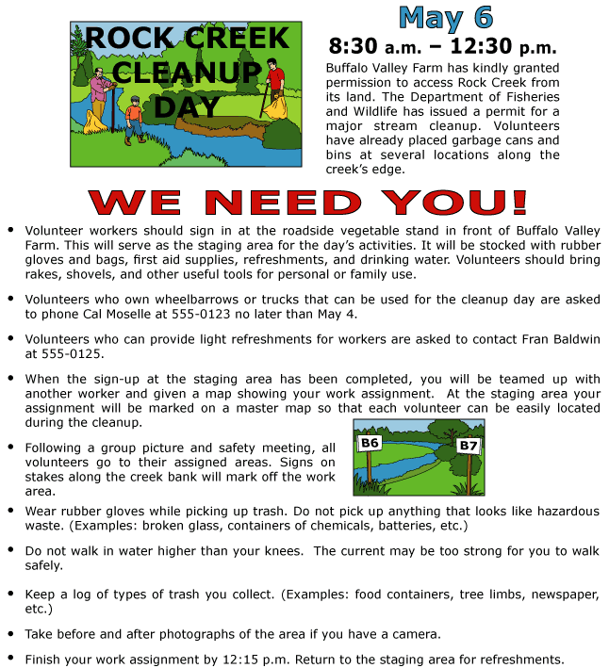

Read the thesaurus entry below.
personal — adj. 1. private, secret; individual, own, special. 2. close, familiar; face-to-face.
If the author wanted to replace the word personal in the first bulleted item of this flyer, what would be the best word to use from the thesaurus entry?
 |  | A. | individual
 |  | B. | special
 |  | C. | own
 |  | D. | familiar

Question 19 of 25
What does the word "sale" mean?
 |  | A. | to travel on water
 |  | B. | part of a boat
 |  | C. | a store closing
 |  | D. | discount

Question 20 of 25
In 1776, the American colonies sent a message to George III: They did not want to be ruled by a monarch.
As used in the sentence above, the word monarch means __________.
 |  | A. | butterfly
 |  | B. | king or queen
 |  | C. | president
 |  | D. | foreign country

Question 21 of 25
What is the function and definition of the word "envelop" in the following sentence?
The tornado enveloped the sky and turned the light of day into the blackest of nights.
 |  | A. | verb; covered or consumed
 |  | B. | adjective; sucked in
 |  | C. | noun; sealed it like a package
 |  | D. | verb; discarded

Question 22 of 25
In which sentence is the underlined word spelled correctly?
 |  | A. | On her vacation, Sessie visited the South--her favorite rhegion of the United States.
 |  | B. | On her vacation, Sessie visited the South--her favorite rheegun of the United States.
 |  | C. | On her vacation, Sessie visited the South--her favorite region of the United States.
 |  | D. | On her vacation, Sessie visited the South--her favorite reegion of the United States.

Question 23 of 25
Banjo Seeds
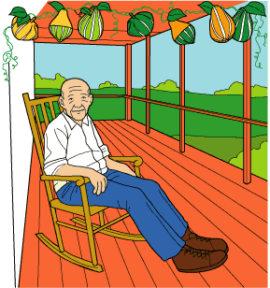
1 Jerry just had to have a banjo, but how was he to get one? Living miles away from town in 1900, you could not just go to a store and buy whatever you wanted. As his mother often said, 'Use it up, wear it out, make it work, or do without.' Usually, Jerry just did without.
2 Not this time, though. He was determined to have a banjo, even if he had to make it himself—even if he had to grow it himself.
3 Jerry had first heard a banjo the year before when his family had visited Grandpa Souder. As they approached the house, Jerry heard a twanging and plucking that set his heart to dancing.
4 On the front porch, Grandpa sat in his rocking chair with the strangest instrument Jerry had ever seen. It was a large, oblong, hollowed-out gourd with a stick poking out the top. Strings ran from the far end of the stick down across the gourd. Small wooden sticks had been set into the end of the gourd, securing the strings.
5 'Play a fast one, Dad,' Jerry's father requested.
6 The old man obliged, playing a song called 'Round and Round.' As Jerry listened, he watched the old man's fingers moving fast, plucking one string and then another. When it was over, Jerry looked at Grandpa Souder and said, 'Could I play?'
7 All afternoon, Grandpa Souder taught Jerry to play the banjo. He showed his grandson how to hold the instrument, how to place the fingers of his left hand at the top of the instrument's neck, and how to use his right hand to pluck the strings.
8 As the shadows lengthened, Jerry still sat playing the chords for 'Round and Round.' With practice, he grew less conscious of his fingers moving. They began to move more like Grandpa's, like wind through the corn.
9 'That boy's a natural banjo player,' Grandpa said. 'Just listen to him!'
10 As Jerry prepared to go home, his grandfather took his hand and placed something in it. Jerry peered through the darkness and saw five small seeds in his hand. 'What are these?' he asked.
11 'Banjo seeds,' his grandfather said, nodding. 'If you plant and water them, they will grow you a banjo, just like mine.'
12 All summer, Jerry watched his plants. The five seeds grew into large vines that spread all over the garden. Jerry could not believe that these would grow into banjos like Grandpa's. Jerry kicked at one of the heavy, green gourds. How could you play 'Round and Round' on a thing like this?
13 One day, Grandpa Souder visited Jerry's gourd plot. 'On a day like this,' he said, 'you can hear the corn grow if you listen carefully.'
14 Jerry looked his Grandpa in the eye and asked, 'Were those really banjo seeds you gave me?'
15 Grandpa nodded. 'I told you they would grow if you planted them. Didn't they grow?'
16 'Yes, Grandpa, they grew really well, but they do not look anything like your banjo.'
17 'No, they do not—yet. But those seeds did not look anything like a gourd, did they? Just look at them now. See, you had to help the seeds grow into gourds, and now you have got to help the gourds grow into banjos.'
18 When the leaves fell and the fall rains came, Jerry left the gourds in the garden, for they did not look anything like Grandpa's banjo. By the end of winter, they changed from green to tan. When Jerry went out to spade the garden, he hit at one of the gourds with the shovel. It flew across the yard. Jerry picked one up and found it was not heavy anymore. When he shook it, the gourd made a sound like a baby's wooden rattle. He cracked one open, and dried seeds fell out. He tapped on a gourd with his knuckles, and it sounded like a drum. Jerry looked at the dried-up gourds in the garden. Grandpa's words came back to him: 'You have got to help the gourds grow into banjos.'
19 Jerry experimented with the gourds, hollowing them out and stretching leather over them, trying different types of wood for the neck, and placing wooden plugs in the base to secure the strings. After many attempts and many ruined gourds, he finally succeeded in making a banjo that looked like his grandfather's. But would it sound like his grandfather's banjo?
20 He began to tune the instrument, plucking first one string and then another. Increasingly, his fingers grew accustomed to the banjo. They began to fly over the strings almost like Grandpa's. His banjo even sounded like Grandpa's!
21 One day, Jerry sat on the porch with his banjo, playing 'Round and Round' as fast as Grandpa Souder had. He was so entranced by his own music that he did not hear the old man step onto the porch.
22 'I see the seeds grew,' said Grandpa Souder, laughing. 'And from the sound of it, I would say you had a really good crop.'
23 Jerry laughed. 'It was a good crop, Grandpa, but you were right. Those gourds did need little help to grow into a banjo. You know, I could use a little help growing into a banjo player. Do you think you could teach me some more songs?'
24 'I surely can, Jerry. That is how music grows—with practice!'

Read this part of an analogy.
fingers are to hand as strings are to _____
Which word from the passage best completes the analogy?
 |  | A. | pluck
 |  | B. | gourd
 |  | C. | music
 |  | D. | banjo

Question 24 of 25
Which word best completes the analogy?
Cheap is to expensive as awkward is to __________.
 |  | A. | costly
 |  | B. | graceful
 |  | C. | clumsy
 |  | D. | excellent

Question 25 of 25
The homonym "lie" could be used in which two sentences?
 |  | A. | My grandma uses ________ soap to wash clothes. Janet likes to ________ on the coach to read.
 |  | B. | Victor will ________ to the market. Uncle Ted has to ________ the cattle home.
 |  | C. | Washington did not tell a ________. Aunt Susie had a ________ in her eye.
 |  | D. | Phil told a ________ to his dad. The dog will ________ on the floor.

Copyright © Discovery Education Assessment 2012. Proprietary Information. All rights reserved.
Discovery Education Page

