Progress Probe #1662639: 5th Grade TCAP Coach Chapter 1 Lesson 13, 14, and 15 (Grade 05 RE)
Teacher Key with Answers
Ques | Answer | Level | Skill | Subskill | Item #
1 | A | Hard | Language & Vocabulary | SPI 0501.1.7 Correct Spelling [69150] | D70876
2 | C | Hard | Language & Vocabulary | SPI 0501.1.10 Correct Incomplete Sentences [69153] | D52667
3 | C | Hard | Language & Vocabulary | SPI 0501.1.1 Use of Nouns/Pronouns [69144] | D64518
4 | D | Hard | Language & Vocabulary | SPI 0501.1.9 Run-On Sentences [69152] | D99701
5 | A | Hard | Language & Vocabulary | SPI 0501.1.1 Use of Nouns/Pronouns [69144] | D102411
6 | A | Moderate | Language & Vocabulary | SPI 0501.1.4 Usage Errors [69147] | D68301
7 | B | Moderate | Language & Vocabulary | SPI 0501.1.1 Use of Nouns/Pronouns [69144] | U48104
8 | B | Hard | Language & Vocabulary | SPI 0501.1.14 Compound Words, Contractions, and Abbreviations [69157] | D104166
9 | B | Hard | Language & Vocabulary | SPI 0501.1.5 Use of Commas/Colons [69148] | D67686
10 | D | Moderate | Language & Vocabulary | SPI 0501.1.1 Use of Nouns/Pronouns [69144] | U48136
11 | D | Moderate | Language & Vocabulary | SPI 0501.1.5 Use of Commas/Colons [69148] | U47788
12 | D | Hard | Language & Vocabulary | SPI 0501.1.5 Use of Commas/Colons [69148] | D17267
13 | B | Moderate | Language & Vocabulary | SPI 0501.1.7 Correct Spelling [69150] | D17231
14 | D | Hard | Language & Vocabulary | SPI 0501.1.7 Correct Spelling [69150] | D60687
15 | D | Hard | Language & Vocabulary | SPI 0501.1.7 Correct Spelling [69150] | D59022
16 | C | Moderate | Language & Vocabulary | SPI 0501.1.10 Correct Incomplete Sentences [69153] | D2572
17 | D | Hard | Language & Vocabulary | SPI 0501.1.10 Correct Incomplete Sentences [69153] | D56509
18 | D | Hard | Language & Vocabulary | SPI 0501.1.1 Use of Nouns/Pronouns [69144] | D69819
19 | C | Moderate | Language & Vocabulary | SPI 0501.1.9 Run-On Sentences [69152] | U47932
20 | B | Hard | Language & Vocabulary | SPI 0501.1.5 Use of Commas/Colons [69148] | D67446
21 | B | Moderate | Language & Vocabulary | SPI 0501.1.4 Usage Errors [69147] | D99492
22 | C | Hard | Language & Vocabulary | SPI 0501.1.8 Appropriate Sentence-Combining Techniques [69151] | D60944
23 | A | Hard | Language & Vocabulary | SPI 0501.1.4 Usage Errors [69147] | D53204
24 | D | Moderate | Language & Vocabulary | SPI 0501.1.4 Usage Errors [69147] | D57580
25 | B | Moderate | Language & Vocabulary | SPI 0501.1.8 Appropriate Sentence-Combining Techniques [69151] | U46077
26 | D | Moderate | Language & Vocabulary | SPI 0501.1.14 Compound Words, Contractions, and Abbreviations [69157] | D86950
27 | B | Hard | Language & Vocabulary | SPI 0501.1.10 Correct Incomplete Sentences [69153] | D54202

Name: Date:
5th Grade TCAP Coach Chapter 1 Lesson 13, 14, and 15
Question 1 of 27
Which sentence is not spelled correctly?
 |  | A. | The players were cooperateing with their coach.
 |  | B. | The repetitive drills improved their game.
 |  | C. | Winning a trophy was an irresistible goal.
 |  | D. | The crowd showed their appreciation by cheering.

Question 2 of 27
Choose the best way to correct these incomplete sentences.
A beautiful rainbow. Formed after the rain. It disappeared quickly.
 |  | A. | A beautiful rainbow formed after the rain disappeared quickly.
 |  | B. | A beautiful rainbow formed and disappeared after the rain quickly.
 |  | C. | A beautiful rainbow formed after the rain, but it disappeared quickly.
 |  | D. | Quickly a beautiful rainbow disappeared.

Question 3 of 27
What is the simple subject in the following sentence?
Add two small cans of tomato paste.
 |  | A. | cans
 |  | B. | tomato
 |  | C. | (You)
 |  | D. | add

Question 4 of 27
Which of the following is the most appropriate method for correcting the run-on sentence below?
My crazy dog ran away this morning she found a park nearby she played with the children until we found her.
 |  | A. | My crazy dog ran away this morning and she found a park nearby and she played with the children until we found her.
 |  | B. | My crazy dog ran away this morning; and she found a park nearby; and she played with the children until we found her.
 |  | C. | My crazy dog ran away this morning. She found a park nearby. She played with children until we found her.
 |  | D. | My crazy dog ran away this morning, found a park nearby, and played with the children until we found her.

Question 5 of 27
In which of the following sentences is the pronoun "she" the subject of the sentence?
 |  | A. | She drove over to their house for dinner.
 |  | B. | The student should make sure he/she has a pencil.
 |  | C. | It was agreed that she would give the demonstration.
 |  | D. | Maria thought she should have gotten the lead role.

Question 6 of 27
As the fans cheered, the football players put on there helmets and took the field.
The given sentence contains a mistake. Which choice would fix the mistake?
 |  | A. | change there to their
 |  | B. | change there to they're
 |  | C. | change helmets to helmet's
 |  | D. | change field to feild

Question 7 of 27
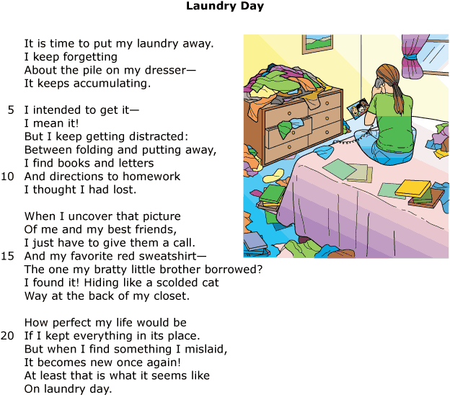

What is the meaning of the word mislaid in line 21?
 |  | A. | not put together correctly
 |  | B. | not put away properly
 |  | C. | put away another time
 |  | D. | put in a cluttered spot

Question 8 of 27
The house was atrocious! I could not believe my mother and father actually wanted to buy that pitiful house!
What does the word atrocious mean in this sentence?
 |  | A. | awful
 |  | B. | beautiful
 |  | C. | huge
 |  | D. | fancy

Question 9 of 27
What part of a business letter should contain a colon?
 |  | A. | heading
 |  | B. | greeting
 |  | C. | closing
 |  | D. | signature

Question 10 of 27
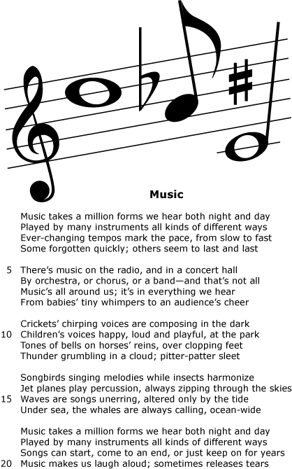

What does the word tempos mean in line 3?
 |  | A. | shapes
 |  | B. | methods
 |  | C. | notes
 |  | D. | speeds

Question 11 of 27
Dear Mayor Ralston
1 I would like to bring an important matter to your attention. The field at the corner of County Road 19 and Smithfield Road is up for sale. The owner of the field Reginald Cooper is willing to sell the property to the city for a reduced price. He would like the city to build a childrens park on the property.
2 The Parent and School Committee has been raising money for a new park. The money we raised can pay for the park equipment. We believe this property would be perfect for our project. The library project was a great success for our city.
3 I would like to meet with you. I would like to discuss the possibility of the city purchasing this property. I think a new park would be a great addition for our city; because we should not pass up this opportunity.
Sincerely,
Jane Stevens
Parent and School Committee President

Read this sentence from the letter.
He would like the city to build a childrens park on the property.
What is the correct way to write the underlined word?
 |  | A. | childrens’s
 |  | B. | childrenss’
 |  | C. | childrens’
 |  | D. | children’s

Question 12 of 27
May 15, 2007
Scott Miller
Plantco seed company
1623 Flowering Way
Bloomingdale, NY 98734
Dear Mr. Miller
I am in the 5th grade at King Elementary School in Smithville, Virginia. I am studying seeds and plants. My science class is studying seeds and plants. We are planning several experiments using seeds. Would you be generous enough to donate some seeds to our class? We would greatly appreciate any donation you can make. For your time and attention to this matter.
Sincerely,
Jennifer Sparks
What punctuation belongs after the letter's greeting?
 |  | A. | a comma
 |  | B. | a semicolon
 |  | C. | a period
 |  | D. | a colon

Question 13 of 27
While cleaning under the bed, Melanie discovered her mother's necklace. Weeks ago, she had borrowed it without asking. She hadn't even realized that the necklace was missing, and she could'nt believe it had escaped her mother's notice. She was able to return it to her mother's jewelry box without getting caught, but she still felt guilty.
Which word from the passage above is spelled incorrectly?
 |  | A. | escaped
 |  | B. | could'nt
 |  | C. | jewelry
 |  | D. | believe

Question 14 of 27
Choose the word that is spelled correctly and best completes the sentence.
The __________ turned cold and windy just as we began our trip.
 |  | A. | whether
 |  | B. | weether
 |  | C. | weater
 |  | D. | weather

Question 15 of 27
Choose the sentence that contains an incorrectly spelled word.
 |  | A. | The troop leader started the meeting.
 |  | B. | Have you heard this song before?
 |  | C. | Yesterday's weather was warm and rainy.
 |  | D. | A heard of buffalo ran across the plain.

Question 16 of 27
Which choice is an example of a run-on sentence?
 |  | A. | Armadillos are fascinating animals that are native to North and South America.
 |  | B. | The nine-banded armadillo, which lives in the American Southwest, is considered a pest in some areas.
 |  | C. | Most types of armadillos give birth to four babies at a time the babies are called pups.
 |  | D. | Most people believe that armadillos curl up in a ball to protect themselves, but only one type of armadillo can do this.

Question 17 of 27
How should this run-on sentence be corrected?
Allison put her dog into the bathtub he immediately jumped out.
 |  | A. | He immediately jumped out before Allison. The terrier immediately jumped out after Allison got into the tub.
 |  | B. | Allsion put her dog into the bathtub. Will he jump out?
 |  | C. | Allison put her dog into the bathtub but he immediately jumped out.
 |  | D. | Allison put her dog into the bathtub, but he immediately jumped out.

Question 18 of 27
In which sentence is the underlined noun a plural possessive noun?
 |  | A. | It was Matthias's turn to give a speech in front of the class.
 |  | B. | The Smith family's holiday decorations go up earlier each year.
 |  | C. | If you get lost, ask for a policeman's help.
 |  | D. | The library shelves were filled with children's books.

Question 19 of 27
The Trace
1 The United States saw the value of the Trace too. President Thomas Jefferson bought the Louisiana Territory in 1803. This land was west of the trail. The Trace soon became much more important to the United States. The government used the trail to connect with the new land. A postal route was also started along the Trace. The trail was soon widened to have more room for travelers.
2 Many parts of the Natchez Trace are still around today. Natchez Trace State Park is located in Wildersville, Tennessee. The route is now a highway that stretches from Nashville, Tennessee, to Natchez, Mississippi. The road took about 70 years to finish.
3 Natchez Trace is a historic and lengthy trade route of about 450 miles. The word “trace” is another word for “trail.” The Choctaw and Chickasaw Indians used the Trace for trading with other tribes. The route linked the three major rivers in the area. The Indians traveled the trail in a single-file line on horseback they followed the winding trail over swamps, creeks, and rivers.
4 With more traffic, the people living along the trail built inns and trading posts. The Trace attracted all types of people, traders, bandits, soldiers, preachers, and of course, new settlers. Traveling on the Trace was known to be very dangerous. Even so, the trail became worn with use. Meriwether Lewis, one of the explorers from the Lewis and Clark Expedition, died at a stop near Hohenwald, Tennessee. By 1816, the use of the trail had decreased. Steamboats had been invented.

Read this sentence from the passage.
The Indians traveled the trail in a single-file line on horseback they followed the winding trail over swamps, creeks, and rivers.
What is the best way to correct this run-on sentence?
 |  | A. | The Indians traveled the trail in a single-file. Line on horseback they followed the winding trail over swamps, creeks, and rivers.
 |  | B. | The Indians traveled the trail in a single-file line on horseback, they followed the winding trail over swamps, creeks, and rivers.
 |  | C. | The Indians traveled the trail in a single-file line on horseback. They followed the winding trail over swamps, creeks, and rivers.
 |  | D. | The Indians traveled the trail in a single-file line on horseback they followed, the winding trail over swamps, creeks, and rivers.

Question 20 of 27
Look at these parts taken from a friendly letter and choose the one that correctly uses a comma.
 |  | A. | January 3 1999,
 |  | B. | 1228 Lakeview Rd. Memphis, TN 37442
 |  | C. | 18 Larson Dr. Dallas,Texas, 56200
 |  | D. | Dear,Aunt Jean,

Question 21 of 27
Which of the following words are homographs that would describe a cat licking milk and one revolution around a track?
 |  | A. | finish, finish
 |  | B. | lap, lap
 |  | C. | drink, drink
 |  | D. | turn, turn

Question 22 of 27
Choose the best way to combine these sentences.
I was surprised to be chosen.
Many people had wanted to go.
 |  | A. | I was surprised to be chosen, many people had wanted to go.
 |  | B. | I was surprised to be chosen many people had wanted to go.
 |  | C. | I was surprised to be chosen because many people had wanted to go.
 |  | D. | I was surprised to be chosen, and many people had wanted to go.

Question 23 of 27
Choose the most appropriate interjection to complete this sentence.
________! Here is the folder I've been looking for.
 |  | A. | Aha
 |  | B. | Ouch
 |  | C. | Oh, well
 |  | D. | Now

Question 24 of 27
Which sentence is written correctly?
 |  | A. | Haven't you never been to Disney World?
 |  | B. | The driver didn't not stop for any red lights.
 |  | C. | Shannon never eats nothing at lunch.
 |  | D. | Can't you ever remember to lock the door?

Question 25 of 27
The Lake
1Janet was excited. She had been waiting all winter long to go to the lake. Finally summer had arrived, and the temperatures outside were warming up. The weekend after school let out. Janet and her family packed up the car and headed to the lake for a picnic. Janet and her brother asked to go down to the beach for a swim. “Don’t be too long. Her mother said. We're going to eat lunch soon.”
2Janet nodded and ran after her brother. They charged into the lake together. Janet felt a chill rush through her body. The water was freezing! She and her brother jumped out quickly. Her father had taken a day off from work. They ran back to their picnic site.

Read these sentences from the passage.
The weekend after school let out. Janet and her family packed up the car and headed to the lake for a picnic.
Which is the best way to combine these two sentences?
 |  | A. | The weekend after school let out, and Janet and her family packed up the car and headed to the lake for a picnic.
 |  | B. | The weekend after school let out, Janet and her family packed up the car and headed to the lake for a picnic.
 |  | C. | Janet and her family packed up the car and headed to the lake for a picnic, and the weekend after school let out.
 |  | D. | Janet and her family packed up the car, headed to the lake for a picnic, the weekend after school let out.

Question 26 of 27
Choose the sentence with the correct underlined contraction that means Who is.
 |  | A. | Whos's coming over for supper tonight?
 |  | B. | Whos' coming over for supper tonight?
 |  | C. | Who'se coming over for supper tonight?
 |  | D. | Who's coming over for supper tonight?

Question 27 of 27
Choose the best way to correct the run-on sentence.
I walked two miles to the store and the store was still far away.
 |  | A. | I walked two miles but, the store was still far away.
 |  | B. | I walked two miles, but the store was still far away.
 |  | C. | I walked two miles or the store was still far away.
 |  | D. | I walked two miles but the store was still far away.

Copyright © Discovery Education Assessment 2012. Proprietary Information. All rights reserved.
Discovery Education Page

