Progress Probe #1660905: 4th Grade TCAP Coach Chapter 4 Lesson 37 (Grade 04 RE)
Teacher Key with Answers
Ques | Answer | Level | Skill | Subskill | Item #
1 | A | Moderate | Literature | SPI 0401.8.6 Similes and Metaphors [69137] | U43644
2 | C | Moderate | Literature | SPI 0401.8.6 Similes and Metaphors [69137] | U43671
3 | A | Hard | Literature | SPI 0401.8.6 Similes and Metaphors [69137] | D62418
4 | C | Hard | Literature | SPI 0401.8.6 Similes and Metaphors [69137] | D50840
5 | C | Moderate | Literature | SPI 0401.8.6 Similes and Metaphors [69137] | U43642
6 | C | Hard | Literature | SPI 0401.8.6 Similes and Metaphors [69137] | D63739

Name: Date:
4th Grade TCAP Coach Chapter 4 Lesson 37
Question 1 of 6
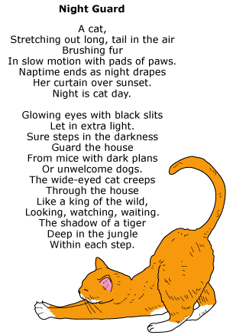

Read this line from the poem.
Night is cat day.
Which of the following best explains what this line means?
 |  | A. | Cats are active at night.
 |  | B. | Cats behave more like dogs during the day.
 |  | C. | Cats take naps during the day.
 |  | D. | Cats sleep under curtains at night.

Question 2 of 6
The First Walk on the Moon
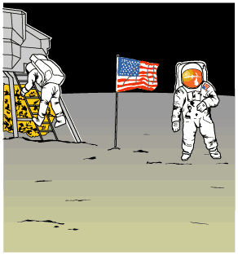
1 It was the night of July 20, 1969. All across America, people were doing the same thing. They were gathered in front of their television sets. They were waiting to witness an unforgettable moment in history. This was the night that, for the first time, a human being would set foot on the moon. It was a goal scientists had worked for many years to accomplish.
2 Greg Mitchell was amazed by space. Grandpa called him the family space expert. Astronauts Neil Armstrong and Buzz Aldrin were going to walk on the moon tonight, and Greg couldn't wait. It was all he had thought about ever since Apollo 11 launched into space.
3 He was sitting in the family room with his mom, sister, brother, and grandpa. The newscaster announced that the moonwalk had been moved up several hours. The Mitchell family cheered. It wouldn't be long now.
4 There was just one problem. Greg's beloved dog, Bessie, who meant so much to him, was about to have puppies. Greg's dad came in from the barn. 'Greg,' Dad said, 'I know how much you want to see that moonwalk. But Bessie's your dog, and she's about to have those pups.'
5 'Aw, Dad,' Greg protested, 'I can't miss this!'
6 'Now, Greg,' Dad said, 'You know that you're responsible for Bessie. Not only that, she needs you. Put on your shoes, and I'll meet you out there.'
7 Deep down, Greg knew his dad was right. Bessie was his dog, and he loved her a lot. She would feel better having Greg there. He glanced up at the moon as he hurried out to the barn. 'Please, Mr. Armstrong and Mr. Aldrin,' he wished, 'please wait until the puppies are born. Don't start without me.'
8 He sat next to Bessie on the blanket. She liked having her head petted. Soon, Bessie had four healthy puppies. They were so cute. Greg was glad he hadn't missed it.
9 'Son,' his dad offered, 'you go see how those astronauts are doing. I'll finish up here.'
10 Greg got back in time to see Neil Armstrong climb slowly down the ladder of the spaceship. He held his breath in amazement as Armstrong announced with wonder, 'That's one small step for man, one giant leap for mankind.' Buzz Aldrin joined Armstrong a few minutes later. The two men placed an American flag on the moon's surface.
11 It was a night Greg would never forget. Not only had he witnessed history in the making, but also there were four new additions to the family. He had no trouble figuring out what to name the puppies. Neil, Buzz, Armstrong, and Aldrin had not only very special names but a very special birthday too.

Read this sentence from the passage.
He held his breath in amazement as Armstrong announced with wonder, 'That's one small step for man, one giant leap for mankind.'
Which sentence best explains what Armstrong's words mean?
 |  | A. | This would be a very important step in the history of America.
 |  | B. | Much of the ground was covered with just one step.
 |  | C. | The short step taken represented many important scientific gains.
 |  | D. | Armstrong was walking on the moon with small steps and giant leaps.

Question 3 of 6
Which sentence below uses a metaphor to compare?
 |  | A. | The snow was a blanket of cotton.
 |  | B. | The snow was like a blanket of cotton.
 |  | C. | The snow fell heavy on the land.
 |  | D. | The snow made me as happy as a puppy.

Question 4 of 6
Which of the sentences below is a metaphor?
 |  | A. | The cat was black as night.
 |  | B. | She cried like a newborn baby.
 |  | C. | The sun was a ball of fire in the sky.
 |  | D. | Polly parrot picked at the pickles.

Question 5 of 6

Read these lines from the poem.
The shadow of a tiger
Deep in the jungle
Within each step.
What do these lines suggest?
 |  | A. | The cat's shadow looks the same as a tiger's shadow.
 |  | B. | The cat wants to walk with tigers in the jungle.
 |  | C. | The cat moves and acts like a tiger.
 |  | D. | The cat pretends to be a tiger in the jungle.

Question 6 of 6
Which sentence below uses a simile to compare?
 |  | A. | The wind began to blow.
 |  | B. | The wind was a fierce bull.
 |  | C. | The wind was like a gentle breath.
 |  | D. | The wind blew with force.

Copyright © Discovery Education Assessment 2012. Proprietary Information. All rights reserved.
Discovery Education Page

