Progress Probe #1660876: 4th Grade TCAP Coach Chapter 4 Lesson 33, 34, 35, 36, and 38 (Grade 04 RE)
Teacher Key with Answers
Ques | Answer | Level | Skill | Subskill | Item #
1 | B | Moderate | Literature | SPI 0401.8.5 Forms of Text [69136] | U44239
2 | C | Moderate | Literature | SPI 0401.8.3 Problems and Solutions [69134] | U45548
3 | A | Hard | Literature | SPI 0401.8.1 Plot Features [69132] | D73842
4 | A | Moderate | Literature | SPI 0401.8.8 Sounds of Language [69139] | U44693
5 | A | Hard | Literature | SPI 0401.8.2 Characters, Setting, and Plot [69133] | D75788
6 | B | Hard | Literature | SPI 0401.8.5 Forms of Text [69136] | D54044
7 | B | Moderate | Literature | SPI 0401.8.2 Characters, Setting, and Plot [69133] | U44272
8 | B | Moderate | Literature | SPI 0401.8.8 Sounds of Language [69139] | U43987
9 | A | Hard | Literature | SPI 0401.8.8 Sounds of Language [69139] | D17499
10 | A | Moderate | Literature | SPI 0401.8.8 Sounds of Language [69139] | U46036
11 | C | Hard | Literature | SPI 0401.8.1 Plot Features [69132] | D58424
12 | A | Moderate | Literature | SPI 0401.8.3 Problems and Solutions [69134] | U45466
13 | B | Hard | Literature | SPI 0401.8.8 Sounds of Language [69139] | D16896
14 | A | Hard | Literature | SPI 0401.8.5 Forms of Text [69136] | D57771
15 | A | Hard | Logic | SPI 0401.5.3 Fact/Opinion and Reality/Fantasy [69117] | D16930
16 | B | Hard | Logic | SPI 0401.5.3 Fact/Opinion and Reality/Fantasy [69117] | D17443
17 | D | Hard | Literature | SPI 0401.8.5 Forms of Text [69136] | D50209
18 | A | Hard | Literature | SPI 0401.8.2 Characters, Setting, and Plot [69133] | D53988
19 | D | Hard | Literature | SPI 0401.8.3 Problems and Solutions [69134] | D75666
20 | A | Hard | Literature | SPI 0401.8.1 Plot Features [69132] | D68828
21 | A | Hard | Literature | SPI 0401.8.2 Characters, Setting, and Plot [69133] | D75167
22 | B | Hard | Literature | SPI 0401.8.3 Problems and Solutions [69134] | D75668
23 | B | Hard | Logic | SPI 0401.5.3 Fact/Opinion and Reality/Fantasy [69117] | D55279
24 | D | Moderate | Literature | SPI 0401.8.1 Plot Features [69132] | U45643

Name: Date:
4th Grade TCAP Coach Chapter 4 Lesson 33, 34, 35, 36, and 38
Question 1 of 24
My Lucky Star
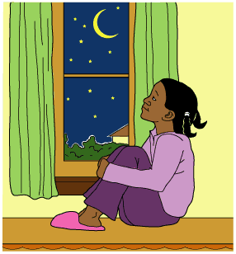
1 Molly looked up at the dark August sky from her bedroom window and found the brightest star. In a quiet voice, she said, 'Star light, star bright ... first star I see tonight ... I wish I may, I wish I might ... have the wish I wish tonight.' She closed her eyes and wished harder than she had ever wished before. 'I wish everything would just stay the same.'
2 Molly was supposed to move to a new house the next day, but she was not ready for the change. She fell asleep hoping that bright star would make her wish come true.
3 'Wake up,' called her mother. Molly opened her eyes and looked around. She wondered if the bright, twinkling star of the previous night had worked its magic. 'It is moving day,' her mom called again. 'The boxes have already been taken out to the moving van.' Molly was discouraged to know that the sparkly star was not so lucky after all.
4 As Molly got dressed, she stopped to take one last look around the bedroom she loved so much. As hard as it was to say goodbye to her room, saying goodbye to her next-door neighbor would be even harder. Natasha had been her best friend for as long as she could remember.
5 'Hi,' Natasha called, as she came running out of her house to meet Molly in the front yard.
6 'Today is moving day, Natasha,' Molly said softly. 'I am really going to miss you.'
7 Natasha squeezed Molly's hand. 'I am going to miss you too, but I will call you every day. We will always be friends, even if you don't live right next door.' One of the things that Molly had always admired about Natasha was her refusal to let anything get her down for too long.
8 'We are ready to go now,' Molly's mother called. The girls hugged and said goodbye one last time. Molly climbed up into the moving van. Natasha continued to wave as Molly and her family departed.
9 The moving van squeaked and bumped as it made its way to the new house. Just as Molly's father was saying, 'Here we are, 123 Chestnut Street,' she noticed a girl standing quietly at a window of the house next door. She looked like she was worried about something, but as Molly stepped onto the sidewalk a big smile lit up the girl's face and she waved.
10 Molly waved back and went into her new house. She thought about her wish and suddenly realized things might not be so different after all. Maybe that lucky star really did make her wish come true!

Which of these best describes this story?
 |  | A. | A tale about stars
 |  | B. | Realistic fiction
 |  | C. | Historical fiction
 |  | D. | A girl's journal

Question 2 of 24
On the Case
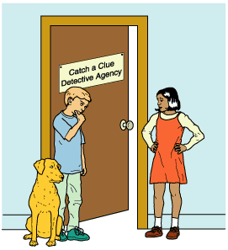
1 It was a cloudy Tuesday evening when she knocked on the door of the Catch a Clue Detective Agency. Luckily, my faithful companion, Watson, was there. I was busy watching TV and didn't hear the soft knocking. Only when I heard Watson's whining did I look up and see a shadow through the curtains. Never one to neglect a possible customer, I jumped up quickly and opened the door.
2 'Welcome to Catch a Clue Detective Agency,' I said, in my deepest voice. 'How may we help you today?' I did not open the door all the way because all the detective books say that a detective needs to be careful when meeting a stranger. A girl wearing a red dress and a T-shirt stood outside the door. Her shoes were also red and had laces. The books also say to observe and make note of tiny details, even if they don't seem important. I was very good at this.
3 'Hi, Tom,' the girl said. 'Listen, I heard you help people find things. One of my favorite stuffed animals is missing. I think someone stole it.'
4 'You must have me mistaken with someone else,' I sneered. 'My name is Ace. You need to get that straight.' This happened all the time in my line of work. I was often mistaken for this Tom guy. I can't say for sure who he is, but the confusion made my life difficult.
5 'Whatever. Can you help me or not?' the girl snapped. She had crossed her arms and was tapping her foot. The books say to pay close attention to body language. People sometimes give themselves away by the things they do NOT say.
6 'Come in and have a seat,' I said. I led her into the office and directed her to sit on the couch. I sat behind my desk, which is sometimes used as a coffee table. Watson lay down on the floor beside me and rested his head on my foot. 'Tell me about the circumstances connected with the theft, and I will tell you if I can help. But before you describe the facts of the case, you can start by telling me your name.' I took out my notepad and waited.
7 'You already know what my name is,' she said. 'We're in the same class at school, Tom.'
8 I looked questioningly at her, tapping my notepad with a pencil.
9 'Okay, fine. I get it. Ace, my name is Kate. I went into my room this morning after breakfast. That's when I noticed that Shasta was missing.' Kate looked down at her hands. I noted that she seemed sad.
10 'What's a Shasta?' I asked.
11 'Shasta is my stuffed bear. I've had him since I was a baby. I don't know how I can sleep tonight without him.' Kate's eyes spilled over with tears. She took a deep breath, glared at me and warned, 'If you tell anyone at school about this, I will never forgive you.'
12 'This may require going to the scene of the crime,' I said. 'Take me to the last place you remember seeing Shasta.' I motioned for Kate to lead. 'Watson, come on. We have a mystery to solve.'
13 'I thought your dog's name was Buddy,' Kate said, as we walked the short distance to her house.
14 I let the comment slide. She had been through enough grief.
15 Kate led me through her front door and down the hallway. The smell of grilled cheese sandwiches came from the kitchen. I could tell it was almost time for dinner. Nothing gets past me. I was about to congratulate myself when Kate's baby brother walked past.
16 'Hey, your brother is walking now. That's cool!' As soon as I said it, I regretted the comment. It is important to keep things on a professional level with customers.
17 'He's always getting into my things,' Kate said. 'It drives me crazy.'
18 By this time, we were at the doorway of Kate's room. I pulled out my notebook and began taking notes about everything I saw. I wasn't quite sure what I was looking for, but I knew good notes would lead me to the suspect. It was then that Kate's mother walked by with a basket full of laundry.
19 'By the way, Kate, Nicholas brought Shasta to me. I told you to keep your door closed now that he's walking.' Red-faced, Kate took the bear from her mother without a word.
20 I shut my notebook with a satisfied snap. Another case solved by the Catch a Clue Detective Agency!

What is the main problem in this passage?
 |  | A. | Ace is mistaken for Tom.
 |  | B. | Nicholas is learning to walk.
 |  | C. | Shasta is missing.
 |  | D. | Kate is angry at Tom.

Question 3 of 24
King of the Birds
Eagle called a meeting of all the birds. "I have asked you here," he said in a loud voice, "for an important reason. We birds have no king. We should choose a leader!" A great chirping arose as the birds discussed the idea. Eagle said proudly, "As I am the most regal bird, I believe that I should be king!"
Owl spoke out. "It is I who should be king. My eyes are sharpest, and I see everything. Because of this, I am the wisest of birds and would make the best leader."
Then Great Bustard spoke. "I should be king. I am the largest and strongest, and strength is most important in a leader!"
Every bird started speaking at once. But a high voice came piping up over the noise. It was little Warbler. "I think I should be king!" All the birds roared with laughter. How could such a tiny, insignificant bird imagine he should be king? It was unthinkable!
"Why should we choose you as our king?" sneered Eagle.
"Because I should have a chance like anyone else!" said the brave little bird. The crowd laughed, but they were impressed with his courage all the same.
The birds decided on a competition. They would all take off at once, and whoever flew highest would become king. Warbler knew that he was too small and weak to win. He crept silently beneath Eagle's wing and hid.
The birds took off, soaring higher and higher. The smallest fell back first, followed by the larger birds. Soon, only three were left in the contest: Eagle, Owl, and Bustard. Up they flew, until finally Eagle pulled ahead with his mighty wings. Suddenly Warbler flew from his hiding place and shot into the sky. Mighty Eagle had no strength left to fly higher.
The other birds were annoyed by the little one's trickery. As he came back to the ground, the others chased him. He quickly fled into an empty snake's hole. "Come out!" the others cried. "We want to give you the prize that you deserve!"
But Warbler stayed hidden all day and night. The next morning, Eagle suggested that they guard the hole in shifts. The other birds, tired and hungry, agreed. "I'll go first," said Owl, "as long as someone relieves me after a bit."
Owl sat patiently for what seemed like forever. Eventually he fell fast asleep by the hole. Warbler, who had been waiting for the right moment, flew quickly out of the hole and disappeared.
Owl was so embarrassed that to this day, he sleeps during the daytime and hunts at night so that the other birds cannot tease him about sleeping on the job. Warbler still flies quickly from here to there, never stopping long enough to be caught.
In the traditional Zulu tale above, the main climax occurs when __________.
 |  | A. | Warbler flies out from under Eagle's wing to win
 |  | B. | Owl volunteers to take the first turn guarding the hole
 |  | C. | all the birds decide that Warbler should be king
 |  | D. | the birds decide to settle the argument with a contest

Question 4 of 24
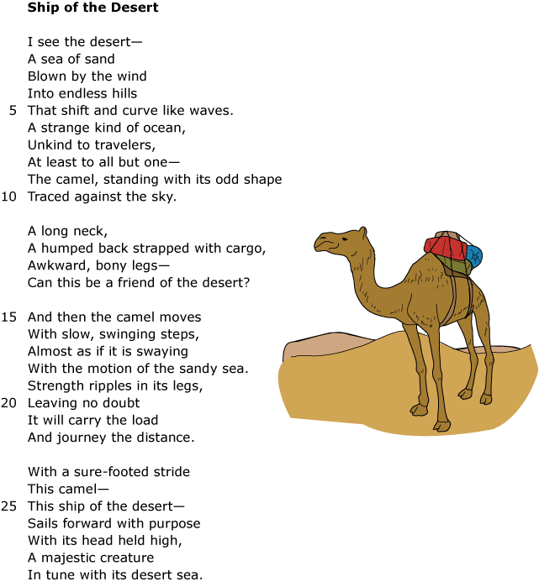

Read line 16 from the poem.
With slow, swinging steps,
This line contains an example of which of the following?
 |  | A. | Alliteration
 |  | B. | Onomatopoeia
 |  | C. | Rhyme
 |  | D. | Consonance

Question 5 of 24
from The Call of the Wild (edited)
by Jack London
1. from Chapter 1, "Into the Primitive"
Buck did not read the newspapers, or he would have known that trouble was brewing. Not alone for himself, but for every working dog, strong of muscle and with warm, long hair, from Puget Sound to San Diego. Because men, searching in the Arctic, had found a yellow metal. Steamship and train companies were rushing thousands of men into the Northland. These men wanted dogs. The dogs they wanted were heavy dogs, with strong muscles by which to work, and furry coats to protect them from the frost.
Buck lived at a big house in the sun-kissed Santa Clara Valley. Judge Miller's place, it was called. It stood back from the road, half-hidden among the trees. Through the trees one could see the wide, cool porch that ran around its four sides. The house had gravel driveways that wound through wide lawns and under tall poplars. In the rear were great stables. There were rows of vine-covered servants' cottages, an endless array of outhouses, long grape arbors, green pastures, orchards, and berry patches. Then there was the pumping plant for the well, and the big cement tank where Judge Miller's boys took their morning plunge and kept cool in the hot afternoon.
2. from Chapter 6, "For the Love of a Man"
When John Thornton froze his feet in the previous December, his partners had made him comfortable and left him to get well. They went on up the river to get a raft of saw-logs. He was still limping slightly when he rescued Buck, but with the warmer weather even the slight limp left him. Buck lay by the riverbank through the long spring days, watching the running water, listening to the songs of birds and the hum of nature. He slowly won back his strength.
A rest is very good after one has traveled three thousand miles. Buck grew lazy as his wounds healed, his muscles swelled out, and the flesh came back to cover his bones. They were all loafing -- Buck, John Thornton, and Skeet and Nig -- waiting for the raft to come. Skeet was a little Irish setter who early made friends with Buck. In a dying condition, Buck had been unable to resist. She had the doctor trait that some dogs possess. As a mother cat washes her kittens, she had washed and cleaned Buck's wounds.
What sentence from Chapter 6 tells you that the setting is different from the setting of Chapter 1?
 |  | A. | When John Thornton froze his feet in the previous December, his partners had made him comfortable and left him to get well.
 |  | B. | As a mother cat washes her kittens, so she washed and cleansed Buck's wounds.
 |  | C. | He was still limping slightly when he rescued Buck, but with the warmer weather even the slight limp left him.
 |  | D. | Buck grew lazy as his wounds healed, his muscles swelled out, and the flesh came back to cover his bones.

Question 6 of 24
The rain forest is calling, "Help save my Habitat!"
Voices from the wild call, "Help save my Habitat!"
Listen as the trees call, "Help save this place!"
The birds in the trees sing out, "Help this rain forest survive."
The above text is a form of which type of literature?
 |  | A. | rhyming poetry
 |  | B. | fiction
 |  | C. | non-fiction
 |  | D. | drama

Question 7 of 24
Ant and Cricket
(A story from China)
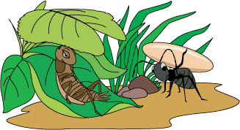
1
Cricket yawned and stretched under the broad leaf of a ginkgo plant. The shade kept her cool and comfortable. She rubbed her legs together and sang contentedly. Chirp, chirp!
2
Suddenly, Cricket's singing stopped. She watched as six tiny legs moved a large grain of rice past her ginkgo leaf. The legs belonged to Ant, who carried the grain of rice on his back. Ant panted under his heavy load, but he did not stop to rest. Instead, he continued his journey homeward.
3
'Why do you work so hard?' asked Cricket. 'It is a beautiful summer day. Why bother marching back and forth, back and forth?'
4
Ant set down his grain of rice. 'Yes, there is much to eat now; food is plentiful. But soon, the sun will not be so bright. The cold wind will blow, and ice will cover the ground. Then there will be no food.'
5
'Ha!' Cricket closed her eyes and laughed at Ant's foolishness. 'Just look around. All the food I need is right here.' She nibbled at the grass growing beside her. 'Work if you like, Ant. I am going to rest. Ho-hum!'
6
Ant continued with his work. Every day he gathered rice while Cricket yawned and dozed beneath the ginkgo leaf. Every day, Ant's supply of food for the winter grew larger.
7
Then, one day, the sun stayed hidden behind the clouds. A cold wind swept across the fields. Soon, ice painted the leaves and trees, and frost covered the ground. Cricket shivered. Before long, she grew hungry. She hurried here and there looking for food. But the grass had turned brown and withered away. Only cold, dry earth remained. Cricket trudged home, tired and disappointed. She had searched everywhere, but there was no food to be found. Miserably, she crawled into her hole and drifted off to sleep.
8
As Cricket slept, she dreamed of a warm summer day. Shoots of tender, green grass grew within her reach. Sadly, she was awakened from her dream by the growl of her empty stomach. Cricket patted her belly and made a promise to herself. Next year she would spend more time preparing for winter and less time relaxing.

Which word best describes Cricket from 'Ant and Cricket' and Felix from 'A Heavy Load'?
 |  | A. | Clumsy
 |  | B. | Lazy
 |  | C. | Careless
 |  | D. | Proud

Question 8 of 24
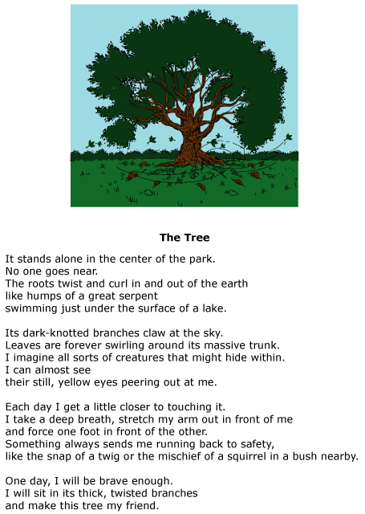

Which word from the poem makes the sound of the word it describes?
 |  | A. | sound
 |  | B. | snap
 |  | C. | yellow
 |  | D. | mischief

Question 9 of 24
Tying Shoes
Trixie is trying.
Christie is crying.
Spencer is spying.
Dillon is dying.
Lilly is lying.
Timmy is tying.
This poem is a good example of __________ .
 |  | A. | alliteration
 |  | B. | hyperbole
 |  | C. | personification
 |  | D. | onomatopoeia

Question 10 of 24
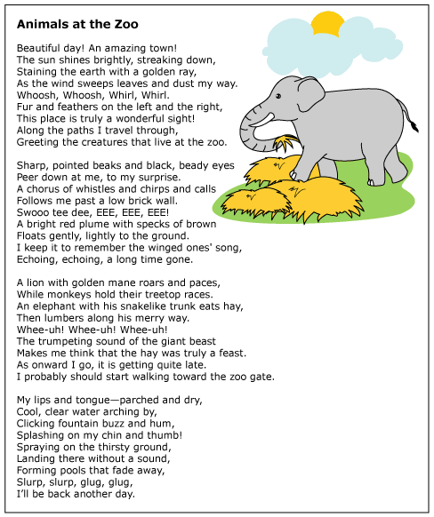

Read this line from the poem.
Clicking fountain buzz and hum,
Which of these is used in this line?
 |  | A. | Onomatopoeia
 |  | B. | Alliteration
 |  | C. | Rhyme
 |  | D. | Simile

Question 11 of 24
Read the two passages below.
I think that I shall never see
A poem lovely as a tree
A tree whose hungry mouth is pressed
Against the Earth's sweet flowing breast
Trees are beautiful in different ways all during the year. Sometimes their leaves are green. Sometimes the leaves turn bright colors. Trees limbs are even beautiful when there are no leaves at all.
What is the difference between these two passages?
 |  | A. | The first passage is a paragraph. The second is a poem.
 |  | B. | The first passage is a longer paragraph than the second passage.
 |  | C. | The first passage is a poem. The second is a paragraph.
 |  | D. | One passage is about trees. The other passage is about animals.

Question 12 of 24
Tyrone's Substitute Teacher
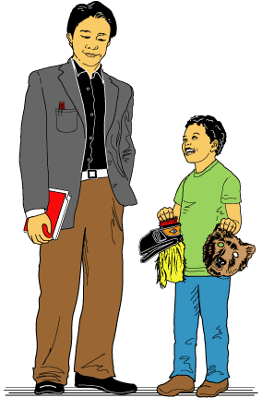
1 Tyrone was very proud of his Native American animal masks. He had just finished making them yesterday in his art class with his substitute teacher, Mr. Ito.
2 At the end of class, Mr. Ito had told the students it was his last day substituting for their regular art teacher, Miss Zinn.
3 'Will you substitute for Miss Zinn again?' Tyrone had asked. He was glad Miss Zinn was coming back, but he had suddenly realized he was going to miss Mr. Ito.
4 'Well, you never know. I am sure we will see each other again, Tyrone,' Mr. Ito had said with a friendly smile.
5 In the past few weeks, Mr. Ito had taught them many wonderful things about art. They learned how to fold paper cranes and make other origami shapes. Mr. Ito said that origami was just like math. It took a lot of practice. He always smiled as he explained. He seemed to truly enjoy teaching the students new things. Tyrone made a paper sailboat and a paper hat for his sister.
6 Mr. Ito also taught them about Inuit carving. They made animals in a unique way. They made them out of bars of soap! His favorite project was making animal masks. Mr. Ito explained how Native Americans made animal masks to represent their feelings.
7 Tyrone chose to make a raven mask and a bear mask. The raven represented bravery, while the bear represented friendship. He was not sure what he would do with the masks, but he really liked them. Tyrone speculated about whether or not Native Americans had an animal mask for sadness because that was how he felt about Mr. Ito leaving. He slowly put the masks in his locker and took out his books for math class. There would be a big test next week. The math teacher, Mr. Ferrare, had told Tyrone he would help him study for the test.
8 When Tyrone walked into the classroom, Mr. Ferrare was not seated at his desk as usual. Tyrone blinked. He could not believe his eyes.
9 'Mr. Ito!' he said excitedly. 'Are you substituting for Mr. Ferrare?'
10 'Yes, I am,' he smiled. 'Mr. Ferrare told me that you like to review your multiplication tables right before a test. I would be happy to spend a few minutes helping you review.'
11 'Thanks, Mr. Ito,' Tyrone said, smiling. All of a sudden, Tyrone knew exactly what he was going to do with his bear mask.

Which of these statements best describes Tyrone's problem?
 |  | A. | Tyrone will miss Mr. Ito.
 |  | B. | Miss Zinn is returning.
 |  | C. | The problem is Tyrone's substitute teacher.
 |  | D. | Tyrone needs to decide what to do with his masks.

Question 13 of 24
Amelia and Abby always ask Aunt Anne about Alex.
This sentence is an example of ______________.
 |  | A. | metaphor
 |  | B. | alliteration
 |  | C. | rhyme
 |  | D. | simile

Question 14 of 24
What form of writing is the following probably from?
Kennedy, John (1917-1963) was born in...
 |  | A. | biography
 |  | B. | autobiography
 |  | C. | drama
 |  | D. | poem

Question 15 of 24
Your forearm and foot are about the same length.
This passage is stating a/an __________ .
 |  | A. | fact
 |  | B. | opinion
 |  | C. | cause
 |  | D. | effect

Question 16 of 24
Marley's Ghost
Marley was dead: to begin with. There is no doubt whatever about that. The register of his burial was signed by the clergyman, the clerk, the undertaker, and the chief mourner. Scrooge signed it. And Scrooge's name was good upon 'Change, for anything he chose to put his hand to. Old Marley was as dead as a door-nail. Mind! I don't mean to say that I know, of my own knowledge, what there is particularly dead about a door-nail. I might have been inclined, myself, to regard a coffin-nail as the deadest piece of ironmongery in the trade. But the wisdom of our ancestors is in the simile; and my unhallowed hands shall not disturb it, or the Country's done for. You will therefore permit me to repeat, emphatically, that Marley was as dead as a door-nail. Scrooge knew he was dead? Of course he did. How could it be otherwise? Scrooge and he were partners for I don't know how many years. Scrooge was his sole executor, his sole administrator, his sole assign, his sole residuary legatee, his sole friend, and sole mourner. And even Scrooge was not so dreadfully cut up by the sad event, but that he was an excellent man of business on the very day of the funeral, and solemnised it with an undoubted bargain.
Which statement about this passage is a fact?
 |  | A. | Marley was a good man.
 |  | B. | Scrooge was Marley's only friend.
 |  | C. | Scrooge was sad.
 |  | D. | Many people attended Marley's funeral.

Question 17 of 24
What makes a poem and a song alike?
 |  | A. | Both songs and poems are short.
 |  | B. | Both songs and poems are always sung.
 |  | C. | Both songs and poems are written to read silently.
 |  | D. | Songs and poems often rhyme.

Question 18 of 24
The brown, black, and white striped kitten was left on my mother's doorstep. As it walked toward the door, she picked it up and took it inside. She could tell it was hungry by the way it began to eat from the dog bowl. Mother thought cats were wonderful pets. She believed they were easy to care for.
If the writer's mother gets another pet, she will probably choose one that
 |  | A. | is easy to care for.
 |  | B. | will eat dog food.
 |  | C. | has black and white stripes.
 |  | D. | walks up to the back door.

Question 19 of 24
Read the story. Then answer the question below.
Detention
Jackson leans forward in the desk and writes in the notebook. I don't know why I am in detention, he writes. All I did was throw a pea at my friend, Michael. He's the one who accidentally dumped the peaches on that girl. I don't know who she was anyway. She probably wasn't even supposed to be in the cafeteria with the rest of us.
Just then, Ms. Polly sticks her head in the doorway and asks, "How's it coming, Jackson? Are you writing about what happened like I asked you to?"
"Yeah," Jackson snaps back. Ms. Polly raises her eyebrows and stares at Jackson. He ducks his head. "I mean, yes, ma'am." Jackson goes back to writing in his journal.
If she hadn't been in the lunchroom, none of this would have happened, Jackson writes. It's all her fault. All I did was throw one little pea. Now I have to stay here in prison for the rest of the day.
"Excuse me," says a voice from the hallway. Jackson turns around expecting to see Ms. Polly. Instead, he sees the girl with peach juice all over her lap. Jackson glares at her. "I'm sorry you got in trouble," says the girl. "I know it was just an accident. You didn't mean for your friend to dump peaches on a girl in a wheelchair." She smiles at Jackson. He softens a bit. "It was funny, though," she continues, laughing. "You hit that boy on the nose with that pea."
"Yeah," Jackson laughs. "That's my friend, Michael. I beaned him right on the nose." Michael's face lights up with laughter. "Hey," he says, "I'm sorry you got peach juice all over you. I didn't mean for you to get caught in the crossfire."
"I know. Like I said, it was just an accident. My name's Lana," says the girl.
"I'm Jackson. And I am really sorry."
"Thanks," says Lana, "I have to go. I need to get out of these wet pants." As she wheels into the hall, she adds, giggling, "I just hope they're not serving peas and peaches in the lunchroom tomorrow." Jackson laughs as he watches her leave. Then he turns back to his notebook and looks at the words he has written. He rips out the page and wads it up. On a new sheet in the notebook, he writes, "Today I made a new friend…"
Why did Jackson rip out the page he had written?
 |  | A. | His handwriting was sloppy, and he wanted it to rewrite it more neatly.
 |  | B. | He wanted Ms. Polly to know that the food fight was not his fault.
 |  | C. | He wanted Michael to know that the food fight was Lana's fault.
 |  | D. | He felt bad about what he had written and wanted to start over.

Question 20 of 24
The Fox and the Goat (Paraphrased) by Aesop
One day, a Fox fell in a deep well and could not get out. A Goat, who was thirsty, came to the same well, and seeing the Fox, asked if the water was good. Hiding that he was stuck, the Fox smiled and said the water was good and invited the Goat to join him. The Goat, who could think only of his thirst jumped into the well. As he drank, the Fox told him they both were stuck now. The Fox told the Goat he had a plan to get them out of the well. "If," said the Fox, "you will place your front feet on the wall and bend your head, I will run up your back and get out. After I get out, I will help you out." The Goat said he would and the Fox jumped on his back. With the help of the Goat's horns, the Fox made it to the top of the well and ran off as fast as he could. When the Goat yelled at him for breaking his promise, the Fox turned and cried out, "You fool! If you had as many brains in your head as you have hairs in your beard, you would never have gone down before you had found a way out, nor would you have risked yourself to dangers with no means of escape." The moral of this story is to look before you leap.
Which of the following is the plot of the story?
 |  | A. | The Goat's thirst caused him to get stuck with the Fox.
 |  | B. | The Fox ran away from the Goat because he was scared.
 |  | C. | The Fox used the Goat's back to get out of the well.
 |  | D. | The Goat yelled at the Fox when he did not save him.

Question 21 of 24
Read the story. Then answer the question below.
Elyse Shoots a Deer
Elyse and her dad are going on their annual camping trip. All the gear is loaded in the truck. They drive for hours. Finally they make it to the mountains and look for a campsite. They find the perfect spot. It is a flat patch of grass in a clearing. Dad pitches the tents while Elyse gathers old limbs nearby. Then they build a campfire not too far from Dad's tent.
"Why don't you go for a hike?" Dad says while he watches the fire. "You are so restless that you'd make a hummingbird dizzy." Elyse grabs her backpack and heads for the tree line. She is careful to stay on the marked trails. After a mile of winding through the woods, Elyse sees a creek. "This will be a great place to fish," she says to herself. A little bit further down the trail, Elyse comes upon a waterfall. "Wow! This is gorgeous," she says. She takes her digital camera from her backpack and snaps some pictures. "I can't wait to show these to Dad," she says.
A cool wind blows and kicks up the leaves at her feet. The leaves dance in the breeze. Just then something catches her eye across the creek. A doe has come down for a drink. She dips her head to the water and laps it up. Then she raises her head and looks at Elyse. Elyse points the camera at the deer and takes its picture. "Gotcha!" she whispers. "What a great shot." Elyse snaps a few more pictures of the deer. Then she takes a few more of the waterfall and heads back to camp.
Dad is untangling the line on a fishing pole when Elyse walks up. "Hey, Dad," Elyse calls out, "I found a creek and a huge waterfall! And then a deer came up to the creek to drink. Here, look at these pictures." She hands the camera to her dad. He flips through the photos.
"Wow, these are great pictures," Dad says. "You are a good photographer. I wish I had an eye for pictures like you do." That makes Elyse smile. Dad asks, "Are you ready to go fishing? I have the poles ready."
"Sure," says Elyse. "And I'll bring my camera!"
Based on what the story says, how are Dad and Elyse different?
 |  | A. | Elyse is a better photographer than her dad.
 |  | B. | Elyse is better than her dad at pitching the tent.
 |  | C. | Dad is better than Elyse at building a campfire.
 |  | D. | Dad is better than Elyse at catching fish.

Question 22 of 24
Read the story. Then answer the question below.
The Cheater
Brett is a third grader at Blackwell School. Every morning he rides the bus to school. When he gets to his classroom, he hangs up his backpack and jacket on the coat rack. Then he goes to his desk to begin his morning work. Today the teacher wants the students to work on their multiplication tables, so there are math sheets on everyone's desk. Brett starts to panic. He was supposed to have practiced at home last night, but he forgot.
Just then, Trish walks into the room. She hangs up her backpack and jacket and walks to her desk beside Brett. She whips out her sword and starts conquering the math problems. Brett watches her work. Trish is solving the problems faster than the speed of light. He looks at her answers and copies them onto his own paper. Trish sees him cheating. She gives him a disapproving stare. He ignores her and continues writing down her answers onto his sheet.
"Brett," Mrs. Jones barks. Brett is startled to hear the teacher's voice. "Come here to my desk," she says. Brett makes his way to Mrs. Jones. "Were you getting answers from Trish's paper?" Brett hangs his head and nods. "Then I'm afraid you will get zeroes on your papers. Bring them to me. And on your way, stop to apologize to Trish for using her answers."
Brett looks at Trish's math paper because ____________________________________.
 |  | A. | he wants to see which answers he got wrong
 |  | B. | he does not know how to work the problems himself
 |  | C. | he wants see if he is working the problems correctly
 |  | D. | he wants to show Trish which answers she got wrong

Question 23 of 24
The search for new places for homes and work often hurts Earth. Rain forests are being cut down to make room for farms and cattle ranches. When we lose forests, animals lose their homes, rare plants disappear, and our air is affected. Factories that are built provide jobs but also pollute our air. This pollution thins the layer of gas that protects the Earth from harmful rays of the Sun. As the Earth continues to be changed, many plants and animals are in danger of dying out. If it continues, humans could also be in danger.
Which of the following sentences is an opinion?
 |  | A. | Rain forests are being cut down to make room for farms and cattle ranches.
 |  | B. | If it continues, humans will all be destroyed.
 |  | C. | When we lose forests, animals lose their homes, rare plants disappear, and our air is affected.
 |  | D. | Factories that are built provide jobs but also pollute our air.

Question 24 of 24
The Concert
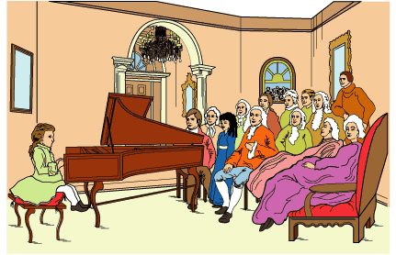
1 Sophie looked out the carriage window and sighed loudly. Her grandfather, sitting next to her on the red velvet seat, pretended not to hear. Sophie could not sit still. She fidgeted for a moment. Then she burst out, 'Grandfather, I do not see why we have to go to another concert.' Now it was her grandfather's turn to sigh.
2 Sophie knew how much her grandfather loved music. Unfortunately for him, no one else in the family shared his interest. Sophie's older brother and sister had taken music lessons, of course. In 18th-century Paris, most young people from wealthy families were made to study music. Neither her brother nor her sister had any talent or interest. Now it was Sophie who struggled to learn to play the harpsichord, a keyboard instrument like a small piano that was mainly heard long ago.
3 To make matters worse, her grandfather seemed convinced that she had real talent if she were only willing to practice. To encourage her, he had begun taking her to concerts in the homes of other wealthy families. Sophie loved her grandfather, but she found the concerts tedious and boring. All the musicians seemed to be old men playing the same type of music over and over.
4 'I think you will find this concert different from the others,' her grandfather said. Just then,the carriage pulled up and came to a stop. They had arrived. Sophie smoothed her blue silk gown and followed her grandfather out of the carriage.
5 The house was magnificent, but Sophie barely glanced at the painted ceilings, rich carpets, or fine furniture. She and her grandfather made their way to the drawing room, where the visitors would listen to the concert. The room was already full of men in long, powdered wigs and fancy coats and stockings. The ladies in the room wore fine dresses and lots of jewelry.
6 While her grandfather greeted his friends, Sophie looked around the drawing room. She was surprised to see a young boy there. Usually, she was the youngest person at a concert. Sophie was even more amazed when the boy took a seat at the harpsichord. He had to sit on pillows in order to reach the instrument! No one laughed. When the boy began to play, she understood why.
7 There was nothing boring about his playing. Each note of music rippled like a crystal-clear drop of water in a pool. The lovely sounds filled the room. They made Sophie think of the stars moving in the night skies and of children dancing through a meadow. When the boy finished playing, she clapped as hard as everyone else.
8 Her grandfather whispered, 'His name is Mozart. He wrote that piece of music he just played. He is only eight years old!'
9 The rest of the concert passed in the blink of an eye. At one point, Sophie looked over at her grandfather and saw him brush away a tear. Suddenly, she was filled with shame for not practicing. She saw now what music could be. She might never be a Mozart, but she would learn to play—for her grandfather and for herself.

What is the main reason Grandfather takes Sophie to the concert?
 |  | A. | Grandfather does not want to go to the concert alone.
 |  | B. | Grandfather thinks Sophie is more talented than her brother and sister.
 |  | C. | Grandfather knows Sophie would like to see such a talented young boy play in a performance.
 |  | D. | Grandfather believes that the concert will inspire Sophie to work harder at her own music.

Copyright © Discovery Education Assessment 2012. Proprietary Information. All rights reserved.
Discovery Education Page

