Progress Probe #1660854: 4th Grade TCAP Coach Chapter 3 Lesson 31 (Grade 04 RE)
Teacher Key with Answers
Ques | Answer | Level | Skill | Subskill | Item #
1 | D | Hard | Writing & Research | SPI 0401.4.3 Graphic Organizer [100067] | D108836
2 | A | Moderate | Writing & Research | SPI 0401.4.3 Graphic Organizer [100067] | U45890
3 | B | Hard | Writing & Research | SPI 0401.3.10 Graphic Organizer [69110] | D56963
4 | B | Moderate | Informational Text | SPI 0401.6.5 Interpret Information [69125] | U46818
5 | B | Hard | Writing & Research | SPI 0401.3.10 Graphic Organizer [69110] | D52670
6 | D | Moderate | Writing & Research | SPI 0401.4.3 Graphic Organizer [100067] | U45092
7 | C | Moderate | Writing & Research | SPI 0401.3.10 Graphic Organizer [69110] | D108406
8 | A | Moderate | Writing & Research | SPI 0401.4.3 Graphic Organizer [100067] | U46825
9 | C | Hard | Informational Text | SPI 0401.6.5 Interpret Information [69125] | D108847
10 | D | Moderate | Writing & Research | SPI 0401.3.10 Graphic Organizer [69110] | D108408

Name: Date:
4th Grade TCAP Coach Chapter 3 Lesson 31
Question 1 of 10
Adapted Speech: Votes for Women Speech
By: Mark Twain
Ladies and Gentlemen – I would like to ask your help. It is help that one can give from the heart through the mouth. The report of Mr. Meyer was excellent, and I was as interested in it as you have been. I've had so much experience that I said to him when he asked for help, "Ask for the money now."
We are all people that can act without thinking. We must be worked up to act quickly. Get them to write their wills now, or it may be too late. Fifteen or twenty years ago I had an experience I will never forget. I got into a church which was crowded. The missionary of our town asked for help. He told us a personal experience about the poor in cellars and that they need help. The poor are always good to the poor. When a person with lots of money gives a hundred thousand dollars it is heard everywhere, and he does not miss it. It's the widow's help that makes no noise, but does the best work.
I remember that time in the church the collection was being taken up. The need made want to give so much that I could hardly wait for the hat or plate to come my way. I had four hundred dollars in my pocket, and I was anxious to drop it in the plate and wanted to borrow more. But the plate was so long in coming my way that the excitement was growing less and less. It was going down at the rate of a hundred dollars a minute. The plate was passed too late. When it finally came to me, my enthusiasm had gone down so much that I kept my four hundred dollars. I even stole a dime from the plate. So, you see, time sometimes leads to crime. I thought of that and regretted it, and I ask you all to give while the fever is with you.
This is the web the author used to create his speech. What part of the web is missing to complete his speech?
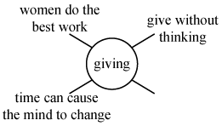
 |  | A. | Women should work much harder with the poor.
 |  | B. | People should not give to the poor.
 |  | C. | Churches are not good.
 |  | D. | People should give to the poor.

Question 2 of 10
The Father of Water–Skiing
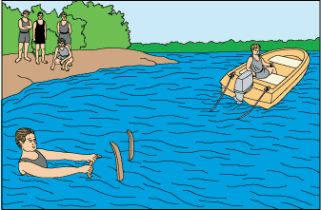
1 One part determination, one part bravery, two parts imagination—that's the recipe for a creative inventor.
2 Ralph grew up in Lake City, Minnesota. He and his friends spent the long winter months skiing on the nearby Mississippi River bluffs. In the summer, nearby Lake Pepin stretched out for 30 miles. Ralph had spent hours bumping across the lake on his aquaplane, a large flat board. It was towed behind his brother Ben's powerboat. In the spring of 1922, when he was 18, Ralph had a brand-new idea.
3 He told his brother he wanted to ski behind the boat, and he brought his snow skis down to the lake.
4 The skis were too heavy. Ralph sank, much to the amusement of the schoolboys who gathered to watch. They didn't believe Ralph would actually ski on water. His attempts made an entertaining show, though.
5 Next, Ralph tried experimenting with barrel staves, the curved wooden strips of a barrel. Ralph sank again, and most of the local boys thought he was a bit crazy.
6 But Ralph kept turning the problem over in his mind. He realized the boat only went 20 miles per hour at top speed. His skis needed to have a larger surface to better spread his weight over the top of the water. The staves from the barrel were too thin. He promptly purchased two eight-foot long pine planks. Each one was nine inches wide. Next, Ralph softened the ends by boiling them in his mother's copper kettle. He curved the ends upward and put the tips in some clamps so they would set in this shape.
7 Two days later, Ralph loosened the clamps. His older sister, Harriet, helped him paint the skis white. Ralph fastened a leather strap to the middle of each ski. He bought a 100-foot cord to use as a towrope. A blacksmith made an iron ring for a handle, and Ralph covered it with tape to protect his hands.
8 Ralph lugged his new skis down to Lake Pepin. For three days, he tried to get up on them behind his brother's boat.
9 Each time, Ralph hollered to his brother when he was ready. He stood on the aquaplane with his skis level to the water.
10 The boat engine roared, and Ralph was pulled face down into the lake! Ralph was completely embarrassed once again.
11 Ralph had another idea. On July 2, a day before his nineteenth birthday, the local boys had gathered to watch him try his crazy 'water' skis again.
12 This time, Ralph put the tips of the skis up in the air and sat back on them. When the boat took off, Ralph pulled himself up. To the amazement of the onlookers, Ralph became the first person to water-ski. When he came to shore, the boys had one question: Could he do it again?
13 Daredevil Ralph spent the next five years water–skiing. In 1923, a small bandstand was built near the lake for the small crowds that came to watch, often numbering over 1000. One afternoon, Ralph decided to add a new trick to his show. He took a diving platform and removed the floating supports from one end so that it sank into the water on a slope. Then he tried to ski off his improvised ramp. Ralph's skis stuck to the ramp, and he fell off the five-foot ramp headfirst into the lake. But that didn't stop Ralph. Next, he covered the ramp with lard, or grease, so it would be slippery. The next time Ralph tried his trick, he sailed off the ramp and became the world's first water-ski jumper.
14 A month later, Ralph had a new stunt planned for his growing crowd of spectators. He advertised with hundreds of handbills. Ralph planned to water-ski behind an old World War I plane. Ralph's feat made the front page of the county paper that August 28, 1925. Over 2000 people watched the plane pull him across the lake on his water skis at 80 miles per hour!
15 Sadly, Ralph's new career ended after only five years. He broke his back in a work accident, and he could no longer water-ski. Soon people forgot about Ralph, and other men in different towns began making water skis. In fact, for many years, several people took credit for the invention. Finally, in 1963, a reporter named Margaret Mason visited Minnesota. She spotted Ralph's old skis hanging in a boathouse. After some detective work, the reporter tracked down Ralph.
16 Before long, Mason wrote Ralph's story for everyone to read. At last, in 1966, the American Water Ski Association named Ralph the 'father of water–skiing.' All adventure seekers owe Ralph a debt of gratitude for the thrilling water sport. Ralph Samuelson is an inspiration to all people with a 'crazy' idea.

Read the chart of events from the passage.
Year | What Ralph Samuelson Did
1922 | Became first  person to water-ski
1923 | Became first  water-ski jumper
1925
1927 | Ended his  water-skiing career
Which of the following belongs in the empty box on the chart?
 |  | A. | Water-skied behind a World War I airplane
 |  | B. | Appeared on the front page of the county paper
 |  | C. | Claimed to be the father of water-skiing
 |  | D. | Gave an interview to reporter Margaret Mason

Question 3 of 10
Ferdinand Magellan
I. Life
a. Born in 1480, Portugal
b.
c. Joined the army at a young age
II. Sea Captain
a. Sailed for Spain
b. Reached Argentina in 1519
c. Discovered the Strait of Magellan
d. Discovered the Pacific Ocean
III. Death
a. Quarrel with natives
b. Died in 1521</BR< ul>Which detail goes in the blank in the outline?
 |  | A. | Put down a revolt of his officers
 |  | B. | As a child, worked for the queen
 |  | C. | Proved you could sail around the world
 |  | D. | Gave mapmakers an idea of world's size

Question 4 of 10
Pulling for a Miracle
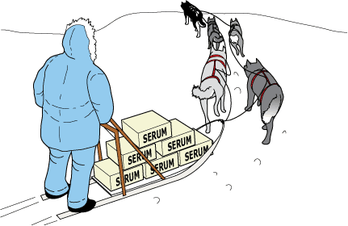
1 Robert was just rolling his bike out of the garage when the sound of his mother's voice startled him. Dropping the bike, he trotted toward the back door.
2 'Yes, Mother?'
3 'I made some cookies,' his mother smiled.
4 Robert pulled off his jacket and hung it on the peg. The bike ride could wait. Once he was inside, his mother surveyed his appearance. She followed with the usual, 'Why don't you go clean up first?'
5 He grinned as he washed his face and hands. So far the only downside to this day was a slightly sore throat. It had been bothering him since he woke up this morning. He was sure it was nothing that a few of his mom's cookies couldn't fix.
6 At the kitchen table, Robert's mother placed a glass of milk in front of him and smoothed his hair. Her hand lingered on his forehead for a moment. Robert recognized her concerned-mother look, so he pulled away. 'Just let me feel your forehead. You feel warm.'
7 'Ah, Mom,' Robert protested. This was not the way he'd planned to spend his day—being treated by his mother for some ailment. 'I feel fine!'
8 'You have a fever,' she insisted. 'You're going to need rest and liquids until further notice.'
9 Robert flipped on the radio and got settled on the sofa. Gloomily, he stared out the window at the beautiful day. He hoped he could regain his freedom after the next check of his forehead. Suddenly, his thoughts were drawn to the radio as an important news story was announced.
10 'News update for February 2, 1925. This just in: Sled drivers and their dogs continue to battle winter weather while trying to bring medicine for the children of Nome, Alaska. Doctors are treating a diphtheria outbreak. They are waiting for delivery of the medicine needed to fight the disease. It must be transported from Anchorage, Alaska, nearly 1000 miles away from Nome. Icy weather conditions make it unsafe for planes to fly the entire distance. Sled dog teams have been relaying the medicine in this rescue mission.
11 'Winds strong enough to knock over sleds and drivers have been making travel for the dog teams risky. Weather updates from Alaska tell us winds are blowing at 80 miles per hour. Temperatures are 36 degrees below zero. Many are afraid the teams will fail to make it through. We will continue to keep our audience posted about this astounding rescue attempt. We now return you to our regular program.'
12 A song began playing, and Robert's attention again drifted to the window. 'Thirty-six below zero,' Robert wondered aloud. 'How will they ever make it?'
13 A while later, Robert's mother declared his fever gone, and he no longer needed to stay inside. When he didn't jump up and head outdoors, she was concerned. 'Are you sure you are feeling all right, Robert?'
14 'Yes, but I think I'll stay and listen for another news update.' He told her the story he'd heard about the rescue mission in progress. 'Do you think they can do it, Mom?' he asked.
15 'Anything is possible, son. You just have to hope for the best.'
16 All afternoon Robert listened and waited. Finally, after the sun had set and dinner dishes were cleared, Robert's mother ordered him to turn off the radio. 'There will be more news tomorrow,' she said.
17 The next morning, Robert searched the newspaper for news about the mission. They had made it to Nome! As he read the story, he imagined the lead sled dog, Balto, pulling through the last leg of the journey. The achievement became even more admirable when he learned that Balto had led his team through a blinding blizzard. The sled dog relay allowed Gunnar Kasson, the driver of Balto's team, to successfully deliver the medicine. Many had worked together to save the lives of Nome's citizens.
18 Robert did some quick figuring in his head. 'Wow!' he thought. 'They beat impossible odds to cover 53 miles in just 20 hours!' Relieved and excited about the news, Robert gobbled down his breakfast and headed outdoors. He wanted to be sure to get something done in his next 24 hours before heading back to school.

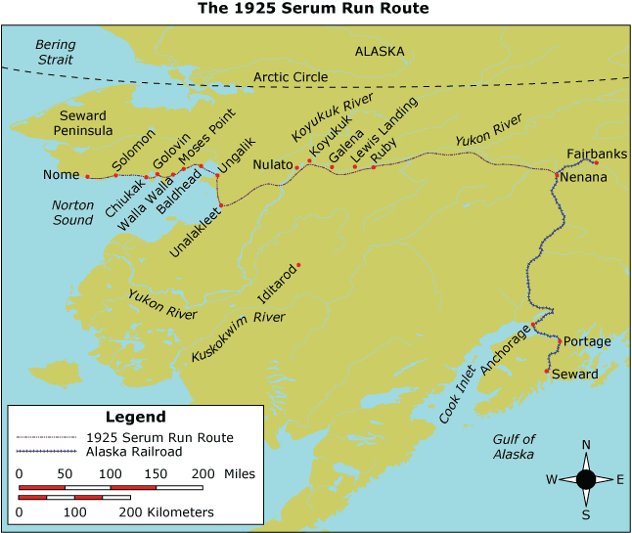

According to the map, which town along the Serum Run Route is nearest to Nome?
 |  | A. | Baldhead
 |  | B. | Solomon
 |  | C. | Fairbanks
 |  | D. | Anchorage

Question 5 of 10
Which of the following subtopics can not be used to complete the following outline?
Animals of North America
I. Animals with fur
A. Bears
B. Mountain lions
C. Raccoons
D. Beavers
II. Animals with scales
A. Alligators
B. Turtles
C. _____________
 |  | A. | Iguanas
 |  | B. | Beavers
 |  | C. | Rattlesnakes
 |  | D. | Lizards

Question 6 of 10
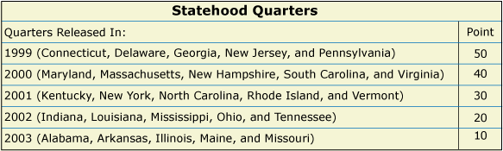

State Quarters Game
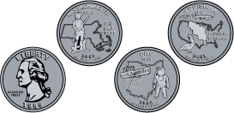
The most common quarters before 1999 had a picture of President George Washington on one side and a picture of an American eagle on the other side. In 1999, the United States Mint stopped making these 'old' quarters. That is when it began making quarters to honor each of the 50 states in America.
Each new coin has a special design on the back showing the history, customs, or symbols of a state. The design for each state's quarter is chosen from designs drawn by ordinary citizens. The quarters are being made in the same order that the states became part of the United States. A new quarter will be presented about every 10 weeks until the year 2008. When the program ends, the United States Mint will begin making the 'old' quarters again.
There are two mints in the United States that make these special coins. One is located in Denver, Colorado, and the other in Philadelphia, Pennsylvania. A small mark on each quarter shows whether the coin was made at the Denver or the Philadelphia mint. You can look for a D or P on the front of the next quarter you get.
About the game
Playing with money is a great way to increase math skills. Here is a game that you and a friend can play using old and new quarters. Take along a bag of quarters on your next trip. This is a fun game you can play anywhere.
You will need:
- 5 old quarters with an eagle on one side
- 5 new quarters, each from a different state
- A small paper bag
- A pencil and paper
Directions:
Flip an old quarter to decide who will start the game. As the coin is flipped in the air, one player calls out 'heads' or 'tails' before the coin lands. The picture of George Washington is considered 'heads' and the picture of the eagle is considered 'tails.' If the side that is called out faces up, the caller gets to go first. If the side that is called out lands face down, the other player goes first.
- Put all the quarters in the bag. Shake the bag to mix the coins.
- Without looking, the first player chooses 5 quarters. The other player gets the remaining 5 quarters.
- Turn the coins over so that the state sides are facing up. Finish the round by using the following chart to add up your points.
- Now flip an old quarter again to decide who will begin the next round of the quarters game.
- Put the coins back in the bag. Shake the bag again.
- Each player chooses another 5 quarters. Use the chart to add up your points after each round.
Play 3 rounds of this game to determine the winner.

Where is the best place to find more information about President George Washington?
 |  | A. | Dictionary
 |  | B. | Math book
 |  | C. | Game book
 |  | D. | Encyclopedia

Question 7 of 10
The Gardening Business
One day, Sue and her mother were working in the garden. Sue loved to work with her mother in the garden. Her mother was a gardener. They pulled weeds and watered flowers every day. Sue asked her mother if she could cut some flowers and take them into the house. Her mother said yes. Sue cut some flowers and took them into the house. She put the flowers in a basket. Her mother came into the house. She loved the flowers. Sue put the flowers on the table. They enjoyed the flowers at every meal. After dinner, Sue sat at the table. She told her mother that she wanted to make more flower baskets. Her mother thought that was a good idea. Sue and her mother came up with a plan. Sue could put a sign in the yard that said Flowers for Sale. She would then make flower baskets and take them to people. This was exactly what she did. Sue had many orders. She had so much fun. She made lots of flower baskets. Many people were pleased with her work. Sue told her mother that when she grows up she wants to own a flower shop. Her mother hugged her. She thought that was a good idea.
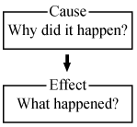
From the following, choose the cause and effect from the passage.
 |  | A. | Cause- Sue's mom made her work in the garden with her.  Effect- Sue was forced to like flowers.
 |  | B. | Cause- Sue and her mom gardened to make money.  Effect- Sue and her mom did not make any money with a flower business.
 |  | C. | Cause- Working in the garden taught Sue that she had a love for flowers.  Effect- Sue decided that her love for flowers has led her to think that she would like to work with flowers when she grows up.
 |  | D. | Cause- Sue's mom loved to garden and this taught Sue a love for flowers.  Effect- Sue's mom decided to develop a business with flowers and made Sue work for her.

Question 8 of 10
Transit of Venus 2004
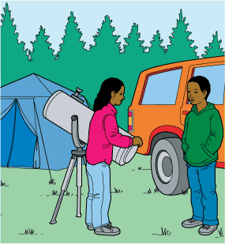
1 The weirdest thing in the world, Darrel thought, was to come all the way from Fresno, California, to Circle, Alaska, and find Amy Johnson, the biggest pain in the fifth grade, setting up a telescope in the campground next to theirs.
2 'Darrel!' Amy said, as if she owned the place. 'What are you doing here?'
3 'I came with my mom,' Darrel said. 'We're here to observe the transit of Venus, whatever that is.'
4 'Well,' Amy sniffed. 'How could you possibly not know that?'
5 Darrel saw license plates from all over the United States. His mother had found two astronomer friends of hers. There was a troop of Boy Scouts from Philadelphia and a couple all the way from Argentina. That evening at supper, Darrel asked his mother, not for the first time, 'What's the big deal about this transit-of-Venus thing?'
6 His mother replied, 'Once, the greatest problem in astronomy was that no one knew the distance from the Earth to the Sun. One way to measure it is by observing Venus's path when it crosses the face of the Sun. That's why we all came here, but we're doing this for fun. Scientists have developed better ways to measure the distance since earlier transits, such as those in 1769 and 1874.'
7 'If you wanted me to have fun, you should've let me bring my video games,' Darrel responded.
8 The campground was noisy that night because it never got dark and because everyone was excited. In the morning, after breakfast, Darrel went out to find Amy puttering around her telescope. 'Hey,' he said to her. 'Are we having fun yet?'
9 'Sure,' she said. 'You're enjoying this, aren't you?'
10 'Not really. I miss my video games. Mom wouldn't let me bring them.'
11 'I brought some of mine,' she said. 'Maybe we'll play later. Do you want to watch a mother eagle feed her chicks? I've got my telescope focused on their nest.'
12 Darrel looked through Amy's telescope. The eagles were upside down until he properly adjusted the equipment to see them right side up. 'This is neat,' he said, feeling better about the trip. 'Baby eagles.'
13 'Just think,' Amy said. 'There'll be another transit of Venus eight years from now. After that, it won't happen again until 2117. Maybe our grandchildren will see it.'
14 'Maybe,' Darrel said.
15 That evening Darrel watched as Amy attached a special filter to the telescope to protect their eyes. Then he looked through the telescope as a black dot slowly moved across the Sun.
16 'Whatever you do,' warned Amy, 'never look directly at the Sun, especially through a telescope!'
17 Amy, Darrel, his mom, and her friends stayed awake all night as the Sun lightly touched the horizon and came right back up. The transit was over by five in the morning, but then people began calling friends in South Africa and Madagascar and punching numbers into their computers. When they had all figured out the distance from the Earth to the Sun—no two answers were the same. Darrel finally decided to call it a day, thinking that his mother's friends were weird but fun, and that he might try talking to Amy Johnson again.
18 He had learned one thing for sure: astronomy made you sleepy.

Transit of Venus 1769
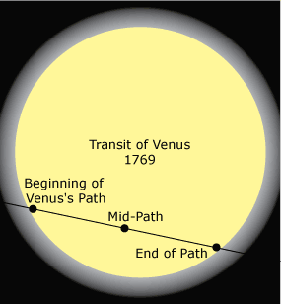
This selection tells about an event that occurred in June of 1769. A group of observers, led by Lt. James Cook, had been ordered to sail from England to the island of Tahiti in the South Pacific. Their mission was to establish themselves among the islanders and gather information about an unusual event in the solar system.
1 Tam watched the strange men from a distance, since her mother had warned her about them. Her mother said it would be better not to get too close.
2 The Englishmen had built a fort on a point of land near where their ship was anchored. Now they were working inside their fort. Their work centered around a tube that pointed toward the sky. As she got close enough to listen to them, she found that they didn't seem dangerous. They acted like ordinary men, yelling at each other and trying to get everything to work right. Whatever the tube was, it had something to do with the Sun.
3 When she asked her grandfather about it, he gave her a strange look. 'Ah, yes,' he said. 'Evening Star will soon cross the path of the Sun. How did you know?'
4 'I watched the Englishmen in their fort,' she said. 'They know it too.'
5 'I wonder how they know,' he said. 'Not many of us Boat Steerers know it. I only heard of it happening once before.'
6 'Maybe they are Boat Steerers,' she said. 'Grandfather, teach me the stars.'
7 'I cannot teach you,' he said. 'You are not a boy. You must ask your grandmother.'
8 'My granny is not a Boat Steerer.' The Boat Steerers were a society of men who knew the pathways of the sea. They could guide a canoe for days without ever seeing land.
9 'No woman can become a Boat Steerer. It is time for you to go home.'
10 Tam had heard rumors that spoke of books and writing. 'Those men,' she said to her mother, 'I've been watching them. They study the writing on their papers at every step.'
11 'I forbid you to watch them,' her mother replied. 'If a paper comes into this house, it must be burned.'
12 There was excitement at the Englishmen's fort the next day; the event they waited for was happening. In Tam's village, the Boat Steerers gathered at her grandfather's, singing and drumming. Tam peered at the Sun, but she couldn't see anything crossing its path. Though she turned away quickly so it wouldn't burn her eyes, a black dot remained in her vision; it took the shapes of the dots on the forbidden pages of paper. 'I will learn to read the English letters,' she said. 'Grandfather won't teach me, but after I know the letters, I can teach myself.'
13 Many years later, Tam became the first woman in her village to read and write. She learned that the Englishmen had used their telescope to measure the distance from the Earth to the Sun, an important achievement. She always believed, however, that her own achievement—learning to speak and read and think for herself in a village in which women were forbidden to do so—was much greater.

Use 'Transit of Venus 1769' and 'Transit of Venus 2004' to answer this question.
Look at the diagram of information from the two selections.
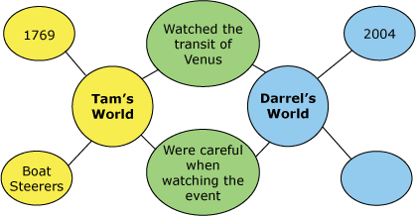
Which information belongs in the empty oval?
 |  | A. | Astronomers
 |  | B. | Telescopes
 |  | C. | Video games
 |  | D. | Americans

Question 9 of 10
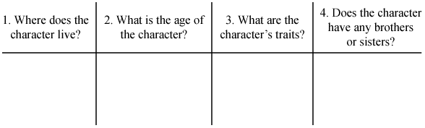
What column would this sentence go under in this Character Chart?
Amy is a very kind and giving person.
 |  | A. | Where does the character live?
 |  | B. | What is the age of the character?
 |  | C. | What are the character's traits?
 |  | D. | Does the character have brothers and/or sisters?

Question 10 of 10
Complete the list of ideas for a report about the water cycle.
1.evaporation
2.condensation
3.____________
4.collection
 |  | A. | run-off
 |  | B. | ground water
 |  | C. | water storage
 |  | D. | precipitation

Copyright © Discovery Education Assessment 2012. Proprietary Information. All rights reserved.
Discovery Education Page

