Progress Probe #1660805: 4th Grade TCAP Coach Chapter 3 Lesson 26 (Grade 04 RE)
Teacher Key with Answers
Ques | Answer | Level | Skill | Subskill | Item #
1 | C | Moderate | Literature | SPI 0401.8.7 Author's Purpose [69138] | U45677
2 | B | Moderate | Writing & Research | SPI 0401.3.1 Purpose for Writing [69101] | D56021
3 | D | Hard | Writing & Research | SPI 0401.3.2 Identify the Audience [69102] | D16484
4 | D | Moderate | Writing & Research | SPI 0401.3.1 Purpose for Writing [69101] | D53725
5 | D | Moderate | Writing & Research | SPI 0401.3.2 Identify the Audience [69102] | D101339
6 | C | Moderate | Literature | SPI 0401.8.7 Author's Purpose [69138] | U46865
7 | B | Moderate | Writing & Research | SPI 0401.3.1 Purpose for Writing [69101] | D50648
8 | D | Hard | Writing & Research | SPI 0401.3.2 Identify the Audience [69102] | D68837
9 | A | Moderate | Writing & Research | SPI 0401.3.2 Identify the Audience [69102] | D59495
10 | D | Moderate | Writing & Research | SPI 0401.3.2 Identify the Audience [69102] | D57983

Name: Date:
4th Grade TCAP Coach Chapter 3 Lesson 26
Question 1 of 10
The Olympics, Then and Now
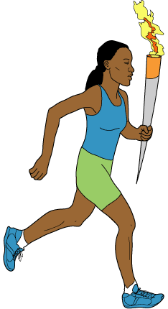
1 Every four years, athletes from all over the world compete in the Olympic Games. Some of the athletes will take medals home. These winners are proud because they have proven that they are the best in the world at their sports.
2 Nearly 3000 years ago, athletes in ancient Greece competed in much the same way. They met on a broad, flat plain called 'Olympia.' Athletes came from all over Greece to race, jump, and throw. These ancient Olympic games were so important that wars would stop so that they could be held.
3 Today, the site of the ancient Olympic games is mostly in ruins. We remember the location with a special torch. The torch is lit in Greece before the games begin. Runners carry the flaming torch to the place where the Olympics will be held. There it burns brightly during the games.
4 The first modern Olympic games were held in 1896 in Athens, Greece. They were initiated by a man from France named Pierre Coubertin. He thought the games were a good way for people from different countries to get to know one another.
5 Only men competed at the first Olympics. Now, most Olympic sports have both men's and women's events. Many of the sports, though, have different rules and equipment for men and women.
6 In most Olympic sports events, both amateur and professional athletes may compete. An athlete is an amateur if he or she is not paid to perform. Each athlete must also be a citizen of the country he or she represents.
7 Since 1896, the Olympics have been held every four years, except when there were world wars. The four-year period between Olympics is known as an Olympiad. Winter sports were added to the Olympics in 1924. The Winter and Summer Olympics used to be held in the same year. Since 1994, the Winter Olympics have been held two years apart from the Summer Olympics.
8 When the last event of the Olympics is over, the lighted torch is extinguished. The thousands of people who watched and took part in the games go home. Many of the athletes will work to do even better in the next Olympics.
9 It is an honor to win a medal at the Olympic games. It is a reward for many hours of training and practice. Yet, even for the athletes who do not win, it is a special experience to be in the Olympics. It gives them the chance to compete against the best in their fields. For everyone, it is a chance to travel and to make friends from all over the world.

How can you tell that this passage is written to inform the reader?
 |  | A. | It tells how hard athletes need to train.
 |  | B. | It does not include any characters or things that people say.
 |  | C. | It gives the reader mostly facts about the Olympics.
 |  | D. | It persuades the reader to play sports.

Question 2 of 10
What is the purpose of writing a letter to the newspaper editor?
 |  | A. | to put an ad in the paper to sell something
 |  | B. | to tell a newspaper your ideas about something
 |  | C. | to tell the editor about your summer vacation
 |  | D. | to find out what the weather will be

Question 3 of 10
Janet just really loved to write. As she was talking with her friend, Bernice, she began to tell her how excited she would get when she was going to write. She explained to Bernice that she would decide what questions she would ask, focus in on her topic, and then develop a plan to gather information. Another important step of prewriting was to determine who her audience would be. She also would decide the purpose of her writing. Even though prewriting is the longest step of the writing process, Janet felt it was the most fun. Janet and Bernice decided to talk with the editor of the school paper to see if they could have their work printed in the paper for all the students to read. Bernice felt lucky to have Janet as her friend.
If Janet is going to determine who her audience will be, what is she going to do?
 |  | A. | be determined to make certain people read her story
 |  | B. | go to the ballgame to sit with the audience
 |  | C. | turn up the audio, or volume, on her radio
 |  | D. | consider who will read her story

Question 4 of 10
An audience that wants to be entertained will enjoy what type of writing?
 |  | A. | straight and to the point
 |  | B. | writing convincing them to believe something
 |  | C. | a list of dates and facts
 |  | D. | light, good-humored, everyday language

Question 5 of 10
Katie is giving a storytelling presentation. What is the mostly likely purpose of her presentation?
 |  | A. | to teach the audience
 |  | B. | to persuade the audience
 |  | C. | to demonstrate a new skill
 |  | D. | to entertain the audience

Question 6 of 10
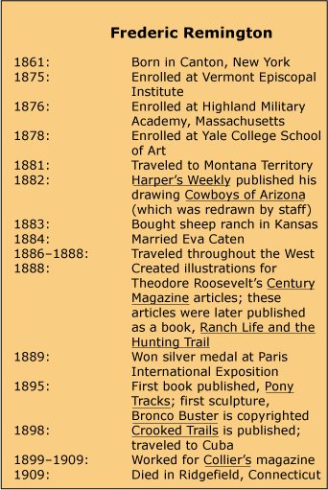

Frederic Remington, Artist of the West
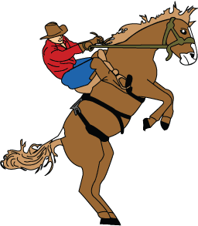
1 What do you think about when someone mentions the Wild West? What pictures are created in your mind? Maybe you picture the pounding hooves of wild horses racing across the plains. Where did you get these ideas about the Wild West? Perhaps you have seen a painting done by Frederic Remington.
2 Remington was born in 1861 and grew up in Canton, New York. As a boy, he was not a good student. He liked playing sports, but the thing he enjoyed doing most was drawing. Remington filled his notebooks with pictures. The pictures contained lots of action. Horses were one of the animals he frequently sketched. Since one of his favorite pursuits was riding horses, he was familiar with the way they looked and moved. He tried to capture those sights and feelings in his drawings.
3 When he was a teenager, Remington decided to enroll as a student in an art school. Later he traveled out West, where he did many of his drawings. He sent some of his work to New York, asking people whether they would be interested in publishing his work. In 1882, a magazine used one of those drawings. The drawing was called Cowboys of Arizona. However, the magazine hired another artist to make changes to Remington's work. The magazine then put Remington's name on the drawing even though it had been retouched. Imagine how Remington felt about that!
4 Remington visited many places in the West and tried different jobs. He attempted to raise sheep in Kansas, but he found that he did not like it. He tried being a soldier and discovered that he enjoyed this type of work. However, he still liked art most of all and often drew pictures of cowboys and soldiers. He also drew Native Americans and other images that he felt portrayed the West. He wanted people to understand the true West. His pictures made life on the frontier look exciting.
5 In 1885, Remington took his art to New York. Many people there praised both his ink drawings and his oil paintings. He was able to sell some of his pieces to important magazines. The pictures that they printed were truly his this time. He also drew illustrations for a book written by a man named Theodore Roosevelt, who later became President of the United States.
6 Remington kept drawing and continued to paint. He also began writing. He wrote about the West and then drew pictures for his books. His first book was called Pony Tracks.
7 In 1895, Remington created his first statue, Bronco Buster, which was in the same style as his drawings and paintings. All of his art was meant to reveal the way the people in the West lived.
8 Frederic Remington died in 1909. He enjoyed fame during his lifetime. Today, he still is the most famous artist of the West.

Which sentence best describes the author's opinion of Remington's work?
 |  | A. | Remington's work is the best in the world.
 |  | B. | Remington's statues are better than his drawings.
 |  | C. | Remington's work is the best known western art.
 |  | D. | Remington's book is better than Roosevelt's book.

Question 7 of 10
You are going to write a letter to a friend about the wonderful time you had at a concert. You will describe the fantastic light show and the fireworks display. You want the reader to feel as if she had been there. What is your purpose for writing?
 |  | A. | to complete a task
 |  | B. | to entertain
 |  | C. | to instruct
 |  | D. | to persuade

Question 8 of 10
Put the glove on the hand you do not use to throw. Pick up the ball with the non-glove hand. Point the glove at the target, and step with the glove-side foot. Throw the ball and follow through with your arm. Point, step, and throw.
Who would be the audience and what would be the purpose of this paragraph?
 |  | A. | older football players getting ready to throw a ball
 |  | B. | younger football players learning to kick a ball
 |  | C. | older baseball players getting ready to throw a ball
 |  | D. | younger baseball players learning to throw a ball

Question 9 of 10
You are trying to teach small children how to care for pets. What do you need to do to be sure they understand?
 |  | A. | Use short simple sentences.
 |  | B. | Write some funny stories about pets.
 |  | C. | Skip some steps so the essay will be short.
 |  | D. | Write a long story with many, many sentences.

Question 10 of 10
The author wrote the following passage for what audience.
We need more vacation time during the school year. We only have seven weeks off in the summer to spend with our family and friends. School is hard, and we are overworked. Please consider giving us more time off.
 |  | A. | teachers
 |  | B. | friends
 |  | C. | parents
 |  | D. | the school board

Copyright © Discovery Education Assessment 2012. Proprietary Information. All rights reserved.
Discovery Education Page

