Progress Probe #1660740: 4th Grade TCAP Coach Chapter 2 Lesson 15 (Grade 04 RE)
Teacher Key with Answers
Ques | Answer | Level | Skill | Subskill | Item #
1 | A | Moderate | Informational Text | SPI 0401.6.1 Focus and Clarify Thinking [69121] | U45690
2 | A | Moderate | Informational Text | SPI 0401.6.1 Focus and Clarify Thinking [69121] | U45723
3 | B | Moderate | Informational Text | SPI 0401.6.1 Focus and Clarify Thinking [69121] | U45738
4 | B | Hard | Informational Text | SPI 0401.6.1 Focus and Clarify Thinking [69121] | D54236
5 | B | Hard | Informational Text | SPI 0401.6.1 Focus and Clarify Thinking [69121] | D52865
6 | B | Hard | Informational Text | SPI 0401.6.1 Focus and Clarify Thinking [69121] | D61619

Name: Date:
4th Grade TCAP Coach Chapter 2 Lesson 15
Question 1 of 6
The Olympics, Then and Now
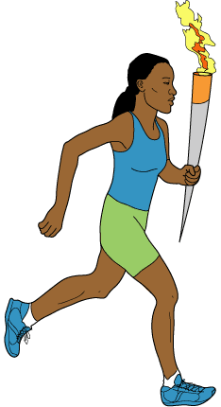
1 Every four years, athletes from all over the world compete in the Olympic Games. Some of the athletes will take medals home. These winners are proud because they have proven that they are the best in the world at their sports.
2 Nearly 3000 years ago, athletes in ancient Greece competed in much the same way. They met on a broad, flat plain called 'Olympia.' Athletes came from all over Greece to race, jump, and throw. These ancient Olympic games were so important that wars would stop so that they could be held.
3 Today, the site of the ancient Olympic games is mostly in ruins. We remember the location with a special torch. The torch is lit in Greece before the games begin. Runners carry the flaming torch to the place where the Olympics will be held. There it burns brightly during the games.
4 The first modern Olympic games were held in 1896 in Athens, Greece. They were initiated by a man from France named Pierre Coubertin. He thought the games were a good way for people from different countries to get to know one another.
5 Only men competed at the first Olympics. Now, most Olympic sports have both men's and women's events. Many of the sports, though, have different rules and equipment for men and women.
6 In most Olympic sports events, both amateur and professional athletes may compete. An athlete is an amateur if he or she is not paid to perform. Each athlete must also be a citizen of the country he or she represents.
7 Since 1896, the Olympics have been held every four years, except when there were world wars. The four-year period between Olympics is known as an Olympiad. Winter sports were added to the Olympics in 1924. The Winter and Summer Olympics used to be held in the same year. Since 1994, the Winter Olympics have been held two years apart from the Summer Olympics.
8 When the last event of the Olympics is over, the lighted torch is extinguished. The thousands of people who watched and took part in the games go home. Many of the athletes will work to do even better in the next Olympics.
9 It is an honor to win a medal at the Olympic games. It is a reward for many hours of training and practice. Yet, even for the athletes who do not win, it is a special experience to be in the Olympics. It gives them the chance to compete against the best in their fields. For everyone, it is a chance to travel and to make friends from all over the world.

What should the reader ask to understand more about the Olympics?
 |  | A. | What kinds of sports are played at the Olympics?
 |  | B. | Are women able to compete in the Olympics?
 |  | C. | What is a good question to ask about the Olympics?
 |  | D. | Why do students enjoy reading about the Olympics?

Question 2 of 6
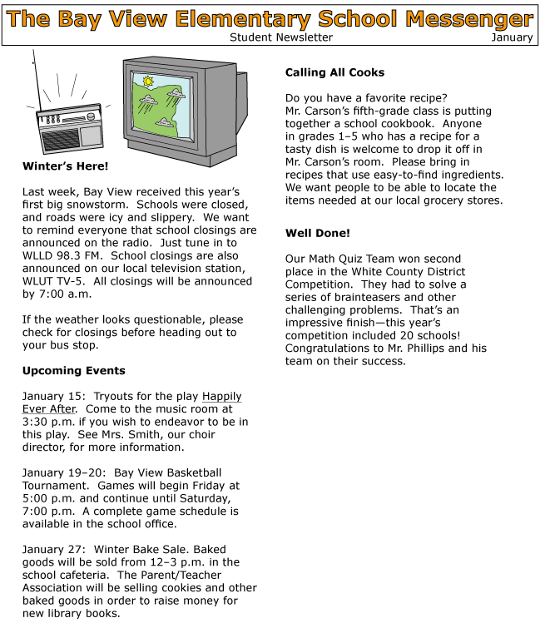

In order to determine the writer's viewpoint, what is most important for the reader to ask?
 |  | A. | Does the writer work at or attend Bay View Elementary School?
 |  | B. | Does the writer think it is good to raise money for new books?
 |  | C. | Does the writer take different viewpoints in the various sections?
 |  | D. | Does the writer hope that school will close due to icy roads?

Question 3 of 6
Living in a Cave
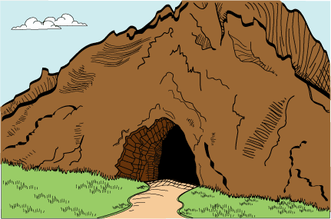
1 What do you think of when you think of caves? You might think of a very dark place, but it is probably not a place where you would want to live. However, many animals would not agree with you. Bears, bats, and cave fish all make their homes in caves. They do not all live in the same part of the cave, though.
2 A cave can be divided into three different parts: the entrance zone, the twilight zone, and the dark zone. Each of these zones attracts different types of animals.
The Entrance Zone
3 The entrance zone is home to animals such as mice, birds, and bears. They come to rest in the entrance zone after hunting for food outside the cave. Most of the time they choose the entrance zone because it is similar to other places outside the cave in which they might make a home. They just happen to live in caves because they are handy and offer some shelter.
4 There is some sunlight in the entrance zone, so animals that live there do not have to have better eyesight than animals that do not choose to live in caves. The climate in the entrance zone is similar to the climate outside the cave.
The Twilight Zone
5 If you keep going deeper into the cave, you come to the twilight zone. The twilight zone receives very little sunlight, just like the time of day called twilight. It is also much cooler and damper than the entrance of the cave. Animals such as spiders, crickets, owls, and bats live in this part of the cave. Some of them leave the cave to get food. Other animals, however, get their nourishment inside the cave. They have very good eyesight in the dark. Some animals such as bats do not even have to use their eyes. They find their way by making noises and then reacting to the echo as the sound of their chirps bounces off objects.
The Dark Zone
6 The dark zone is absolutely dark. It is so deep in the cave that not even a little bit of sunlight can reach it. Cave fish, worms, and some insects live in this area. They never leave. In order to see with eyes, there must be some light. Because there is no light, animals in the dark zone have no eyesight at all. They either have no eyes or tiny eyes.
7 Going into caves and observing how animals live in them can provide a pleasurable and educational experience. Some people, called spelunkers, even explore and study caves as a hobby. Since many caves are open to the public, people can see for themselves what life is like for the residents that live there.

How can you tell that this is an informational article?
 |  | A. | There are events from history in the article.
 |  | B. | There are facts about the topic in the article.
 |  | C. | There are interesting characters in the article.
 |  | D. | There is a surprise ending in the article.

Question 4 of 6
This was the night everyone had been waiting for. It was the final football game of the season for the Jones High School Lions. The score was tied 10 to 10 in the final quarter with only minutes to play. The Lions had the football. Everyone was so excited that the Lions had won. They were declared the State Champions.
What major part of this story had been left out?
 |  | A. | The name of the team they were playing
 |  | B. | How the Lions won the game
 |  | C. | Who coached the Lions
 |  | D. | Where the final game was played

Question 5 of 6
In 1912, the Titanic was the largest ship that had ever been built. The boat was capable of holding about 3,500 passengers. Titanic set sail on April 10, 1912 for its maiden voyage. Only a few days later, the Titanic hit a large piece of ice which created a hole in its side. Water poured into the side of the ship through this opening. The Titanic was beginning to sink. The passengers ran for the lifeboats, but only 700 people were able to find a space in one of them.
What question should the reader ask in order to determine how many people did not make it into the lifeboats?
 |  | A. | Where was the boat heading?
 |  | B. | How many people were on the boat?
 |  | C. | How many people can fit in a boat today?
 |  | D. | How big was the ice?

Question 6 of 6
Marvin and Max were best friends who loved to play basketball. They were both on the basketball team at Watson Junior High. It was the middle of ball season and Marvin hurt a muscle in his ankle. The doctor said it would take six weeks to get better. This put him out for the season. His younger brother, T.J., was the next person to take his place. T.J. was not as good as his brother, but he tried hard. T.J. began to spend more time with Max at ball practice and after ballgames. They became great friends. They even practiced basketball together on the weekends. Marvin was jealous of the friendship Max and T.J. had. Marvin stopped talking to both of them.
One Saturday morning, while eating breakfast, Marvin's mother asked him how Max was doing. Marvin just shook his head. T.J. spoke up and said that Max was doing great and that they were planning on seeing a movie later that afternoon. Marvin's mother asked T.J. if he would take out the trash. She did not want it to begin to smell. T.J. did as his mother told him, and Marvin's mother sat at the table with her other son.
What major event in the story is left unanswered?
 |  | A. | Will T.J.'s mother take the trash out herself?
 |  | B. | Will Marvin and Max ever be friends again?
 |  | C. | Will Max make the team next year?
 |  | D. | Will Watson Elementary win the tournament game?

Copyright © Discovery Education Assessment 2012. Proprietary Information. All rights reserved.
Discovery Education Page

