Progress Probe #1660702: 4th Grade TCAP Coach Chapter 1 Lesson 8 and 9 (Grade 04 RE)
Teacher Key with Answers
Ques | Answer | Level | Skill | Subskill | Item #
1 | D | Hard | Language & Vocabulary | SPI 0401.1.8 Spelled Words [69089] | D80546
2 | C | Moderate | Language & Vocabulary | SPI 0401.1.15 Compound Words, Contractions, and Abbreviations [69096] | U46029
3 | A | Moderate | Language & Vocabulary | SPI 0401.1.8 Spelled Words [69089] | D56689
4 | C | Hard | Language & Vocabulary | SPI 0401.1.7 Usage Errors [69088] | D67444
5 | B | Moderate | Language & Vocabulary | SPI 0401.1.7 Usage Errors [69088] | D2877
6 | C | Hard | Language & Vocabulary | SPI 0401.1.8 Spelled Words [69089] | D99472
7 | A | Moderate | Language & Vocabulary | SPI 0401.1.8 Spelled Words [69089] | D61930
8 | B | Hard | Language & Vocabulary | SPI 0401.1.8 Spelled Words [69089] | D80544
9 | C | Moderate | Language & Vocabulary | SPI 0401.1.8 Spelled Words [69089] | D51933
10 | A | Hard | Language & Vocabulary | SPI 0401.1.15 Compound Words, Contractions, and Abbreviations [69096] | D64072
11 | B | Moderate | Language & Vocabulary | SPI 0401.1.15 Compound Words, Contractions, and Abbreviations [69096] | U46045
12 | C | Hard | Language & Vocabulary | SPI 0401.1.15 Compound Words, Contractions, and Abbreviations [69096] | D55022
13 | B | Moderate | Language & Vocabulary | SPI 0401.1.7 Usage Errors [69088] | D52708
14 | D | Hard | Language & Vocabulary | SPI 0401.1.15 Compound Words, Contractions, and Abbreviations [69096] | D2187
15 | D | Moderate | Language & Vocabulary | SPI 0401.1.7 Usage Errors [69088] | D16680
16 | A | Hard | Language & Vocabulary | SPI 0401.1.7 Usage Errors [69088] | D55073

Name: Date:
4th Grade TCAP Coach Chapter 1 Lesson 8 and 9
Question 1 of 16
I wrote to my pen pal, but she never _______ to my letter.
Which word choice spells the past tense form of the word reply correctly and fits into the sentence?
 |  | A. | replyed
 |  | B. | replide
 |  | C. | replyd
 |  | D. | replied

Question 2 of 16
A Lasting Gift
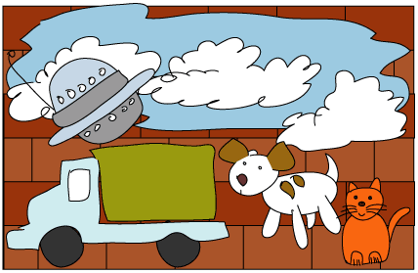
1 It was almost the end of an exciting school year at Lakeview Elementary, and our class was feeling great. We would be the very first students ever to graduate from this place! At a special class meeting we decided that we wanted to leave a lasting gift behind so that the whole town would remember the event. What could be the perfect gift?
2 After much discussion and many suggestions, we decided to paint a mural, a large picture or scene painted directly on a wall. There was a long brick wall that faced the playground. The wall had always looked plain, dull, and boring. We could improve it by painting pictures that had special meaning. Each fifth-grade student could paint a picture on a small section of the wall.
3 The next three days were messy, colorful, and fun. The result was an interesting disaster. Ten students at a time painted. The first ten students decided to paint a sky as blue as the ocean, with fluffy white clouds floating here and there. That turned out rather pretty. Then other kids painted pictures that had their own special meanings: a brown-and-white dog, a goldfish in a bowl, an orange cat, and four delicate butterflies dancing in the wind. There was a boy on a bicycle, a girl at bat, people dancing, hills, and big fields. There was even a silver spaceship by a lake, not to mention a mule wearing a big straw hat and a pair of sunglasses. Although each picture looked okay by itself, together they made no sense at all. Our gift just looked like a gigantic mess.
4 Everyone in the class wondered what we should do. We held an emergency meeting. No one wanted to paint over the mural and start again, so we just had to find a way to pull the mural together and make it look organized. Every suggestion was met with arguments and groans. Frustration and disappointment hung in the air. Obviously, we had not planned our gift very well. Suddenly, I had a wonderful idea.
5 'Maybe it's just not finished yet,' I said. 'We can add to each others' pictures in little ways that will help them look better together. You know, add some houses here, a few trees there, and roads to give the animals and people homes and places to go. And …' I hesitated, '… how about a big rainbow in the sky to bring the whole scene together?' At first, nobody said a word. The silence was deafening, and I felt my cheeks begin to burn. I thought I had really blown it! I held my breath. Then a few heads began to nod. Soon everyone was in agreement and people even started clapping. I smiled happily and thought, 'Great ideas just take a little time to sink in.'

Which word from the passage is a compound word?
 |  | A. | almost
 |  | B. | disaster
 |  | C. | spaceship
 |  | D. | agreement

Question 3 of 16
Choose the correct word to complete the sentence.
The students were assigned twenty ______ problems.
 |  | A. | addition
 |  | B. | adition
 |  | C. | addision
 |  | D. | edittion

Question 4 of 16
Choose the word that correctly completes the sentence.
______ is no more pizza. My brother ate two slices for breakfast.
 |  | A. | Their
 |  | B. | They're
 |  | C. | There
 |  | D. | They

Question 5 of 16
Choose the sentence that is not written correctly.
 |  | A. | He asked if he could go to Kenneth's house to go skateboarding.
 |  | B. | It is just to hot to be outside.
 |  | C. | He asked for two sandwiches even though he had already eaten one.
 |  | D. | They are going, and I want to go, too.

Question 6 of 16
Select the word from the list that would need to change the y to an i before adding the suffix "ed."
 |  | A. | play
 |  | B. | destroy
 |  | C. | cry
 |  | D. | stray

Question 7 of 16
Choose the correct spelling.
 |  | A. | balloon
 |  | B. | baloon
 |  | C. | balloone
 |  | D. | ballon

Question 8 of 16
It was no small ____ to squeeze my size 5 ____ into size 3 shoes.
Which word pair is spelled correctly and fits into this sentence?
 |  | A. | feet...feet
 |  | B. | feat...feet
 |  | C. | feet...feat
 |  | D. | feat...feat

Question 9 of 16
The choice of cookies varyed from chocolate chip to peanut butter. Most childern chose cholalate, but a few picked peanut butter.
How many spelling errors does this passage contain?
 |  | A. | 1
 |  | B. | 2
 |  | C. | 3
 |  | D. | 4

Question 10 of 16
Choose the sentence that is written correctly.
 |  | A. | It's a beautiful day for flying a kite.
 |  | B. | The puppy knows it's name.
 |  | C. | The book is labeled by it's color.
 |  | D. | Its wonderful to know you are my friend.

Question 11 of 16
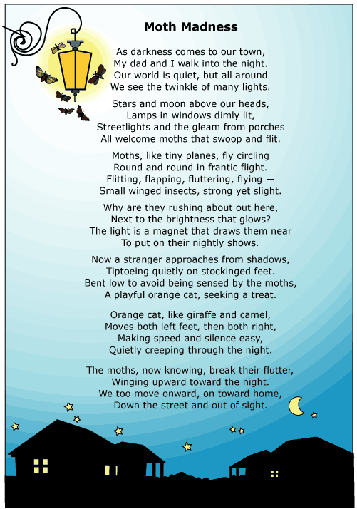

Which of these is a compound word?
 |  | A. | darkness
 |  | B. | streetlights
 |  | C. | stockinged
 |  | D. | onward

Question 12 of 16
Every year Janice and Carol go to visit their grandmother for summer vacation. Their grandmother lives in Williamsburg, Virginia. It's a wonderful place to visit because of its fourth of july events.
Choose the answer that shows the correct capitalization of the part of the sentence in bold print.
 |  | A. | Fourth of july
 |  | B. | fourth of July
 |  | C. | Fourth of July
 |  | D. | Fourth Of July

Question 13 of 16
The girls enjoyed they're trip to the new movie theater.
What word is not used correctly in the sentence?
 |  | A. | enjoyed
 |  | B. | they're
 |  | C. | girls
 |  | D. | trip

Question 14 of 16
Karen ________ believe that silly story.
Choose the contraction that best completes the sentence.
 |  | A. | willn't
 |  | B. | weren't
 |  | C. | isn't
 |  | D. | won't

Question 15 of 16
Choose the sentence that is written correctly.
 |  | A. | Chris and Kim set they're books there on the table.
 |  | B. | Chris and Kim set their books they're on the table.
 |  | C. | Chris and Kim set there books their on the table.
 |  | D. | Chris and Kim set their books there on the table.

Question 16 of 16
What homonym correctly fits in this blank?
The _________ was dark and beautiful. We gazed at the comet as it soared across the sky.
 |  | A. | night
 |  | B. | knight
 |  | C. | nite
 |  | D. | knit

Copyright © Discovery Education Assessment 2012. Proprietary Information. All rights reserved.
Discovery Education Page

