Progress Probe #1660623: 4th Grade TCAP Coach Chapter 1 Lesson 5, 6, and 7 (Grade 04 RE)
Teacher Key with Answers
Ques | Answer | Level | Skill | Subskill | Item #
1 | A | Hard | Language & Vocabulary | SPI 0401.1.16 Unfamiliar Words [69097] | D99871
2 | D | Hard | Language & Vocabulary | SPI 0401.1.13 Grade Appropriate Vocabulary [69094] | D99255
3 | A | Moderate | Language & Vocabulary | SPI 0401.1.13 Grade Appropriate Vocabulary [69094] | D68108
4 | D | Hard | Language & Vocabulary | SPI 0401.1.13 Grade Appropriate Vocabulary [69094] | D83864
5 | C | Moderate | Language & Vocabulary | SPI 0401.1.14 Meaning Within Context [69095] | U46364
6 | B | Hard | Language & Vocabulary | SPI 0401.1.12 Antonyms, synonyms, and homonyms [69093] | D53509
7 | D | Hard | Language & Vocabulary | SPI 0401.1.16 Unfamiliar Words [69097] | D68118
8 | C | Moderate | Language & Vocabulary | SPI 0401.1.13 Grade Appropriate Vocabulary [69094] | D84745
9 | B | Moderate | Language & Vocabulary | SPI 0401.1.13 Grade Appropriate Vocabulary [69094] | U46005
10 | D | Moderate | Language & Vocabulary | SPI 0401.1.16 Unfamiliar Words [69097] | U44662
11 | A | Hard | Language & Vocabulary | SPI 0401.1.12 Antonyms, synonyms, and homonyms [69093] | D55073
12 | A | Moderate | Language & Vocabulary | SPI 0401.1.14 Meaning Within Context [69095] | U46749
13 | B | Moderate | Language & Vocabulary | SPI 0401.1.12 Antonyms, synonyms, and homonyms [69093] | U45254
14 | B | Hard | Language & Vocabulary | SPI 0401.1.13 Grade Appropriate Vocabulary [69094] | D99254
15 | B | Moderate | Language & Vocabulary | SPI 0401.1.12 Antonyms, synonyms, and homonyms [69093] | U45236
16 | B | Moderate | Language & Vocabulary | SPI 0401.1.13 Grade Appropriate Vocabulary [69094] | D88899
17 | B | Hard | Language & Vocabulary | SPI 0401.1.16 Unfamiliar Words [69097] | D99503
18 | C | Hard | Language & Vocabulary | SPI 0401.1.12 Antonyms, synonyms, and homonyms [69093] | D67444

Name: Date:
4th Grade TCAP Coach Chapter 1 Lesson 5, 6, and 7
Question 1 of 18
Which of the following words is used to describe someone who is sad?
 |  | A. | blue
 |  | B. | amber
 |  | C. | chipper
 |  | D. | snazzy

Question 2 of 18
Emma was unable to take her test because she was feeling under the weather. What do the words "under the weather" mean in this sentence?
 |  | A. | wet
 |  | B. | sad
 |  | C. | tired
 |  | D. | sick

Question 3 of 18
George rode a palomino into the stable.
Based on the sentence above, what is the meaning of palomino.
 |  | A. | horse
 |  | B. | bicycle
 |  | C. | bull
 |  | D. | motorcycle

Question 4 of 18
The salesman tried to _________ my mother to buy the expensive car.
Choose the word that fills in the sentence correctly.
 |  | A. | talk
 |  | B. | develop
 |  | C. | harass
 |  | D. | persuade

Question 5 of 18
Pulling for a Miracle
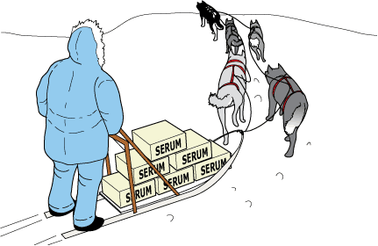
1 Robert was just rolling his bike out of the garage when the sound of his mother's voice startled him. Dropping the bike, he trotted toward the back door.
2 'Yes, Mother?'
3 'I made some cookies,' his mother smiled.
4 Robert pulled off his jacket and hung it on the peg. The bike ride could wait. Once he was inside, his mother surveyed his appearance. She followed with the usual, 'Why don't you go clean up first?'
5 He grinned as he washed his face and hands. So far the only downside to this day was a slightly sore throat. It had been bothering him since he woke up this morning. He was sure it was nothing that a few of his mom's cookies couldn't fix.
6 At the kitchen table, Robert's mother placed a glass of milk in front of him and smoothed his hair. Her hand lingered on his forehead for a moment. Robert recognized her concerned-mother look, so he pulled away. 'Just let me feel your forehead. You feel warm.'
7 'Ah, Mom,' Robert protested. This was not the way he'd planned to spend his day—being treated by his mother for some ailment. 'I feel fine!'
8 'You have a fever,' she insisted. 'You're going to need rest and liquids until further notice.'
9 Robert flipped on the radio and got settled on the sofa. Gloomily, he stared out the window at the beautiful day. He hoped he could regain his freedom after the next check of his forehead. Suddenly, his thoughts were drawn to the radio as an important news story was announced.
10 'News update for February 2, 1925. This just in: Sled drivers and their dogs continue to battle winter weather while trying to bring medicine for the children of Nome, Alaska. Doctors are treating a diphtheria outbreak. They are waiting for delivery of the medicine needed to fight the disease. It must be transported from Anchorage, Alaska, nearly 1000 miles away from Nome. Icy weather conditions make it unsafe for planes to fly the entire distance. Sled dog teams have been relaying the medicine in this rescue mission.
11 'Winds strong enough to knock over sleds and drivers have been making travel for the dog teams risky. Weather updates from Alaska tell us winds are blowing at 80 miles per hour. Temperatures are 36 degrees below zero. Many are afraid the teams will fail to make it through. We will continue to keep our audience posted about this astounding rescue attempt. We now return you to our regular program.'
12 A song began playing, and Robert's attention again drifted to the window. 'Thirty-six below zero,' Robert wondered aloud. 'How will they ever make it?'
13 A while later, Robert's mother declared his fever gone, and he no longer needed to stay inside. When he didn't jump up and head outdoors, she was concerned. 'Are you sure you are feeling all right, Robert?'
14 'Yes, but I think I'll stay and listen for another news update.' He told her the story he'd heard about the rescue mission in progress. 'Do you think they can do it, Mom?' he asked.
15 'Anything is possible, son. You just have to hope for the best.'
16 All afternoon Robert listened and waited. Finally, after the sun had set and dinner dishes were cleared, Robert's mother ordered him to turn off the radio. 'There will be more news tomorrow,' she said.
17 The next morning, Robert searched the newspaper for news about the mission. They had made it to Nome! As he read the story, he imagined the lead sled dog, Balto, pulling through the last leg of the journey. The achievement became even more admirable when he learned that Balto had led his team through a blinding blizzard. The sled dog relay allowed Gunnar Kasson, the driver of Balto's team, to successfully deliver the medicine. Many had worked together to save the lives of Nome's citizens.
18 Robert did some quick figuring in his head. 'Wow!' he thought. 'They beat impossible odds to cover 53 miles in just 20 hours!' Relieved and excited about the news, Robert gobbled down his breakfast and headed outdoors. He wanted to be sure to get something done in his next 24 hours before heading back to school.

In which word does im- have the same meaning as in the word impossible in paragraph 18?
 |  | A. | improve
 |  | B. | important
 |  | C. | impatient
 |  | D. | imitate

Question 6 of 18
Choose an antonym to replace the word in bold print.
The lights at the county fair were stimulating because they were very colorful.
 |  | A. | unimportant
 |  | B. | boring
 |  | C. | creative
 |  | D. | exciting

Question 7 of 18
Sal and Isabella were waiting with a group of teenagers for the movie to start. Sal had been talking loudLY and horsing around with his friends for a long time and barely noticed Isabella. Sal turned to her and asked, "Has the cat got your tongue?"
Based on the paragraph above, what is the best meaning of the idiom, "Has the cat got your tongue?"
 |  | A. | Are you thirsty?
 |  | B. | Do you feel sick?
 |  | C. | Do you like cats?
 |  | D. | Why are you quiet?

Question 8 of 18
Choose the word that best completes the sentence.
Sorting through weeks of unopened mail was an endless __________.
 |  | A. | catch
 |  | B. | box
 |  | C. | process
 |  | D. | upheaval

Question 9 of 18
Stormy Surprise
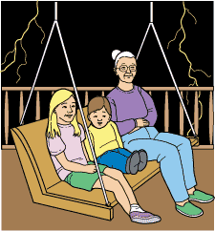
1 Roseanne and her grandmother sat on the porch, watching lightning skip across the desert.
2 'It is so beautiful, Gran,' Roseanne said.
3 'It is to us, sweetheart, but the loud cracks of thunder that follow lightning scare some people,' her grandmother answered as they rocked gently back and forth on the porch swing. 'Your little brother, Robbie, for instance, is terrified by thunder. That is why he is inside right now with your mom and dad. Why don't we bring him out here to rock with us on the swing? If we are both calm during the storm, that might help him be less fearful.'
4 Roseanne stopped the movement of the swing with her feet, stood up, and turned to go into the house to fetch her brother. Grandmother started the swing rocking in a steady rhythm again. She pulled her shawl around her shoulders and hummed as she watched and listened to the summer storm.
5 In a few minutes, Roseanne returned with Robbie. She boosted Robbie onto the swing with Grandmother and then sat down next to him. The light show had stopped, and Robbie sat calmly with his head on his grandmother's arm. Grandmother pushed with her foot to start the porch swing rocking again. The light show started again, and this time the lightning was even more dramatic. Robbie became nervous and squirmed with fear, but Grandmother kept humming as Robbie stared out into the night.
6 'Grandma,' Robbie said. 'May I go back inside, please? I don't like the storm.'
7 'I will make a deal with you,' Grandmother replied. 'How good are you at playing make-believe?'
8 'Pretty good, I guess,' he said.
9 'Well, then, the next time we see lightning and hear thunder, you pretend it is something else. If you can use your imagination to think of something really creative, I will have a big surprise for you. How does that sound?'
10 'Okay. I can do that,' Robbie said as he looked up at the sky.
11 As if on cue, a bright flash of lightning danced across the desert sky. Almost immediately, they heard a loud rumble of thunder. Grandmother and Roseanne rocked steadily, and Robbie seemed not to be so frightened this time. When the thunder stopped, Grandmother asked, 'So, what did you pretend, Robbie?'
12 'Well, the lightning looks like little animals running across the desert, and the thunder sounds like a big bass drum,' Robbie answered. 'No, it is not a drum. The thunder is clapping for the little animals for running so fast.'
13 Grandmother looked over at Roseanne and winked. The three of them continued rocking, watching animals run through the desert and listening to the thunder clapping.
14 'Grandma,' Robbie asked after a few minutes, 'was my make-believe good enough to get a surprise?'
15 'Yes, Robbie. It was more than good enough,' Grandmother replied.
16 'Well?' Robbie looked at her hopefully.
17 'I have two surprises. Your first surprise is that you are not afraid of thunder anymore,' Grandmother answered. 'Your second surprise is that I will make that apple pie you love for dessert tomorrow night.'

Read this sentence from paragraph 12.
'Well, the lightning looks like little animals running across the desert, and the thunder sounds like a big bass drum,' Robbie answered.
Which of the following is used in the sentence?
 |  | A. | Rhyme
 |  | B. | Simile
 |  | C. | Personification
 |  | D. | Onomatopoeia

Question 10 of 18
Mateo's Bunny
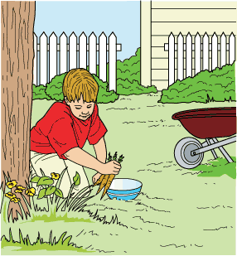
1 Mateo had wanted a dog for as long as he could remember. He had always dreamed of having a puppy to love and play with, but Mom wasn't too happy about having a dog.
2 'No,' Mom said when Mateo asked her for the millionth time.
3 'But Dad's working on the fence right now, Mom. You said we might get a dog when he's finished,' Mateo reminded her.
4 'Yes, but taking care of a dog means much more than simply leaving it in the yard,' Mom said. 'You have to feed it, bathe it, and brush its coat. And you can't take the day off because you're tired or you want to go out and play. The dog would depend on you, Mateo. I don't think you are ready to take on such a big job yet.'
5 With that, Mom walked away as Mateo stared after her. Mateo wished he could somehow prove that Mom could trust him not to let her down.
6 Soon the day came when the fence was almost finished. The yard was now surrounded except for the gates, which Dad would finish very soon. That night, Mateo was in the kitchen eating an apple and looking out the window. He was imagining what it would be like to be playing with his dog in the yard. Suddenly, he noticed something stir under the oak tree. There was a little cottontail rabbit eating some grass. Except for its munching, the rabbit was very still and watchful, alert to any possible danger.
7 'Mom!' Mateo cried. 'Come look!'
8 Mom hurried to the window, and they watched the rabbit for a little while.
9 'I guess it wandered in through the open gate and thought it would have a snack,' Mom said.
10 'Maybe the rabbit will come back tomorrow night. Do you think I should leave it some carrots to eat and a bowl of water?' Mateo asked.
11 'That sounds like a good idea,' Mom replied. She smiled and left Mateo to watch the rabbit.
12 The next evening Mateo laid some carrots in the grass under the oak tree and put a bowl of water next to them so the rabbit could get a drink. Then he went up to his bedroom window to watch for the rabbit. Sure enough, later that night it came hopping across the lawn to where Mateo left the food and water. Each night, Mateo faithfully put out food and water for the rabbit. Mateo's mother quietly observed her son's efforts.
13 The day Dad hung the gates, Mateo stood watching him. Mom pulled up in the car and called to Mateo.
14 'Come and help me carry this in, please,' she said.
15 Mateo ran over to the car. Mom smiled as a very surprised Mateo and a very wiggly puppy met for the first time.
16 'You've done such a wonderful job of feeding the rabbit that I've decided you deserve a chance to show how reliable you can be with a dog,' she said. 'I'm very proud of you, Mateo.'
17 'Wow!' Mateo shouted. He couldn't believe it—he finally had his own dog. He thought for a moment, then said, 'I think I'll call her Bunny. But, now that the gates are hung, the rabbit won't be able to get in the yard. I'll leave its carrots outside of the yard.'
18 'Good idea,' Mom said. She laughed as she watched Mateo run off with the puppy following him. Turning to go inside, she had a feeling that they would take very good care of each other.

If you want to find another word that means the same as the word wonderful in paragraph 16, where should you look?
 |  | A. | In a book about favorite pets
 |  | B. | In an atlas
 |  | C. | In an encyclopedia
 |  | D. | In a thesaurus

Question 11 of 18
What homonym correctly fits in this blank?
The _________ was dark and beautiful. We gazed at the comet as it soared across the sky.
 |  | A. | night
 |  | B. | knight
 |  | C. | nite
 |  | D. | knit

Question 12 of 18
Lady Liberty
A Special Gift
1 The Statue of Liberty was a gift from the French as a symbol of the friendship between our two countries. A French sculptor named Bartholdi planned the statue. He and others wanted to show their support of America. They shared the ideal of freedom for all. Both countries knew it would be costly, so they agreed to share in the project. The French would build the figure; the Americans would build its base.
2 First, money had to be raised before construction could start. It was not easy to raise all the money. Many people liked the idea of the statue, but few wanted to give their money to help pay for it. It took a united effort by the two countries to raise the money. In France, a raffle was held. In the United States, a newspaper owner wrote about the statue in his paper. He urged the American people to help. In the end, the necessary money was raised.
The Torch Sparks Interest
3 July 4, 1876, was the goal for completing the statue. This date would have been perfect, as it marked 100 years of America's freedom. Soon, though, everyone realized that this goal would not be met. There was neither enough time nor money to finish it by that date.
4 Since the entire statue was not yet completed, the sculptor decided to send a part of it. The statue's arm and torch arrived in August, and they were shown at a fair in Philadelphia. For 50 cents, a visitor could climb a ladder to see the giant torch up close. This sparked interest in the project.
Liberty Sets Sail
5 Nearly ten years later than planned, the statue was finished. It was too large to be shipped in one piece, so it was broken down into 350 pieces. These pieces were packed in 214 crates and shipped across the ocean.
6 The statue pieces arrived in New York Harbor in June of 1885. In April of 1886, the base was ready, and at last, the statue was put back together. It was officially presented on October 28, 1886.
Liberty in Detail
7 The Statue of Liberty sits on a small island in the middle of New York Harbor. Visitors can take ferryboats to the island to view the historic statue. Inside the huge base is a 354-step staircase that spirals to the top of the statue. At times, visitors are allowed to climb these stairs to Lady Liberty's crown.
8 The observatory in the crown provides a bird's-eye view of much of New York Harbor. The crown itself consists of 25 windows, each representing one of the 25 gemstones of the earth. The crown has seven rays, which stand for the seven seas and the seven continents of the world. A tablet in Lady Liberty's left hand reads 'July 4, 1776.' This date marks America's Independence Day. The torch in her right hand lights the way for people to come to America.
9 The statue has an iron frame that is covered with thick sheets of copper. Despite the statue's sturdy construction, strong winds can cause it to sway slightly, moving the torch up to five inches back and forth. At a height of 305 feet, the Statue of Liberty is, indeed, a sight to behold.

The suffix -atory means a place for doing something. In paragraph 8, what does the word observatory mean?
 |  | A. | a place for looking
 |  | B. | a place for working
 |  | C. | a place for waiting
 |  | D. | a place for building

Question 13 of 18
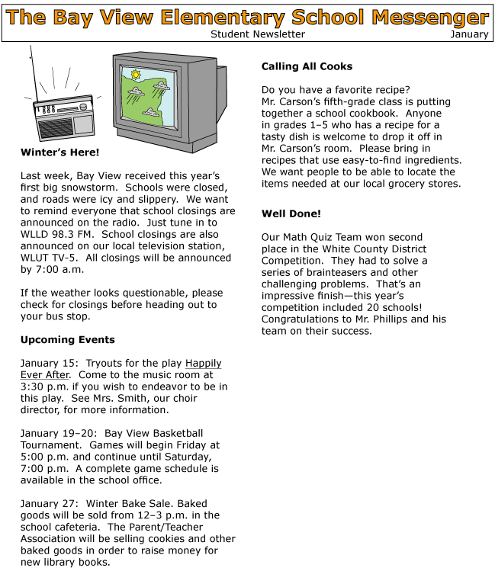

If the reader does not know what the word competition means in the section 'Well Done!' which would be the best thing to do?
 |  | A. | Look for a library book with the word 'competition' in the title
 |  | B. | Read the sentences around the word 'competition' in the newsletter
 |  | C. | Listen to the local radio station to see if the word is mentioned
 |  | D. | Read the student newsletter again

Question 14 of 18
As Matt ran torward the playground, the teacher told him to "hold his horses" because the slide was wet. What does the teacher want Matt to do?
 |  | A. | hold on to horses on the playground
 |  | B. | wait before going to the playground
 |  | C. | take some horses to the playground
 |  | D. | look for horses on the playground

Question 15 of 18
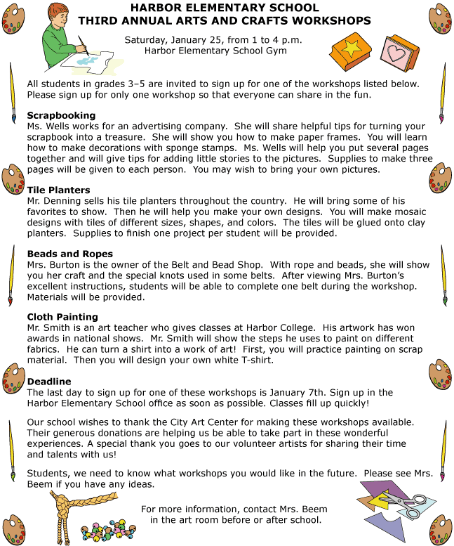

Read this sentence from the passage.
You will make mosaic designs with tiles of different sizes, shapes, and colors.
Which of the following best describes the meaning of mosaic in this sentence?
 |  | A. | musical
 |  | B. | made with many pieces
 |  | C. | part of a pattern
 |  | D. | made with different materials

Question 16 of 18
Jerome walked into Sid's apartment and saw his brother working on something sticking out of the back of the TV set. Sid told him since he could not afford cable, their grandmother gave him her old TV. Jerome said he was adjusting the _________ on the TV and hoped the picture would come in clearer.
 |  | A. | amount
 |  | B. | antenna
 |  | C. | balance

Question 17 of 18
Which word best fits in the blank? ___________→bird→animal→living thing
 |  | A. | fish
 |  | B. | eagle
 |  | C. | amphibians
 |  | D. | feathers

Question 18 of 18
Choose the word that correctly completes the sentence.
______ is no more pizza. My brother ate two slices for breakfast.
 |  | A. | Their
 |  | B. | They're
 |  | C. | There
 |  | D. | They

Copyright © Discovery Education Assessment 2012. Proprietary Information. All rights reserved.
Discovery Education Page

