Progress Probe #1658823: 3rd Grade TCAP Coach Lesson 1 Chapter 7 (Grade 03 RE)
Teacher Key with Answers
Ques | Answer | Level | Skill | Subskill | Item #
1 | D | Moderate | Language & Vocabulary | SPI 0301.1.16 Word Meanings [68611] | U43632
2 | A | Moderate | Language & Vocabulary | SPI 0301.1.16 Word Meanings [68611] | U43635
3 | C | Moderate | Language & Vocabulary | SPI 0301.1.19 Appropriate Vocabulary [68615] | D16535
4 | A | Hard | Language & Vocabulary | SPI 0301.1.19 Appropriate Vocabulary [68615] | D419
5 | C | Moderate | Language & Vocabulary | SPI 0301.1.20 Word Meaning Through Context Clues [68618] | D65455
6 | D | Moderate | Language & Vocabulary | SPI 0301.1.20 Word Meaning Through Context Clues [68618] | D97108
7 | C | Moderate | Language & Vocabulary | SPI 0301.1.20 Word Meaning Through Context Clues [68618] | D97109
8 | C | Hard | Language & Vocabulary | SPI 0301.1.20 Word Meaning Through Context Clues [68618] | D51051
9 | A | Hard | Language & Vocabulary | SPI 0301.1.20 Word Meaning Through Context Clues [68618] | D57010
10 | B | Hard | Language & Vocabulary | SPI 0301.1.20 Word Meaning Through Context Clues [68618] | D58968

Name: Date:
3rd Grade TCAP Coach Lesson 1 Chapter 7
Question 1 of 10
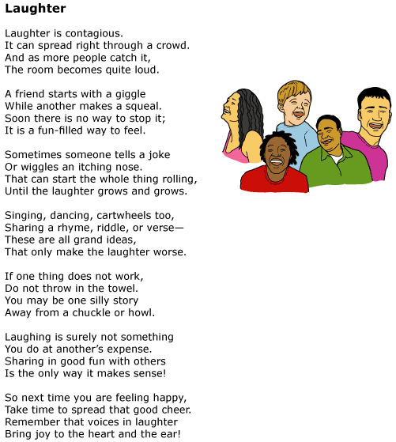

Read this line from the poem.
Laughing is surely not something
You do at another's expense.
In the line from the poem, what does at another's expense mean?
 |  | A. | something that is paid for
 |  | B. | something that is unkind
 |  | C. | something that is expensive
 |  | D. | something that is hurtful

Question 2 of 10

Read these lines from the poem.
If one thing does not work,
Do not throw in the towel.
What does the line 'Do not throw in the towel' mean?
 |  | A. | Do not give up
 |  | B. | Do not be silly
 |  | C. | Do not throw things
 |  | D. | Do not get angry

Question 3 of 10
We are going to the beach for our vacation. I am so ____________! I can hardly wait to jump in the waves!
Choose the best word to complete the sentence.
 |  | A. | good
 |  | B. | well
 |  | C. | excited
 |  | D. | fantastic

Question 4 of 10
Jerry was excited to see Adam. Adam had brought Jerry a cap from his vacation. Adam was being _________________.
Choose the most specific word to complete the sentence.
 |  | A. | thoughtful
 |  | B. | happy
 |  | C. | good
 |  | D. | sad

Question 5 of 10
[Teacher to read the instructions aloud]
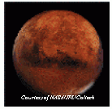
Look at the picture of Mars. Mars is a ______________.
 |  | A. | plant
 |  | B. | paint
 |  | C. | planet
 |  | D. | person

Question 6 of 10
Your teacher is showing you a new book and is telling you the name of the illustrator. What does the illustrator of a book do?
 |  | A. | writes all the words
 |  | B. | checks for mistakes
 |  | C. | publishes the book
 |  | D. | draws the pictures

Question 7 of 10
You are sorting different animals during science. What is a mammal like?
 |  | A. | an animal that has feathers and lays eggs in nests
 |  | B. | an animal that has scales and breathes through gills
 |  | C. | an animal that has hair and feeds its young with milk
 |  | D. | an animal that has hair and feeds its young with eggs

Question 8 of 10
28 - 9 = ____
The boy said, "I need to regroup to solve this subtraction problem."
What does the word regroup mean in this sentence?
 |  | A. | to ask someone for help
 |  | B. | to get a loan from a bank
 |  | C. | to take from the tens place
 |  | D. | to carry over to the tens place

Question 9 of 10
The Circus
I have a lot of fun at the circus because my entire family usually goes together. Before we find our seats, we get lots of snacks. I like to get cotton candy, but my dad gets peanuts. He always saves me some peanuts so that when the elephants are performing, I can imitate them. Going to the circus is one of my family's favorite traditions.
When we walked up to the giant tent, I couldn't stop smiling. We were about to enter a magical place known as the big top. Once the show got started, I patiently waited for the elephants to come out. They are some of the smartest animals. They can be taught lots of tricks like picking up peanuts and sitting on a stool.
According to the passage, what does the word "patiently" mean?
 |  | A. | to act or wait in a calm way
 |  | B. | a person in a hospital
 |  | C. | to be very excited
 |  | D. | to act in an unpleasant manner

Question 10 of 10
"Little Snow White" from Grimm's Fairy Tales
When night fell the masters of the little house came home. They were seven dwarfs, who worked with pickaxe and spade searching for copper and gold in the heart of the mountains. They lit their seven candles and then saw that someone had been to visit them.
When night fell the masters of the little house came home.
What does the word masters mean in this sentence?
 |  | A. | kings
 |  | B. | owners
 |  | C. | dwarfs
 |  | D. | workers

Copyright © Discovery Education Assessment 2012. Proprietary Information. All rights reserved.
Discovery Education Page

