Progress Probe #1660540: 3dr Grade TCAP Coach Chapter 4 Lesson 31, 32, 33,34, and 35 (Grade 03 RE)
Teacher Key with Answers
Ques | Answer | Level | Skill | Subskill | Item #
1 | B | Hard | Literature | SPI 0301.8.4 Plot Features [69079] | D64473
2 | A | Moderate | Literature | SPI 0301.8.4 Plot Features [69079] | U44190
3 | A | Hard | Literature | SPI 0301.8.1 Rhyming Words [69076] | D103911
4 | D | Hard | Literature | SPI 0301.8.1 Rhyming Words [69076] | D2626
5 | A | Hard | Literature | SPI 0301.8.2 Setting, Characters, and Plot [69077] | D97971
6 | B | Hard | Literature | SPI 0301.8.6 Problems and Solutions [69081] | D56448
7 | C | Moderate | Literature | SPI 0301.8.3 Forms of Text [69078] | U44318
8 | C | Moderate | Literature | SPI 0301.8.6 Problems and Solutions [69081] | U52219
9 | A | Moderate | Literature | SPI 0301.8.2 Setting, Characters, and Plot [69077] | U43660
10 | C | Hard | Literature | SPI 0301.8.2 Setting, Characters, and Plot [69077] | D97990
11 | B | Moderate | Literature | SPI 0301.8.4 Plot Features [69079] | U44325
12 | A | Moderate | Literature | SPI 0301.8.3 Forms of Text [69078] | U44147
13 | A | Hard | Literature | SPI 0301.8.4 Plot Features [69079] | D61969
14 | A | Hard | Literature | SPI 0301.8.4 Plot Features [69079] | D60536
15 | B | Moderate | Literature | SPI 0301.8.1 Rhyming Words [69076] | U43687
16 | B | Hard | Literature | SPI 0301.8.3 Forms of Text [69078] | D65328
17 | A | Moderate | Literature | SPI 0301.8.6 Problems and Solutions [69081] | U52669
18 | A | Moderate | Literature | SPI 0301.8.1 Rhyming Words [69076] | U43738

Name: Date:
3dr Grade TCAP Coach Chapter 4 Lesson 31, 32, 33,34, and 35
Question 1 of 18
Which of the following are usually written about magic, fairies, giants, or witches?
 |  | A. | fables
 |  | B. | fairy tales
 |  | C. | folk tales
 |  | D. | myth

Question 2 of 18
Proud Possum
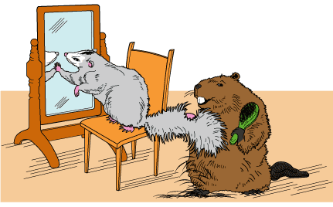
1 Opossums are busy little creatures. They live in the woods, but chances are you may never have seen one. Opossums are gray, with little pink noses and long, pink tails. They come out only at night. During the day, they hide . . . maybe because they don't want anyone to see their tails.
2 Opossums never used to be so shy. A long time ago, in fact, the animal known as Possum was very proud of his tail! You see, in the beginning of time, Possum had a big, furry, bushy tail! Can you imagine that? Yes, it was a beautiful tail!
3 Everywhere he went, he held his tail so everyone could see. He swished it this way and that. All day and night Possum bragged about his tail.
4 The animals in the woods were angry. 'Possum acts so superior because of his tail!' they said.
5 'But what can we do?' they asked.
6 'I have an idea,' said Beaver.
7 The next day, Beaver went to Possum's house. 'I shouldn't say a word,' Beaver began, 'but I thought you should know about the party we planned for tonight. We would hate for you to go out somewhere and miss it.'
8 'Party? What party?' asked Possum.
9 'Why, there's a party tonight! It's a party for you! Everyone will be there to see you and to talk about you. Of course we will talk about your beautiful tail.'
10 'Of course!' said Possum happily.
11 'Now you will want your tail to look its best,' Beaver added. 'So I have come to help you. I will brush your tail and make it look its most beautiful.'
12 'Oh, thank you!' said Possum. He sat back while Beaver set to work, combing and brushing the bushy tail. What Possum didn't notice, however, was that while Beaver was working, he was also snipping off all the hair with his sharp teeth! Beaver's teeth cut like scissors. When he was finished, Beaver wrapped a colorful string all around the tail from one end to the other. Possum could not see that his tail was bare under the wrapping.
13 'The string will keep your tail fur nice and free of tangles until tonight,' said Beaver. 'So don't take it off until the very last minute!'
14 'Thank you, thank you!' said Possum as Beaver left his house.
15 That night all the animals in the woods gathered for the party. Possum pranced up and stood in the light of the moon. He was so excited that all the animals had come to a party just for him! Suddenly he remembered to unwind the colorful string that bound his tail. He turned his backside toward the other animals, pulled off the string and proudly swished his tail this way and that.
16 What he heard next, however, was not expected. The other animals all burst out laughing!
17 'What? How dare you laugh at me?' Possum cried.
18 'Your tail! Your tail!' they all chanted.
19 Possum looked behind him and gasped. Instead of his beautiful, bushy tail, there was nothing but a long, hairless, scrawny, pink tail just like the tail of a giant rat. Possum ran off in disgrace. That is why, today, Possum has a hairless tail. That is also why Possum hides during the day.

Why is Possum so excited about the party?
 |  | A. | Possum thinks everyone wants to see his beautiful tail.
 |  | B. | Possum is giving the party.
 |  | C. | Possum has a colorful string on his tail.
 |  | D. | Possum will get to see all of his animal friends.

Question 3 of 18
Read the poem.
When I see trees bend left and right
I like to think some boy's been swinging.
But swinging doesn't bend them down to stay
As ice-storms do.
You must have seen them
Loaded with ice on a sunny winter morning.
What might be a good next line for this poem?
 |  | A. | And wondered what the trees were thinking.
 |  | B. | And went back to bed.
 |  | C. | And fed the cat some food.
 |  | D. | And played video games with trees.

Question 4 of 18
Choose the pair of words that rhymes.
 |  | A. | pool, dull
 |  | B. | scare, fear
 |  | C. | tall, short
 |  | D. | sleigh, day

Question 5 of 18
Baseball Game
Antonio jumped out of bed with a smile on his face. Today, he will be the starting pitcher for his baseball team. If his team wins today's game, they will move on to the finals. Antonio is excited. He has pitched a million games, and he's been playing baseball since he was a little boy. As he put on his uniform, he thought about the game and how important it is. The rest of the team believes that Antonio will pitch well. Antonio doesn't want to let them down. He knows he has the skill to help his team win the game.
Lauren's Song
Lauren likes to play the piano. Her music teacher at school thinks Lauren plays very well. One day, her teacher said, "Lauren, I'd like for you to play a song in the school program next month." Lauren froze. She had never played in front of such a large group of people. She had only ever played for her family and friends. Lauren went home and practiced the song for two hours. She kept practicing the song every day until she could play it in her sleep. When the day of the program arrived, Lauren was surprised that she did not feel very nervous. She played her song and everyone clapped loudly. She smiled and walked to the front of the stage to take a bow. She was glad her teacher had asked her to play in the program.
Which sentence about Antonio and Lauren is true?
 |  | A. | Lauren was scared at first, but Antonio was excited.
 |  | B. | Antonio has not played baseball for very long, but Lauren has played piano for a long time.
 |  | C. | Lauren likes to perform in front of large groups, but Antonio is nervous about his game.
 |  | D. | Lauren is prepared, but Antonio has not practiced.

Question 6 of 18
Meg's New Game
Meg is in third grade and loves to play video games. She and her friend Blake play for thirty minutes every day. Last month Meg went to the store and saw Super Hero Plus, the best new game on the market. It has new characters and cool graphics. The game costs $49.00. She asked her mother to buy it for her, but her mother said, "No."
"If you really want the game, you will have to earn the money to buy it," her mother said. "I will pay you one dollar for each extra chore that you do at home. You can help with the laundry and work in the yard for the money you need."
Meg has been working hard for the past month. So far she has earned $37.00. Soon she will have earned enough money to buy the game. "When you buy it," her mom said, "I will treat you and Blake to a pizza party. That will be a nice reward for your hard work."
"I can't wait!" said Meg. She gave her mom a hug and went outside to pull the weeds from the garden.
How does Meg decide to get her new video game?
 |  | A. | She delivers newspapers.
 |  | B. | She does extra chores at home.
 |  | C. | She asks Blake to buy it.
 |  | D. | She sells pizza to pay for it.

Question 7 of 18
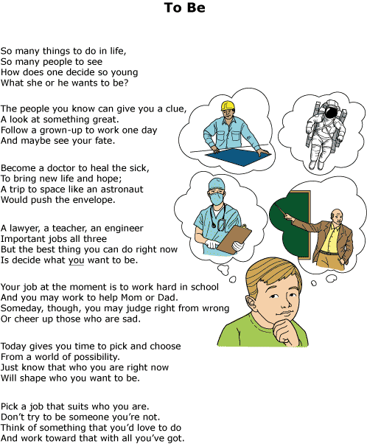

How can you tell this is a poem?
 |  | A. | It has complete sentences.
 |  | B. | The ideas in it are make-believe.
 |  | C. | It has words that rhyme.
 |  | D. | The focus is on things in the future.

Question 8 of 18
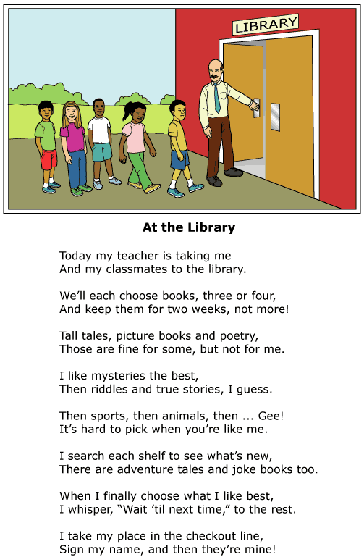

Which sentence best explains the problem of the child in 'At the Library'?
 |  | A. | It is important for children to visit a library with their class.
 |  | B. | Libraries let students keep books for only two weeks.
 |  | C. | It is difficult to pick something when a person likes most of the choices.
 |  | D. | Different people like different kinds of books and writers.

Question 9 of 18
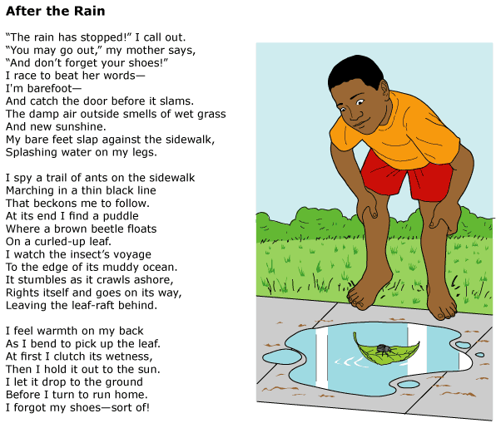

Which of the following lines from the poem best tells the reader that this poem probably takes place in the summer?
 |  | A. | My bare feet slap against the sidewalk,
 |  | B. | At its end I find a puddle
 |  | C. | At first I clutch its wetness,
 |  | D. | Then I hold it out to the sun.

Question 10 of 18
The Walrus and the Carpenter (excerpt)
Lewis Carroll
The sun was shining on the sea,
Shining with all his might:
He did his very best to make
The billows smooth and bright -
And this was odd, because it was
The middle of the night.
The moon was shining sulkily,
Because she thought the sun
Had got no business to be there
After the day was done -
"It's very rude of him," she said,
"To come and spoil the fun."
The sea was wet as wet could be,
The sands were dry as dry.
You could not see a cloud, because
No cloud was in the sky:
No birds were flying overhead -
There were no birds to fly.
The Walrus and the Carpenter
Were walking close at hand;
They wept like anything to see
Such quantities of sand:
Two Sunflowers Move in the Yellow Room
William Blake
"Ah, William, we're weary of weather,"
said the sunflowers, shining with dew.
"Our traveling habits have tired us.
Can you give us a room with a view?"
They arranged themselves at the window
and counted the steps of the sun,
and they both took root in the carpet
where the topaz tortoises run.
How are the settings of the two poems different?
 |  | A. | "Two Sunflowers" takes place in the winter.
 |  | B. | "The Walrus and the Carpenter" takes place inside.
 |  | C. | "The Walrus and the Carpenter" takes place at night.
 |  | D. | "Two Sunflowers" takes place in the rain.

Question 11 of 18
The Ruler of the Swamp
(A Tale from Canada)
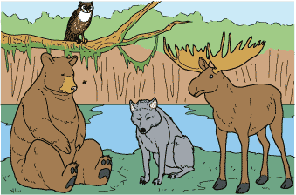
1 The animals could not decide who would rule the northern swamp. Bear thought that he should rule because he was the fiercest. Moose thought that he should rule because his horns made a mighty crown. Wolf thought that she should rule because she was the cleverest.
2 They went to see old Owl, who did as he wished and gave not a hoot for rulers. 'I suggest that you have a race,' Owl said. 'Mark out a course to please yourselves. Then, whoever crosses the finish line first shall be declared the ruler of the swamp.'
3 They immediately began a new quarrel. Bear insisted on a short, straight run. Moose wanted a longer gallop. Wolf argued for a crooked course, thinking that she could use her wits. However, eventually they all came to an agreement, and the big day came.
4 Moose tossed his enormous horns at Wolf. Wolf then bared her teeth and snarled. Bear stood on his hind legs and sniffed the air with pride. 'I am the fiercest and the strongest,' Bear boasted. 'I know I shall win the race. If I do not, then whoever imagines that he rules the swamp had better fear me.' No one saw tiny Mother Mosquito land quietly on the tip of Bear's soft nose.
5 While the weaker animals watched, the great race began. At first, Bear dashed ahead, but Moose gradually took over the lead. Wolf used her cunning, staying close behind Moose and watching for her chance. Finally, she grabbed Moose's leg, causing him to stumble. However, Wolf lost her balance and went down as well. Now Bear leaped easily past them both and, using all his strength, crashed through the bog and across the finish line.
6 'I win!' Bear roared as he pranced about on two legs. 'I am the ruler of the swamp! Everyone must do everything I say.'
7 'Not so fast,' said Owl, who was there to judge the race. 'Who's that sitting on your nose? Is it Mother Mosquito?'
8 'What do I care for Mother Mosquito?' cried Bear angrily. 'I am the champion runner and ruler of the swamp!'
9 'Mother Mosquito,' said Owl, 'how long have you been sitting on Bear's nose?'
10 'I landed here when he stood and sniffed the air before the race,' she replied timidly. 'The bear was bragging that he would win. I thought perhaps he wouldn't notice me.'
11 'It's true that he didn't notice you,' Owl said. 'Now everyone will wish he had noticed you and brushed you away, but it's too late. Mother Mosquito, I declare you the winner of the race. You started with the others, and you crossed the finish line first. I pronounce you ruler of the swamp. And Bear, because he didn't notice you, shall be the one responsible.'
12 To this day, in the summertime at least, Mother Mosquito rules the swamp. And if you happen to meet with Bear, you'd better not stop to talk.

What causes Moose to lose the race?
 |  | A. | Bear and Wolf run faster than Moose.
 |  | B. | Wolf makes Moose fall down.
 |  | C. | Moose's horns get caught in the brush as he runs.
 |  | D. | The race is run on a short course, and Moose wanted to run a longer race.

Question 12 of 18
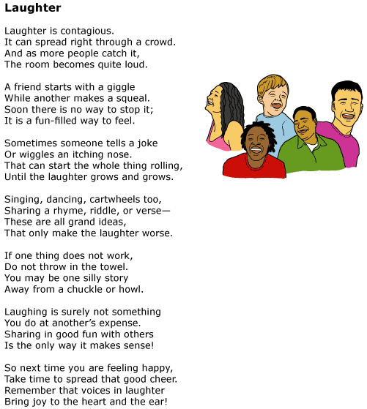

How can you tell this is a poem?
 |  | A. | Many of the words rhyme.
 |  | B. | It teaches us to laugh more.
 |  | C. | The words are arranged in paragraphs.
 |  | D. | The title is only one word.

Question 13 of 18
Which answer is not a characteristic of a fairy tale?
 |  | A. | There is a written moral at the end of the story.
 |  | B. | The story often begins with "Once upon a time."
 |  | C. | Magic is a part of the story.
 |  | D. | Characters include kings, queens, princes or princesses.

Question 14 of 18
You have just read a short story in which some talking animals learned a lesson about being greedy. At the end of the story, the author wrote a sentence which explained the moral of the story to the reader. Which type of writing did you just read?
 |  | A. | fable
 |  | B. | fairy tale
 |  | C. | folk tale
 |  | D. | myth

Question 15 of 18
The First Walk on the Moon
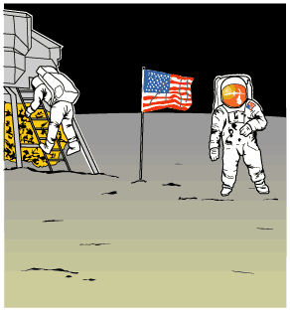
1 It was the night of July 20, 1969. All across America, people were doing the same thing. They were gathered in front of their television sets. They were waiting to witness an unforgettable moment in history. This was the night that, for the first time, a human being would set foot on the moon. It was a goal scientists had worked for many years to accomplish.
2 Greg Mitchell was amazed by space. Grandpa called him the family space expert. Astronauts Neil Armstrong and Buzz Aldrin were going to walk on the moon tonight, and Greg couldn't wait. It was all he had thought about ever since Apollo 11 launched into space.
3 He was sitting in the family room with his mom, sister, brother, and grandpa. The newscaster announced that the moonwalk had been moved up several hours. The Mitchell family cheered. It wouldn't be long now.
4 There was just one problem. Greg's beloved dog, Bessie, who meant so much to him, was about to have puppies. Greg's dad came in from the barn. 'Greg,' Dad said, 'I know how much you want to see that moonwalk. But Bessie's your dog, and she's about to have those pups.'
5 'Aw, Dad,' Greg protested, 'I can't miss this!'
6 'Now, Greg,' Dad said, 'You know that you're responsible for Bessie. Not only that, she needs you. Put on your shoes, and I'll meet you out there.'
7 Deep down, Greg knew his dad was right. Bessie was his dog, and he loved her a lot. She would feel better having Greg there. He glanced up at the moon as he hurried out to the barn. 'Please, Mr. Armstrong and Mr. Aldrin,' he wished, 'please wait until the puppies are born. Don't start without me.'
8 He sat next to Bessie on the blanket. She liked having her head petted. Soon, Bessie had four healthy puppies. They were so cute. Greg was glad he hadn't missed it.
9 'Son,' his dad offered, 'you go see how those astronauts are doing. I'll finish up here.'
10 Greg got back in time to see Neil Armstrong climb slowly down the ladder of the spaceship. He held his breath in amazement as Armstrong announced with wonder, 'That's one small step for man, one giant leap for mankind.' Buzz Aldrin joined Armstrong a few minutes later. The two men placed an American flag on the moon's surface.
11 It was a night Greg would never forget. Not only had he witnessed history in the making, but also there were four new additions to the family. He had no trouble figuring out what to name the puppies. Neil, Buzz, Armstrong, and Aldrin had not only very special names but a very special birthday too.

Which statement best explains why 'The First Walk on the Moon' is historical fiction?
 |  | A. | It explains how to walk on the moon.
 |  | B. | It is based on an event that actually happened.
 |  | C. | It has characters who act and speak like real people.
 |  | D. | It tells a story that is meant for young readers.

Question 16 of 18
This text is an example of which of the following answers.
When Molly's mother arrived home she saw that Molly was crying. She asked, "What's wrong?" Molly replied that she couldn't find her teddy bear. Molly's mother suggested that she retrace her steps. Molly went back to each place she had been that day. She looked under the oak tree outside. She looked in the kitchen. She also looked under the couch. Molly was so upset she ran to her room. There sat her teddy bear right where she had left it.
 |  | A. | poem
 |  | B. | story
 |  | C. | play
 |  | D. | song

Question 17 of 18
A Name for the Baby
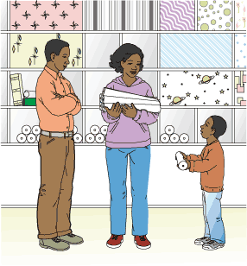
1 It was Friday night when Ernie's parents told him the good news.
2 'Ernie, we are finally adding a baby to our family,' Dad said. 'Mom and I told you that someday we hoped you would have a brother or a sister. Well, we just found out that a new baby is coming to live with us. We have a lot to do to get ready,' he said, smiling.
3 Mom added, 'Yes, we have a lot to do. We will have to pick a name for the baby. We also must fix up the spare bedroom. It is now going to be the baby's room.'
4 Ernie woke up early on Saturday morning. He lay in bed and gave a lot of thought to the baby's name. Finally, he decided on Dave. Dave was his favorite character on television. Baby Dave could be his buddy. They would have adventures together.
5 He ran downstairs. Mom and Dad were in the kitchen making breakfast. They smiled when Ernie told them his idea.
6 Mom said, 'Dave is a good name, Ernie, but it is a boy's name. The baby that is coming to live with us is a girl. We need to think of a girl's name.'
7 Dad agreed. 'We will give it some more thought,' he said. 'I am sure we can think of a nice name.'
8 'The baby is a girl?' Ernie asked. He hoped maybe he had not heard Mom correctly. His parents sensed his sadness. They asked him to sit down. They explained how nice it would be for him to have a little sister. The more they talked, the better Ernie felt. He understood that being a big brother was a special job. He was especially proud when they asked him to help pick out some special wallpaper to fix up the baby's room.
9 That afternoon, the family visited the store. Ernie looked at all the many wallpaper samples on display. He discovered a pattern that he thought would be perfect. The background was a dark blue. Planets were printed on the paper. Ernie identified Mars, the 'red planet,' by its color. He also recognized the planet Saturn by the rings that circled it. Silver spaceships flew among the planets.
10 Ernie proudly showed the pattern to his parents. 'Look!' he cried. 'This one is just right for the baby's room.'
11 Mom and Dad glanced at each other. It was clear to Ernie that his parents were not excited about what he had chosen. He looked at the floor.
12 Ernie's mother crouched down and put her arm around his shoulders. She put her hand under his chin and lifted his head.
13 'Ernie,' she said. 'It is beautiful wallpaper, but it is very dark. We want to make the walls very bright.'
14 Ernie's father bent over and spoke softly. 'If you would like, the next time we need to fix up your room, we will redecorate using this paper. What do you think of this wall pattern for the baby's room?'
15 Ernie's parents showed him bright yellow wallpaper. Printed on the cheerful yellow color was a picture of a backyard. Green grass and trees grew in the yard. A white fence surrounded it. Red roses grew on bushes near the fence. A boy about his age was looking at the roses. On the grass beside him was a baby carriage. In the carriage, a small child slept peacefully.
16 'It is nice,' Ernie whispered. He did like the paper. He only wished his parents would let him help by accepting one of his ideas.
17 On the way home, Ernie thought about the yellow wallpaper for the baby's room. It gave him another idea.
18 'Rose is a pretty name for a girl,' he said.
19 Ernie's parents looked at each other and nodded.
20 'Rose is a beautiful name,' Mom said.
21 'Your sister, Rose, will love her name,' Dad added.
22 In the back seat, Ernie smiled. He was happy.

What is Ernie's main problem in the story?
 |  | A. | Ernie wishes his parents would use one of his ideas to help get ready for the baby.
 |  | B. | Ernie's family will be getting a baby girl instead of a boy.
 |  | C. | Ernie's favorite television character has a boy's name.
 |  | D. | Ernie's parents must tell him that a new baby is soon going to join their family.

Question 18 of 18
Shirley Chisholm
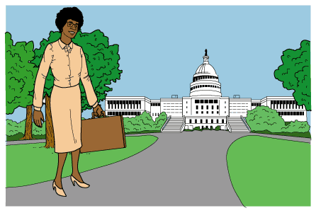
Political Pioneer
1 Shirley Chisholm was a woman who broke down barriers. She once said that she was and always would be someone who brought about change. And change things she did! She became the first African-American woman ever elected to Congress and the first to run for the office of President of the United States.
Her Early Years
2 Chisholm was born Shirley Anita St. Hill in November of 1924, in Brooklyn, New York. When she was three years old, Chisholm was sent to live with her grandmother on the Caribbean island of Barbados. Chisholm later said that it was her grandmother who had the greatest influence on her life. At the age of ten, Chisholm rejoined her parents in New York where she continued her education and did well in her studies.
3 After graduating from high school, Chisholm attended Brooklyn College. There she became involved in the debate society and other campus activities. When Chisholm learned that African-American students at the college were not allowed to join a social club, she refused to sit back and accept it. She started her own club. Many of her classmates and teachers recognized her talent for public speaking and organizing. They encouraged Chisholm to follow a career in politics.
4 Following graduation from college, Chisholm worked as a nursery school teacher. Over the years she became an expert on early education and child care. She also met and married Conrad Chisholm. Both she and her husband were active in their community and lent their support to local political groups.
A Career in Politics
5 Shirley Chisholm's own political career began when she decided to run for a state office. She won the election and a seat in the New York Assembly. During her years of service in the assembly, she helped to sponsor more than 50 proposed laws, known as bills. One of those bills that was passed into law provided money to help poor students attend college.
6 Next, Chisholm set her sights on becoming a member of the U.S. House of Representatives. Winning a seat in the House was something no African-American woman had done before. Chisholm worked hard to prove that she was the right person for the job. She became known as 'Fighting Shirley Chisholm.' She won the election! From 1969 to 1982, Congresswoman Chisholm supported programs to improve education and the lives of working people.
Candidate for President
7 In 1972, Chisholm challenged another barrier. She made a bid for the office of President of the United States. Only a few women had ever run for the presidency, and none had been African-American. Chisholm refused to back away from the challenge. While she did not expect to be nominated, she hoped to be a voice for the people she felt were ignored by the other candidates. Chisholm received more than 150 delegate votes, but not enough to win the nomination. She did, however, continue to speak for others by serving another ten years as a member of the House of Representatives. She was also voted one of the ten most admired women in the world.
Life After Congress
8 After her retirement from Congress, Chisholm taught at Mount Holyoke College. She also supported various political activities and campaigns. In 1993, President Bill Clinton nominated Chisholm for the position of Ambassador to Jamaica. Chisholm declined the job because of her poor health. She died on January 1, 2005, at the age of 80.
9 Chisholm is still admired by many people for both her courage and her achievements. She was unwilling to stand on the sidelines and complain. Instead, Shirley Chisholm found opportunities to take action and bring about change.

How would the author most likely rewrite 'Shirley Chisholm' to make the passage historical fiction?
 |  | A. | By including imaginary characters within the true events of Shirley Chisholm's life
 |  | B. | By rewriting the passage to include historical details about Shirley Chisholm
 |  | C. | By removing the headings used to identify the periods in Shirley Chisholm's life
 |  | D. | By adding important facts about Shirley Chisholm's career as a nursery school teacher

