Progress Probe #1660524: 3rd Grade TCAP Coach Chapter 3 Lesson 29 and 30 (Grade 03 RE)
Teacher Key with Answers
Ques | Answer | Level | Skill | Subskill | Item #
1 | B | Hard | Logic | SPI 0301.5.4 Sequence of Events [69064] | D1969
2 | D | Moderate | Writing & Research | SPI 0301.3.6 Coherent Paragraphs [68641] | D86261
3 | D | Moderate | Informational Text | SPI 0301.6.7 Sequential Order [69071] | U45074
4 | B | Hard | Informational Text | SPI 0301.6.7 Sequential Order [69071] | D3267
5 | C | Moderate | Writing & Research | SPI 0301.3.9 Graphic Organizer [68644] | U43698
6 | B | Moderate | Informational Text | SPI 0301.6.7 Sequential Order [69071] | U52356
7 | D | Moderate | Writing & Research | SPI 0301.3.6 Coherent Paragraphs [68641] | D2765
8 | D | Hard | Writing & Research | SPI 0301.3.9 Graphic Organizer [68644] | D52853
9 | C | Moderate | Logic | SPI 0301.5.3 Cause-Effect Relationships [69063] | U53280
10 | A | Hard | Writing & Research | SPI 0301.3.9 Graphic Organizer [68644] | D53479
11 | C | Hard | Writing & Research | SPI 0301.3.6 Coherent Paragraphs [68641] | D68512
12 | B | Hard | Logic | SPI 0301.5.4 Sequence of Events [69064] | D908
13 | B | Hard | Logic | SPI 0301.5.3 Cause-Effect Relationships [69063] | D59119
14 | C | Moderate | Logic | SPI 0301.5.3 Cause-Effect Relationships [69063] | U53145
15 | A | Hard | Writing & Research | SPI 0301.3.6 Coherent Paragraphs [68641] | D52063

Name: Date:
3rd Grade TCAP Coach Chapter 3 Lesson 29 and 30
Question 1 of 15
1. When the cake was done, Mom carefully placed thirty candles on top.
2. As soon as Dad left for work, Mom started baking.
3. When I saw Dad turning into the driveway, I shouted, "Quick! Everyone hide!"
4. While the cake was cooking, she wrapped the gifts in bright paper with curly ribbons on top.
The sentences of the story above are out of order. Using the numbers, put the sentences in order.
 |  | A. | 1, 2, 3, 4
 |  | B. | 2, 4, 1, 3
 |  | C. | 2, 1, 4, 3
 |  | D. | 2, 3, 4, 1

Question 2 of 15
Roberto went to the grocery store with his dad. "I know that lemons will be perfect to make a great drink," said Roberto. Roberto rushed to the produce department to pick out lemons. Dad said, _____________________________
What should Dad say to best complete this story?
 |  | A. | "I hear a truck coming."
 |  | B. | "Now it will be easy to make dinner."
 |  | C. | "It is hard to make applesauce from apples."
 |  | D. | "Great, we can make fresh lemonade!"

Question 3 of 15
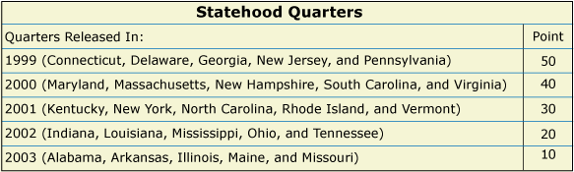

State Quarters Game
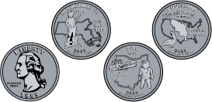
The most common quarters before 1999 had a picture of President George Washington on one side and a picture of an American eagle on the other side. In 1999, the United States Mint stopped making these 'old' quarters. That is when it began making quarters to honor each of the 50 states in America.
Each new coin has a special design on the back showing the history, customs, or symbols of a state. The design for each state's quarter is chosen from designs drawn by ordinary citizens. The quarters are being made in the same order that the states became part of the United States. A new quarter will be presented about every 10 weeks until the year 2008. When the program ends, the United States Mint will begin making the 'old' quarters again.
There are two mints in the United States that make these special coins. One is located in Denver, Colorado, and the other in Philadelphia, Pennsylvania. A small mark on each quarter shows whether the coin was made at the Denver or the Philadelphia mint. You can look for a D or P on the front of the next quarter you get.
About the game
Playing with money is a great way to increase math skills. Here is a game that you and a friend can play using old and new quarters. Take along a bag of quarters on your next trip. This is a fun game you can play anywhere.
You will need:
- 5 old quarters with an eagle on one side
- 5 new quarters, each from a different state
- A small paper bag
- A pencil and paper
Directions:
Flip an old quarter to decide who will start the game. As the coin is flipped in the air, one player calls out 'heads' or 'tails' before the coin lands. The picture of George Washington is considered 'heads' and the picture of the eagle is considered 'tails.' If the side that is called out faces up, the caller gets to go first. If the side that is called out lands face down, the other player goes first.
- Put all the quarters in the bag. Shake the bag to mix the coins.
- Without looking, the first player chooses 5 quarters. The other player gets the remaining 5 quarters.
- Turn the coins over so that the state sides are facing up. Finish the round by using the following chart to add up your points.
- Now flip an old quarter again to decide who will begin the next round of the quarters game.
- Put the coins back in the bag. Shake the bag again.
- Each player chooses another 5 quarters. Use the chart to add up your points after each round.
Play 3 rounds of this game to determine the winner.

Why does the author include the first three paragraphs?
 |  | A. | To explain how quarters will be made in the future
 |  | B. | To tell an amusing story about quarters
 |  | C. | To encourage readers to learn where quarters are made
 |  | D. | To describe the history of quarters

Question 4 of 15
Here are the instructions Angela's mom gave her for bathing the dog.
First, get the shampoo and a towel. Fill the tub with warm water. Next, place the dog in the water. Then, rinse him clean. Finally, remove the dog from the tub and dry him off. Oh, don't forget to clean up the mess.
What did Angela's mom leave out of her instructions?
 |  | A. | Buy the shampoo.
 |  | B. | Shampoo the dog.
 |  | C. | Clean up the mess.
 |  | D. | Brush his teeth.

Question 5 of 15
The Corn Palace
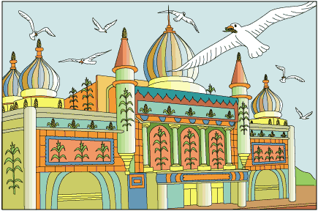
1 Have you ever seen a picture of a palace or a castle? Some old palaces are amazing. With their high towers and beautiful designs, they can take your breath away. Visitors just want to sit and stare at them.
2 One palace in the United States really makes people stop and stare. It is not a usual palace of stone. No palace in the world is like this one. The outside is completely covered with corn. This vegetable-covered building is known as 'The Corn Palace.'
The Corn Capital of the World
3 The Corn Palace can be found in the town of Mitchell, South Dakota. Mitchell is a small prairie town. The farmers there grow wheat, rye, and sorghum crops. Their biggest crop, though, is corn.
4 People who live in Mitchell are very proud of their corn crops. To prove it, they use corn to make a large building that looks just like a palace.
The Original Corn Palace
5 The first corn palace was built in 1892. Early settlers put fruits from their harvests on the outside of a building.
6 The palace that exists today was built in 1921. In that year, people in the town wanted to celebrate their great harvest. They built the new palace as a tribute to the richness of the soil. It was decorated with corn, grain, and other grasses. It showed the outside world that the people from the town took pride in their crops.
Corn Palace Week
7 Every year since 1921, the town has celebrated the end of the harvest season with an event called Corn Palace Week. The Corn Palace is a highlight of Corn Palace Week. Each year it is newly decorated. The old decorations are taken down in the spring. Then, local artists from the town begin to decorate for the new season.
8 The artists create large murals on the outside of the palace. Their pictures are made with corn and grains. They use more than 3000 bushels of corn and 40 tons of other grains and grasses. The designs tell a story about the town and its history. Eleven different shades of corn are used in the designs.
9 By the end of the summer, the palace looks like new again. The artists have it ready for show just in time for the next harvest season.
The Corn Palace Today
10 Today the palace is used for many different events. It has a big room called an auditorium. There is a large stage and plenty of seats where people can watch shows. Many famous singers perform at the palace.
11 In addition, the palace has a large indoor space for sports. The local high school's teams play many of their games on the courts inside the palace.
An Unusual Place
12 The Corn Palace is quite an attraction. People from all over the country come to see the palace that is made of corn.
13 Animals like the palace, too. During the winter, pigeons and squirrels enjoy the tasty corn that covers the outside. In fact, the palace is also known as the 'World's Largest Birdfeeder.'

Look at this diagram of information from the passage.
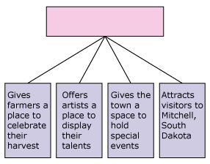
Which of these belongs in the empty box?
 |  | A. | History of the Corn Palace
 |  | B. | Things to Do in the Corn Capital
 |  | C. | Purposes for the Corn Palace
 |  | D. | Life in the Corn Capital

Question 6 of 15
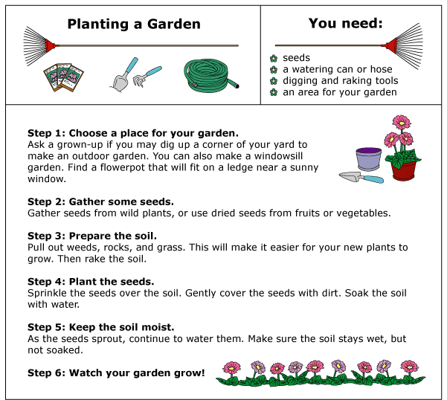

What will probably happen as a result of not properly preparing the soil?
 |  | A. | The rocks will hurt your feet when you stand on them.
 |  | B. | The weeds and rocks will stop the seeds from growing.
 |  | C. | The seeds from wild plants will take over the garden.
 |  | D. | The plants will still need to have water.

Question 7 of 15
1. Billy skated very well, but I kept falling down.
2. Billy and I went skating.
3. I hope we can go skating again tomorrow.
4. After about two hours we were both ready to leave.
Choose the correct order of the sentences to make a paragraph.
 |  | A. | 2, 3, 1, 4
 |  | B. | 1, 2, 3, 4
 |  | C. | 3, 1, 4, 2
 |  | D. | 2, 1, 4, 3

Question 8 of 15
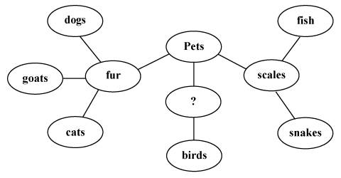
Which answer belongs in the empty circle?
 |  | A. | flying
 |  | B. | water
 |  | C. | clouds
 |  | D. | feathers

Question 9 of 15
The Sleeper
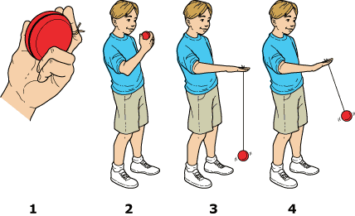
Step 1:
Hold the yo-yo in the palm of your hand. Be sure the string is wound tight and your palm is facing up.
Step 2:
Bend your elbow. Stop when your hand is near your shoulder.
Step 3:
Bring your arm down. Stop when it is pointing straight ahead. Let go of the yo-yo. Quickly, turn your hand so that the palm is facing down. The yo-yo should drop to the bottom of the string and spin. Now it is 'sleeping'!
Step 4:
Pull up on the string. The yo-yo should climb back up the string to your hand.

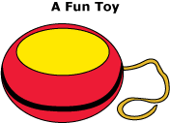
1 I think everyone should have a yo-yo. A yo-yo is the best kind of toy there is. It is made of two round pieces of wood that look like wheels. They are attached to the end of a long string. The wheels go down the string. Then the string rewinds between the wheels as they come up.
2 I can tell you many great reasons to get a yo-yo. A yo-yo does not cost a lot of money to buy. It is small enough to fit into your pocket. You can take it with you wherever you go.
3 You can play with your yo-yo at any time. You need a friend when you want to play checkers. It is impossible to play soccer without a whole team. But you don't need a friend to play with your yo-yo. A yo-yo is fun to play with on a rainy Saturday. It is the perfect toy when you are alone in your room.
4 People all over the world like to play with yo-yos. There are even contests for good yo-yo players. Yo-yo players get together to show each other the tricks they can do. They show each other their best yo-yos and what they can do with them. Some people have yo-yos that light up when they spin. Others have yo-yos with pictures on them or yo-yos that play music. Some yo-yos glow in the dark.
5 You will love how easy it is to play with a yo-yo. You can do many tricks with it. One trick is called 'The Sleeper.' It is the first yo-yo trick that many people learn.
6 The pictures show you how to do the trick. Look at the pictures and read the directions. Then practice the trick until you can do it well.

What would happen to the yo-yo if you skipped Step 4 while doing 'The Sleeper'?
 |  | A. | It would go down the string.
 |  | B. | It would go up the string.
 |  | C. | It would soon stop spinning.
 |  | D. | It would spin more quickly.

Question 10 of 15
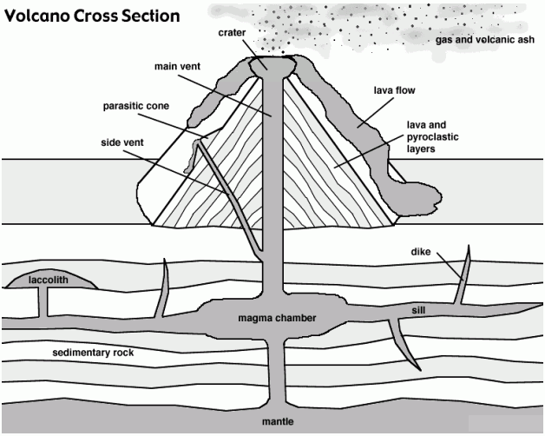
Which statement would not be in a paragraph giving the information about the illustration?
 |  | A. | Magma flows down the side of a volcano.
 |  | B. | Gas and ashes escape through the opening of a volcano.
 |  | C. | Magma flows up the main vent inside the volcano.
 |  | D. | The opening of a volcano is called a crater.

Question 11 of 15
When Michael Jordan was in middle school, he wasn't good enough to make the basketball team. He could have given up, but he tried even harder. His father helped him learn the game, and he practiced every day. He made the team the next time he tried out. He went on to become one of the greatest basketball players in the history of the game.
The author organized this passage with the main idea at the end to show that Michael Jordan _______________________.
 |  | A. | liked to win too much
 |  | B. | liked basketball
 |  | C. | wasn't always the best
 |  | D. | almost gave up

Question 12 of 15
Tommy's Change
Tommy the tadpole lived with his brothers and sisters in Mr. Pool's pond. He enjoyed playing and swimming all day. One day he noticed that his tail was getting longer. "This is nothing to worry about," he thought. He swished his tail and kept having fun.
It wasn't very long before he saw that his brothers and sisters grew little legs. "I wonder if that is happening to me?" he whispered. Sure enough, when he saw his reflection in the water below, he had little legs. He decided not to worry and swished his short tail. He began looking for food among the plants.
A few days went by, and Tommy found it hard to breathe in the water. He had the urge to move up onto land. He saw that his brothers and sisters had the same idea. They hopped onto the land and began croaking.
What happened to Tommy next after his tail grew longer?
 |  | A. | He went up onto land.
 |  | B. | He grew little legs.
 |  | C. | He found it hard to breathe.
 |  | D. | He did not like it.

Question 13 of 15
Matthew had a job in his family. He was supposed to take care of the poodle. Every day Matthew took the poodle for a walk. Three times a week he brushed the poodle. One day a week he bathed the poodle. On Saturday, Matthew and the poodle played and played in the yard. When they were worn out, they took a nap together
Why does Matthew take a nap on Saturday?
 |  | A. | His mother makes him take a nap.
 |  | B. | He gets tired playing in the yard.
 |  | C. | The poodle will not sleep if Matthew is not there.
 |  | D. | He takes a nap to hide from the poodle.

Question 14 of 15
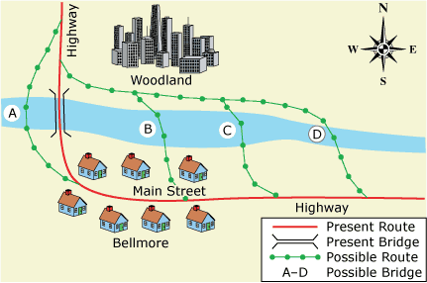

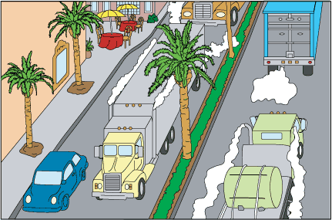
Dear Governor,
1 I live in a lovely little town called Bellmore. It is just a few miles from the city of Woodland. It used to be a nice place to live because it was quiet. Now there is a problem—trucks! A few years ago, trucks began driving through Bellmore. At first, only two trucks passed through the town each day. Then it was three, four, and five trucks. Now, at least twelve trucks pass through Bellmore every day.
2 These big trucks do not stop here. The supplies they carry are not for the people in my little town. They are for the people in Woodland, the city just across the river. To get to Woodland, the trucks must travel through Bellmore to reach the bridge.
3 These trucks make our town very noisy. The roar of their engines drowns out the programs on our TVs and radios. If two friends happen to be talking when a truck comes by, they can't hear one another. They have to stop talking until the truck is gone. Speaking to someone on the telephone is almost impossible when a noisy truck rolls by. Imagine trying to make an emergency phone call and not being able to complete it because of the noise. It is even difficult for the people of Bellmore to get their rest. These large trucks rumble past our homes at all hours of the day and night.
4 The big trucks also cause safety problems for our town. They rush through our streets at high speeds even though the speed limit is clearly posted. Trucks put people trying to cross Main Street in danger. Business owners complain that their businesses are being hurt. Fewer customers are shopping in their stores. People are worried about the truck traffic on Main Street. The trucks also make the air dirty, and that is not healthy. Our air is no longer pleasant to breathe.
5 The people in our town have had to bear these problems long enough. It is time for trucks to get to Woodland without passing through our town. Something must be done, and the time to do it is now.
6 The answer to our problems is simple. The state should build another bridge over the river. There are several places where the new bridge could be built. The best place is about ten miles outside of Bellmore. The river is very narrow there. It would not take long for a small bridge to be built. This would also give trucks a quicker way to reach Woodland.
7 Everyone would be happy with the new bridge. There will be no more noise from the trucks. The people in our town will be safe when they walk across Main Street. The trucks will get to Woodland much faster. One small bridge can make our town a better place to live.
Yours sincerely,
Camilla Smith

In the letter, where does Camilla explain the cause of Bellmore's problems?
 |  | A. | The greeting
 |  | B. | The closing
 |  | C. | The first paragraph
 |  | D. | The last paragraph

Question 15 of 15
Combine the sentences using the word and with the correct punctuation.
We like apples. We eat them at snack time.
 |  | A. | We like apples, and we eat them at snack time.
 |  | B. | We like apples and we, eat them at snack time.
 |  | C. | We like apples and We eat them at snack time.
 |  | D. | We like apples and we eat them, at snack time.

Copyright © Discovery Education Assessment 2012. Proprietary Information. All rights reserved.
Discovery Education Page

