Progress Probe #1660494: 3rd Grade TCAP Coach Chapter 3 Lesson 23, 24 and 25 (Grade 03 RE)
Teacher Key with Answers
Ques | Answer | Level | Skill | Subskill | Item #
1 | D | Moderate | Communications & Media | SPI 0301.7.4 Effective Mediums [100056] | D108314
2 | D | Moderate | Writing & Research | SPI 0301.4.3 Appropriate Sources [100059] | U52508
3 | C | Moderate | Communications & Media | SPI 0301.7.1 Main Idea [100053] | D112415
4 | A | Hard | Communications & Media | SPI 0301.7.2 Appropriate Medium or Media [100054] | D108286
5 | B | Hard | Writing & Research | SPI 0301.4.4 Reference Sources [100060] | D2664
6 | A | Moderate | Communications & Media | SPI 0301.7.1 Main Idea [100053] | D112416
7 | D | Hard | Communications & Media | SPI 0301.7.1 Main Idea [100053] | D112424
8 | D | Moderate | Communications & Media | SPI 0301.7.3 Specific Mediums [100055] | D112457
9 | C | Moderate | Writing & Research | SPI 0301.4.3 Appropriate Sources [100059] | U52065
10 | B | Hard | Communications & Media | SPI 0301.7.3 Specific Mediums [100055] | D108321
11 | D | Hard | Writing & Research | SPI 0301.4.3 Appropriate Sources [100059] | D101505
12 | D | Moderate | Communications & Media | SPI 0301.7.2 Appropriate Medium or Media [100054] | D63748
13 | D | Moderate | Communications & Media | SPI 0301.7.4 Effective Mediums [100056] | D108315
14 | A | Hard | Communications & Media | SPI 0301.7.2 Appropriate Medium or Media [100054] | D54433
15 | D | Moderate | Communications & Media | SPI 0301.7.3 Specific Mediums [100055] | D112462
16 | B | Hard | Communications & Media | SPI 0301.7.1 Main Idea [100053] | D112420
17 | C | Moderate | Writing & Research | SPI 0301.4.4 Reference Sources [100060] | D54621
18 | A | Hard | Writing & Research | SPI 0301.4.4 Reference Sources [100060] | D53995

Name: Date:
3rd Grade TCAP Coach Chapter 3 Lesson 23, 24 and 25
Question 1 of 18
Ken likes to play baseball and wants to form a baseball team at his school. He is going to do a presentation to the entire school. What would help him with his presentation?
 |  | A. | an audio clip of famous baseball players talking to the press
 |  | B. | a two hour movie that includes baseball in it
 |  | C. | a PowerPoint presentation of all of the baseball teams in the area
 |  | D. | a video clip of how to play baseball and why it's fun

Question 2 of 18
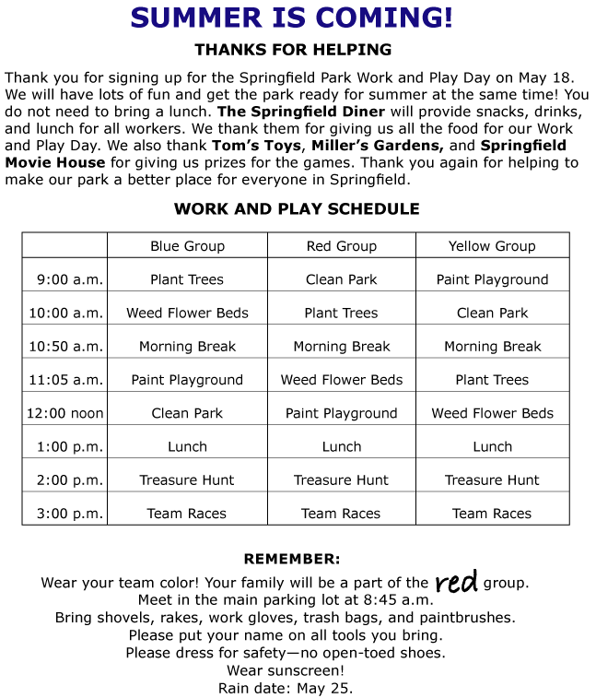

According to the chart, what will the three teams do at the end of the day?
 |  | A. | hunt for treasure
 |  | B. | take a break
 |  | C. | clean the park
 |  | D. | race one another

Question 3 of 18
Jimmy saw this picture near an elevator.
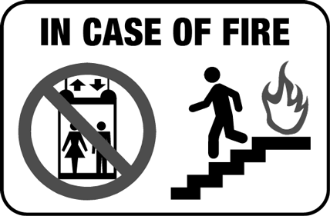
What is the main idea of this picture?
 |  | A. | In case of a fire, use the elevator.
 |  | B. | In case of a fire, do not use the stairs.
 |  | C. | In case of a fire, do not use the elevator.
 |  | D. | In case of a fire, use the elevator or the stairs.

Question 4 of 18
To write a report, where would you look for information about cats and how to care for them?
 |  | A. | an Internet article about pets
 |  | B. | a newspaper article about all animals
 |  | C. | books about wild animals
 |  | D. | an Internet article about birds

Question 5 of 18
Kelee is going from Tennessee to Louisiana to visit her grandparents. She wants to know the shortest way to get from Tennessee to Louisiana.
Which of the following sources would help Kelee the most?
 |  | A. | a chart
 |  | B. | a map
 |  | C. | a photo
 |  | D. | a graph

Question 6 of 18
Look at the picture.
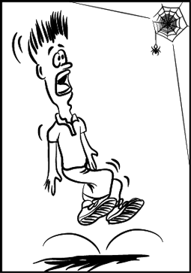
This picture shows a man who is ___________.
 |  | A. | frightened by a spider
 |  | B. | clearing away a spider's web
 |  | C. | learning how spiders spin their webs
 |  | D. | watching spiders eat bugs

Question 7 of 18
Tim saw this image on the back of a smoke alarm box.
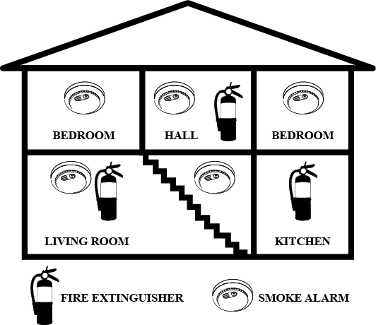
This picture shows __________.
 |  | A. | the safest way to get out of a house in case of a fire
 |  | B. | how to use a fire extinguisher in case of a fire
 |  | C. | the kind of smoke alarms and fire extinguishers that should be in a home
 |  | D. | where smoke alarms and fire extinguishers should be placed in a home

Question 8 of 18
William is watching a DVD called How to Use a Video Camera.
While watching the DVD, William will be able to do all of these except?
 |  | A. | learn how to hold the camera correctly
 |  | B. | find out what each button is used for
 |  | C. | learn how to use each part of the camera
 |  | D. | find out if the camera is easy to hold

Question 9 of 18
The Snowshoe Hare
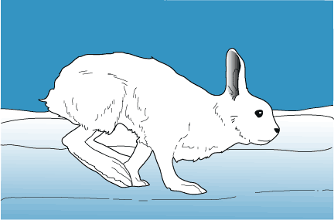
1 Where do animals live when it is wintertime? Bears go to sleep in a cave, and some birds fly south, where it is warmer. An animal called the snowshoe hare lives outside all winter long. A snowshoe hare looks like a rabbit. It lives in forests where snows are heavy. How does this hare manage to live in the cold?
2 A snowshoe hare is able to change its fur color. In summer, the hare has brown, black, and gray fur. When fall comes, the old fur falls out. White fur starts to grow back. The white fur will help the hare look like the winter snow. This means it can stay safe from its enemies, such as foxes and owls.
3 The snowshoe hare has large back feet. The feet are covered with thick fur so the animal will keep warm. The hare's furry hind feet help it in other ways. The hare can stand on its back feet to reach food when there is not any on the ground. This is important in winter because food is very scarce, or hard to find. Also, the snowshoe hare has four long toes on each foot which act like snowshoes. As the hare hops across the snow, its toes spread out wide. This helps the hare to stay on top of the snow and not sink, just like snowshoes help people walk on top of the snow.
4 The snowshoe hare's name comes from its white fur and big feet, which help make this hare always ready for winter! The snowshoe hare is rarely caught off-guard.

A reader would MOST likely look up 'hare' in an encyclopedia to find -
 |  | A. | how an encyclopedia is used
 |  | B. | the meaning of the word ''hare''
 |  | C. | more information about the hare
 |  | D. | that ''rabbit'' is another word for ''hare''

Question 10 of 18
Why is a PowerPoint good to use with some presentations?
 |  | A. | It can help confuse the audience with what to think.
 |  | B. | It can help the audience focus on main points of the presentation.
 |  | C. | It can help the audience not have to listen to the presentation.
 |  | D. | It can help the audience decide if this is a good presentation or not.

Question 11 of 18
What information is important to cite when using an encyclopedia for a report?
 |  | A. | where you got the encyclopedia
 |  | B. | how you got the encyclopedia
 |  | C. | how many encyclopedias are in the library
 |  | D. | the encyclopedia's title

Question 12 of 18
Lucy Lizard and Martin Mole wanted to learn to swim. Martin found a great mud puddle for practicing his swimming. Lucy did not try to learn to swim at all.
One day, Martin and Lucy went to play near the pond. Lucy accidentally got too close to the water and fell in. Martin's practice paid off! He rescued Lucy and was never afraid of water again!
If Lucy cannot swim, how might she help someone who falls into the water?
 |  | A. | Run home and call her friends for help in saving the victim.
 |  | B. | Swim to the victim and pull him out of the water.
 |  | C. | Teach the victim to swim very quickly.
 |  | D. | Swing her strong tail into the water so the victim can grab it.

Question 13 of 18
A ballet group is going to schools to help students become interested in ballet. What would be helpful in their presentation?
 |  | A. | an audio clip of classical music
 |  | B. | a video of a three hour ballet
 |  | C. | a PowerPoint presentation of what to wear in ballet class
 |  | D. | a video clip of a ballet class

Question 14 of 18
This text is an example of which of the following:
PAM: (looking out the window) I can't believe it has started raining.
BOBBY: We'll never make enough money to buy that new game if we can't rake leaves.
Pam and Bobby sit down to think
PAM: Follow me. I just might have an idea.
 |  | A. | play
 |  | B. | story
 |  | C. | poem
 |  | D. | song

Question 15 of 18
How to Wash Your Hands
You have probably heard that it is important to wash your hands, but did you know that there is a proper way to do it?
•First, you need to turn on the water. Make sure it is warm--but not too hot.
•Next, hold your hands under the water. Wet them all over.
•Then apply the soap to your wet hands. Leave the water running while you do this.
•Rub your hands together to make lather.
•Be sure to scrub your fingers and your fingernails, too.
•Sing the song "Twinkle, Twinkle Little Star" while you scrub your hands.
•Don't stop scrubbing until you finish the song.
•Next, put your hands under the water again and rinse off all the soap.
•Leave the water running as you dry your hands with a clean towel.
•Finally, turn off the water with the towel that you used.
If you remember to do this every time you wash your hands, it will help you stay healthy.
After reading the passage to her class, Ms. Jones played a recording of the song "Twinkle, Twinkle Little Star."
Why did Ms. Jones play the song for her class?
 |  | A. | to show how long to let the water run
 |  | B. | to show how long to dry their hands
 |  | C. | to show how loudly they should sing
 |  | D. | to show how long to scrub their hands

Question 16 of 18
The lifeguard at a community pool put these signs where everyone could see them.
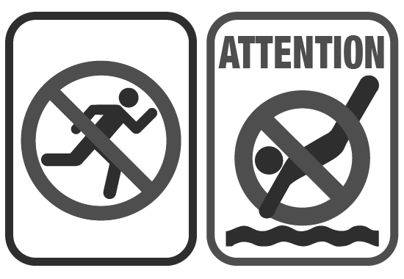
What did the lifeguard want everyone to understand?
 |  | A. | Swimmers should run since the pool is closed for the day.
 |  | B. | Swimmers should not run around or dive in the pool.
 |  | C. | Swimmers should be careful because the area around the pool is slippery.
 |  | D. | Swimmers should wait half hour after eating before swimming.

Question 17 of 18
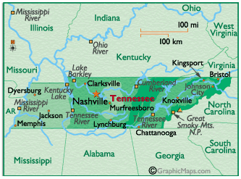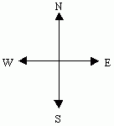
In what direction would you travel to go from Alabama to Indiana?
 |  | A. | south
 |  | B. | east
 |  | C. | north
 |  | D. | west

Question 18 of 18
Meg's New Game
Meg is in third grade and loves to play video games. She and her friend Blake play for thirty minutes every day. Last month Meg went to the store and saw Super Hero Plus, the best new game on the market. It has new characters and cool graphics. The game costs $49.00. She asked her mother to buy it for her, but her mother said, "No."
"If you really want the game, you will have to earn the money to buy it," her mother said. "I will pay you one dollar for each extra chore that you do at home. You can help with the laundry and work in the yard for the money you need."
Meg has been working hard for the past month. So far she has earned $37.00. Soon she will have earned enough money to buy the game. "When you buy it," her mom said, "I will treat you and Blake to a pizza party. That will be a nice reward for your hard work."
"I can't wait!" said Meg. She gave her mom a hug and went outside to pull the weeds from the garden.
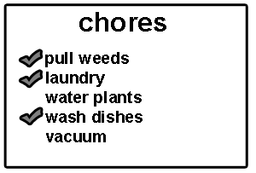
Use the chart to identify what chores Meg still needs to complete.
 |  | A. | water the plants and vacuum
 |  | B. | vacuum and pull weeds
 |  | C. | water the plants and laundry
 |  | D. | laundry, wash dishes, and pull weeds

Copyright © Discovery Education Assessment 2012. Proprietary Information. All rights reserved.
Discovery Education Page

