Progress Probe #1660481: 3rd Grade TCAP Coach Chapter 3 Lesson 20, 21, and 22 (Grade 03 RE)
Teacher Key with Answers
Ques | Answer | Level | Skill | Subskill | Item #
1 | C | Moderate | Writing & Research | SPI 0301.3.8 Appropriate Title [68643] | U44513
2 | A | Moderate | Writing & Research | SPI 0301.3.8 Appropriate Title [68643] | U44925
3 | B | Moderate | Writing & Research | SPI 0301.3.8 Appropriate Title [68643] | U45004
4 | C | Moderate | Writing & Research | SPI 0301.4.2 Organize Information [100058] | U53041
5 | B | Hard | Writing & Research | SPI 0301.4.2 Organize Information [100058] | D65213
6 | A | Moderate | Informational Text | SPI 0301.6.3 Illustration or Graphic [69067] | U44010
7 | B | Moderate | Informational Text | SPI 0301.6.3 Illustration or Graphic [69067] | U44029
8 | A | Hard | Informational Text | SPI 0301.6.3 Illustration or Graphic [69067] | D108859
9 | C | Hard | Informational Text | SPI 0301.6.3 Illustration or Graphic [69067] | D55299
10 | A | Moderate | Informational Text | SPI 0301.6.4 Locate Information [69068] | U51999
11 | D | Moderate | Informational Text | SPI 0301.6.4 Locate Information [69068] | U52019
12 | A | Moderate | Informational Text | SPI 0301.6.5 Parts of a Book [69069] | D65525
13 | C | Moderate | Informational Text | SPI 0301.6.5 Parts of a Book [69069] | D97861

Name: Date:
3rd Grade TCAP Coach Chapter 3 Lesson 20, 21, and 22
Question 1 of 13
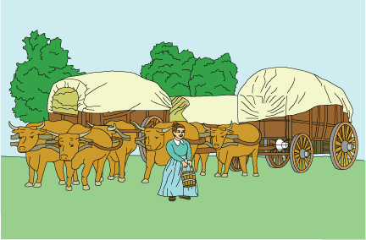
May 6, 1848
Independence, Missouri
Dear Diary,
1 Tomorrow our wagon train heads west for Oregon Country. We are in Independence, our starting point. We have been here for two weeks. Mama has been sewing the canvas cover for our wagon, and Papa has been buying supplies. He has also been meeting with the wagon master, the leader of our journey.
2 There is not much for me to do. Matthew goes on errands with Papa, and Lucy helps Mama with the sewing. I would like to visit the shops and walk along the river, but Mama says that I am too young to do those things alone. I am old enough to take care of David, so I have spent most of my time watching him.
3 The prairie grass has grown enough so that the oxen pulling our wagons can eat it. We can now start our travel. 'This will be a hard trip, Abigail,' Papa has told me. 'It may take six months to reach the Willamette Valley.' I miss Uncle George, Aunt Hannah, and my cousins already. I especially miss Susan, my best friend. Will I ever see any of them again?
4 Everyone is excited about our trip. But I do not care if this is a 'grand adventure.' I wish we were not going!
May 29, 1848
Fort Kearny, Nebraska
Dear Diary,
5 As Papa warned, this has been a hard trip. Mr. Polk, the wagon master, gave us bad news the same day we left Independence. 'Your wagons are overloaded and too heavy,' he announced. 'Go through your belongings. Get rid of anything that you do not need. After today, any family that falls behind gets left behind.' Soon tables, chairs, and other furniture lay beside the trail. Mama and Papa left a table and their iron bed frame. Even food was left behind. Since that day, we have had to walk most of the time. I do not like it, but I am getting used to it.
6 I am also getting to know the other people in our group. There are two other girls my age. Their names are Agnes and Jane. We often walk and talk together. We have been walking along the Platte River for many days now. What astonishing things we have seen! The wind ripples through the grass, making the prairie look like an ocean. Thousands of big bison have passed us. On Saturday, three Native Americans stopped to trade with us. Even the thunderstorms have a special beauty.
7 In the evenings, the grown-ups talk around the campfire. They are excited about making new lives for themselves. I think about what I have seen on our journey across this wonderful country. I am beginning to understand my parents' excitement about our destination.
July 4, 1848
Independence Rock, Wyoming
Dear Diary,
8 It is Independence Day at Independence Rock! We arrived yesterday. I am glad we stayed! Two other wagon trains have come. We will have a big party tonight. My family explored Independence Rock this morning. It is the biggest rock I have ever seen! Papa carved PERKINS into the rock. 'Now people will know that we were here,' he said.
9 We are almost halfway through our journey. Soon we will reach South Pass. Then we will cross the mountains into Oregon Country. There will be weeks of travel. I no longer mind. Even though I miss our old home, I still have my family. Together we will make a great new home in Oregon!

In which book would this selection most likely be found?
 |  | A. | Making Covered Wagons
 |  | B. | Oregon Trail Legends
 |  | C. | Journal of a Pioneer Girl
 |  | D. | Poems of the Prairie

Question 2 of 13
I Know It Can Be Done
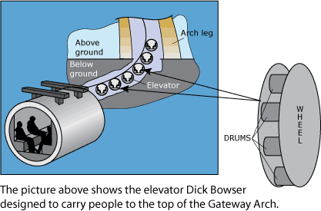
1 The Gateway Arch was completed in 1965. It was built to honor the people who helped settle the American West. The Arch is located near the place where explorers Lewis and Clark began their journey up the Missouri River. The information they brought back from their trip was important in helping the United States grow westward.
2 The beautiful Arch towers 630 feet over the city of St. Louis, Missouri. It is located in a 90-acre park on the banks of the Mississippi River. The Arch represents a doorway to the American West. Windows placed near the top of the Arch were intended to allow visitors to see as far as 30 miles away. There was a problem, though. In 1965, there was no way to get people to the top of the Arch.
3 The Arch is made of stainless steel and has a hollow middle. 'Is it possible to make an elevator that will go up a curve?' people wondered. Dick Bowser's answer was 'Yes.' Dick Bowser was a builder who had spent many hours with his father designing and installing elevators. He was sure a way could be found to carry visitors to the top of the Gateway Arch. But how?
4 He began to think about this big problem. His first idea was to build an elevator that would travel straight up. Passengers would ride to the top of the elevator. There they would get off and walk over to a second elevator. The second elevator would take them even higher up into the Arch. Bowser decided this idea would not work, though. There was not enough waiting space inside the Arch. People would find it difficult to move from one elevator to the next.
5 His second idea was to put moving stairs inside the Arch. This idea had to be thrown out too. He learned that the stairs would be too expensive. They would also not work well near the top of the Arch.
6 Bowser thought and thought. Finally, he pictured a Ferris wheel in his mind. He thought about the carnival ride's moving seats that never tipped the riders over. After measuring the Arch, Bowser continued to think about the problem.
7 Two weeks later, Bowser combined two of his ideas into one. He would create an elevator that worked much like a Ferris wheel. His plan was to make a little tram—a chain of small, round wheels. Sandwiched between the two sides of each wheel were eight drums. Inside each drum were five seats. The wheels moved up a cable like little Ferris wheels. The drums inside turned so the riders never tipped over. The idea worked beautifully.
8 Today, after more than 40 years, Bowser's elevator is still carrying visitors to the top of the Arch. There, people can enjoy a bird's-eye view of the gateway city to the west.

In which book would this passage most likely be found?
 |  | A. | The Gateway Arch, An American Landmark
 |  | B. | The Man Who Invented the Ferris Wheel
 |  | C. | Visiting the American Gateway
 |  | D. | How Elevators Work

Question 3 of 13
Wilma Rudolph, a Special Hero
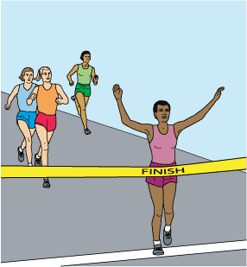
1 Wilma Glodean Rudolph is a hero to many people. She is famous because she won three gold medals in the Olympics. She was the first American woman to do this. That is only a small part of why she is a hero, though.
2 Winning gold medals would be very special to anyone, but it was even more special to Wilma and her family. Wilma was very sick as a child. She did not think she was ever going to be able to walk. She certainly did not realize she would do so well in sports.
3 Wilma was born in Tennessee in 1940. She was born too early, so she was very small. She also had a disease called polio. The disease caused her left leg and foot to be weak. The doctors told her family that there was no hope for improvement. Wilma wore a leg support from the time she was 6 until she was 11 years old. She had to go to the hospital every week for extra care.
4 There was something else special about Wilma. She had 21 brothers and sisters. Her large family worked to help her to get better. The family learned how to help her do special exercises for her leg. Wilma could finally walk normally at the age of 11.
5 Wilma decided she wanted to play sports. She played basketball in high school and became a star. Wilma also wanted to run track. She always seemed to be 'buzzing around,' so her coach gave her the nickname of 'Skeeter.'
6 Wilma went to her first Olympic games at the age of 16. She won a bronze medal for third place in the 4 × 100 meter relay.
7 Four years later, Wilma won three gold medals at the Rome Olympics. She won both the 100-meter dash and the 200-meter dash. She also won the 400-meter relay. She was the anchor of the successful relay team which means she was the last of four runners. The anchor is a very important role.
8 The gold medals made Wilma very famous. Her town wanted to celebrate her victory. The people wanted to give her a parade to welcome her home. Before then, black and white people in her town had not gone to celebrations together. Wilma insisted that her parade would be for all people. It was the first event in the town where black and white people celebrated together. This event was very special to her.
9 Soon after the Olympics, Wilma went to college at Tennessee State University. She became a teacher and a coach. She got married and had four children. She liked to give speeches at worldwide track events. She also spoke to students about her life. Wilma worked on sports television and radio shows. She started a program that gave free coaching in all sports to children in need.
10 In 1993, the President of the United States gave Wilma a special award. She was the first woman ever to receive the National Sports Award. She died only one year later at the age of 54.
11 Wilma Rudolph is still a hero today. She had to work much harder than most to follow her dreams. During her life, she earned many awards. She is a member of the Black Sports Hall of Fame and the National Track and Field Hall of Fame. Her name can also be found in the hall of fame for United States Olympic athletes.

In which book would this selection most likely be found?
 |  | A. | Tips for How to Make the Track Team
 |  | B. | People Who Followed Their Dreams
 |  | C. | Exercises for Building Strong Legs
 |  | D. | The History of Olympic Swimming

Question 4 of 13
Shake, Shake, Shake!
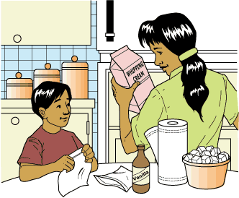
1 Do you enjoy the taste of ice cream? You know you can buy your favorite ice cream in a store. Did you also know that it is fun and easy to prepare your own ice cream at home? This is one way to do it.
2 First, ask a grownup to help. One of the supplies he or she will probably need to get for you is rock salt. This is not the kind of salt you put on your food. Using it is an important step in helping your ice cream become cold.
3 There are other things you will need to gather. You will need two strong plastic bags. They should have a closing that works like a zipper. You will need one large (gallon) bag and one small (quart) bag. Get some ice cubes, too. You will also need measuring cups and spoons, salt, whipping cream, sugar, and vanilla flavoring. The vanilla flavoring smells wonderful, but it doesn't taste good by itself. You will also need some paper towels to clean up any messes as you go along.
4 Once you have all your supplies, you will be ready to begin making your ice cream. First, put ice cubes into the large bag. Fill the bag a little more than halfway. Measure out 1/4 cup of rock salt, and pour it over the ice cubes in the bag. Close the bag, and set it aside until later.
5 Next, measure out 1/2 cup of whipping cream and pour it into the small bag. Add 1 tablespoon of sugar and 1/4 teaspoon of the vanilla extract to the cream. If you like, you can also add little pieces of candy like peppermint or chocolate chips. Tightly close the small bag. Shake it until everything seems well mixed.
6 Now, place the small bag inside the large bag containing the ice. Close the large bag. Shake, shake, shake, and shake some more! If you get tired, ask for help. It is more fun if you have someone sharing the job of shaking the bag with you. After about 5 minutes of shaking, the ice-cream mixture will start to thicken. If you can't wait, you can eat it when it is like a thick milkshake. If you are patient, though, shake the bag some more, and the ice cream will get harder. You might need to shake the bag for 15 or 20 minutes. Once the mixture has hardened, you can enjoy a bowl of ice cream or an ice-cream cone. Any way you eat it, it's so good!
7 Now that you know how to make this delicious treat, invite some friends over for an ice-cream party. You might ask each person to bring his or her favorite topping to share. Everyone can help with the shaking. Everyone will enjoy eating something they helped to make!

Which of the following books would most likely tell about the history of ice cream?
 |  | A. | The Mystery of the Missing Scoop
 |  | B. | Directions for Making Sweet Treats
 |  | C. | Facts About Desserts Through the Ages
 |  | D. | Delicious Poems for Hungry Readers

Question 5 of 13
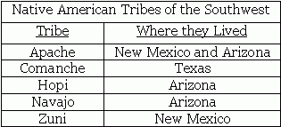
Which statement below would not be in a paragraph that summarizes the information from the table?
 |  | A. | The Apache and Zuni tribes both lived in New Mexico.
 |  | B. | Only one tribe, the Navajo, lived in Arizona.
 |  | C. | Only one tribe, the Comanche, lived in Texas.
 |  | D. | The Apache tribe lived in two states.

Question 6 of 13
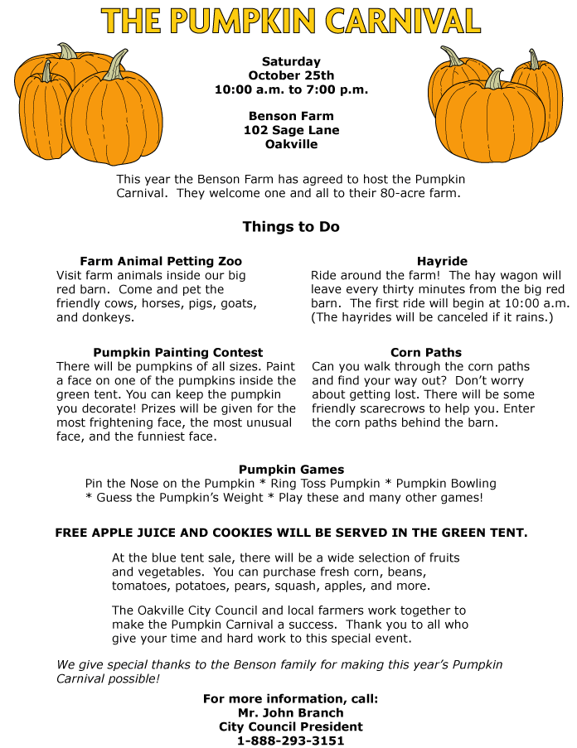

Whom would you call for more information about the Pumpkin Carnival activities?
 |  | A. | Mr. John Branch
 |  | B. | Someone who went to last year's carnival
 |  | C. | A member of the Oakville City Council
 |  | D. | Any local pumpkin farmer

Question 7 of 13
Behold the Butterfly
1 Most people know that butterflies are flying insects with large, beautiful wings. However, most people do not know about other things that make butterflies special.
Butterfly Needs
2 Butterflies live all over the world in warm places. If the temperature is too cold, a butterfly cannot fly. It must warm its body by basking in the sun. Butterflies get their food in liquid form. Some drink juices from fruits, using their tongues like a straw.
Special Senses
3 Like humans, butterflies have five senses. They are able to see, hear, taste, touch, and smell. It's hard to believe, but a butterfly actually uses its feet to help it taste. This is how it tells if a certain juice is good to drink. Butterflies also have special eyes called compound eyes. These eyes see things very differently from the way human eyes see things. Tiny hairs cover a butterfly's body. These hairs help butterflies feel the wind when they fly. A butterfly can also hear sounds through its wings.
Staying Safe
4 Butterflies are small and fragile. This makes it hard for them to look after themselves. A butterfly does different things to keep safe. Flying is one way it can protect itself. Butterflies also have wings that blend into their background. The wings have small scales that come off. If a butterfly gets caught in a spider's web, its scales can fall off, allowing the butterfly to escape. Some butterflies are poisonous. Other animals stay away from these types of butterflies.
Size and Speed
5 Butterflies are many different sizes. Their open wings can measure from one-eighth inch to 12 inches across. They can fly at different speeds. One butterfly can fly as fast as 30 miles per hour. The slowest butterfly can fly only about 5 miles per hour.
6 A butterfly is a small creature. As you can see, it has many special ways of living in the wild.

Why do the words 'Butterfly Needs' appear above paragraph 2?
 |  | A. | To show that it is the most important subject in the passage
 |  | B. | To tell something about the paragraph that follows
 |  | C. | To tell you that you need to buy a butterfly as a pet
 |  | D. | To show the most important words in the passage

Question 8 of 13
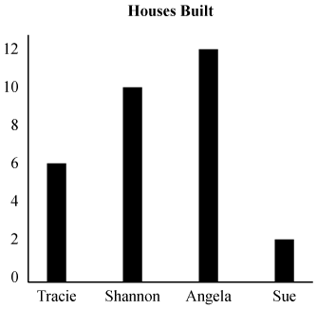
In my story, all of these girls liked to help build houses. I graphed how many houses each built. Use the graph to answer the question.
How many houses did Sue and Tracie build?
 |  | A. | 8
 |  | B. | 6
 |  | C. | 4
 |  | D. | 2

Question 9 of 13
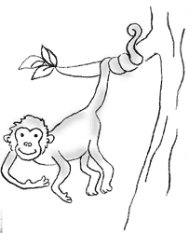
Primates include monkeys and apes. Each primate family has its own traits. When you go to the zoo and spot a primate hanging by its tail, it is a New World monkey. Only New World monkeys have a tail that lets them hold on to branches as if the tail was a hand.
If you went to the zoo and saw this animal, what type of primate would it most likely be?
 |  | A. | orangutan
 |  | B. | ape
 |  | C. | New World monkey
 |  | D. | chimpanzee

Question 10 of 13

Which of these BEST explains why some parts of the poster are in bold print?
 |  | A. | To show which information is most important
 |  | B. | To make the words easy to recognize
 |  | C. | To show the order in which steps should be done
 |  | D. | To make the words fit inside the box

Question 11 of 13
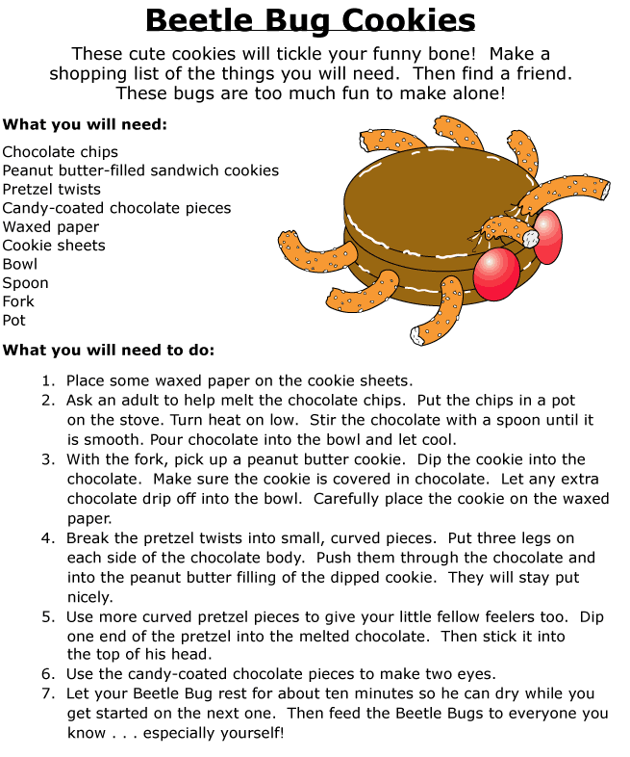

Which of these best explains why some of the sentences in the passage are numbered?
 |  | A. | To show how long it will take to bake the cookies
 |  | B. | To show that the sentences are directions
 |  | C. | To show the importance of each step
 |  | D. | To show the order in which the steps should be done

Question 12 of 13
What part of a book is featured below?
Chapter 1 Groups of Animals.......3
Chapter 2 Reptiles.......8
Chapter 3 Amphibians.......15
Chapter 4 Mammals.......24
Chapter 5 Birds.......37
Chapter 6 Fish.......45
 |  | A. | table of contents
 |  | B. | glossary
 |  | C. | index
 |  | D. | title page

Question 13 of 13
You are interested in visiting these five missions in California. Use this map of California missions to answer the question.
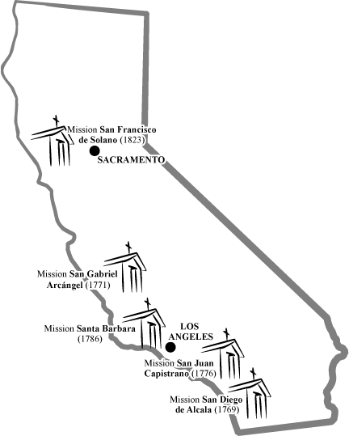
The numbers in parentheses tell the date that each mission was established. If you wanted to visit the oldest mission, which one would you visit?
 |  | A. | Mission San Francisco de Solano
 |  | B. | Mission San Gabriel Arcangel
 |  | C. | Mission San Diego de Alcala
 |  | D. | Mission San Juan Capistrano

Copyright © Discovery Education Assessment 2012. Proprietary Information. All rights reserved.
Discovery Education Page

