Progress Probe #1660448: 3rd Grade TCAP Coach Chapter 2 Lesson 17 (Grade 03 RE)
Teacher Key with Answers
Ques | Answer | Level | Skill | Subskill | Item #
1 | D | Moderate | Logic | SPI 0301.5.2 Fact and Opinion [69062] | U43908
2 | C | Hard | Logic | SPI 0301.5.2 Fact and Opinion [69062] | D61436
3 | A | Moderate | Logic | SPI 0301.5.1 Appropriate Inferences and Conclusions [69061] | U43637
4 | D | Hard | Logic | SPI 0301.5.1 Appropriate Inferences and Conclusions [69061] | D2344
5 | D | Hard | Logic | SPI 0301.5.2 Fact and Opinion [69062] | D63520
6 | A | Moderate | Logic | SPI 0301.5.1 Appropriate Inferences and Conclusions [69061] | U43801
7 | C | Hard | Logic | SPI 0301.5.2 Fact and Opinion [69062] | D67260
8 | C | Hard | Logic | SPI 0301.5.1 Appropriate Inferences and Conclusions [69061] | D928

Name: Date:
3rd Grade TCAP Coach Chapter 2 Lesson 17
Question 1 of 8
The Wonderful World of Gum
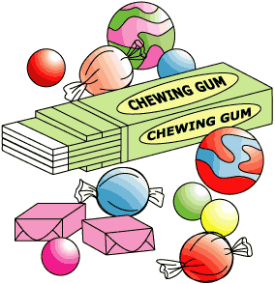
Something to Chew On
1 People have been chewing gum for thousands of years. For most of this time, people have chewed natural gum. This comes from trees. Ancient Greeks chewed mastiche. This was made from the mastic tree. Ancient Mayans chewed chicle. This was made from the sap of the sapodilla tree. North American Indians chewed the sap from spruce trees. They shared this with the early settlers. The settlers enjoyed chewing gum. They used sap and beeswax to make their own gum.
Chewing Gum Changes
2 For many years, natural chewing gum saw no major changes. The settlers who added wax to the sap made the first change to gum in thousands of years. The biggest change for chewing gum took place in 1869, when the Mexican general Santa Anna told Thomas Adams about chicle. He suggested Adams make a new kind of rubber using the chicle. Adams tried to make the rubber, but he was not successful. Still, he did not want to waste all of the tons of chicle he had bought. He used the chicle to make his own gum. This first modern chewing gum had no flavor. He called it 'Adams New York No. 1.' The gum sticks were sold at drugstores. The public was amazed by the gum sticks, and they were a huge sensation.
Flavors, Bubbles, and More
3 Adams made one of the first gums with flavor in the 1870s. Soon, many new gums were made. William Wrigley's flavored gums came in the late 1800s. Different shapes of gum were also made. There were tiny pieces. There were small balls of gum, called gumballs, too. The public loved the new gums! Many gum makers tried to make bubble gum. It was a flop. It was too sticky and weak to blow bubbles. Then, Walter Diemer made a better bubble gum in 1928. It could stretch without breaking when filled with air. This was a big improvement for gum. Then, sugarless gum was made in the 1950s. Gum had gone through many changes since 'Adams New York No. 1.'
Gum Today
4 Today, gum is more popular than ever. There are over a thousand kinds of gum. The flavors, shapes, sizes, and colors seem to be endless. There is some kind of gum for everyone!

Which of these is an opinion in this passage?
 |  | A. | The first modern chewing gum had no flavor.
 |  | B. | The public loved the new gums!
 |  | C. | People have been chewing gum for thousands of years.
 |  | D. | There is some kind of gum for everyone!

Question 2 of 8
Meg's New Game
Meg is in third grade and loves to play video games. She and her friend Blake play for thirty minutes every day. Last month Meg went to the store and saw Super Hero Plus, the best new game on the market. It has new characters and cool graphics. The game costs $49.00. She asked her mother to buy it for her, but her mother said, "No."
"If you really want the game, you will have to earn the money to buy it," her mother said. "I will pay you one dollar for each extra chore that you do at home. You can help with the laundry and work in the yard for the money you need."
Meg has been working hard for the past month. So far she has earned $37.00. Soon she will have earned enough money to buy the game. "When you buy it," her mom said, "I will treat you and Blake to a pizza party. That will be a nice reward for your hard work."
"I can't wait!" said Meg. She gave her mom a hug and went outside to pull the weeds from the garden.
Which of the following statements is a fact from the story?
 |  | A. | Meg worked hard for a month.
 |  | B. | Super Hero Plus is the best new game.
 |  | C. | Meg and Blake play video games every day.
 |  | D. | A pizza party is a nice reward.

Question 3 of 8
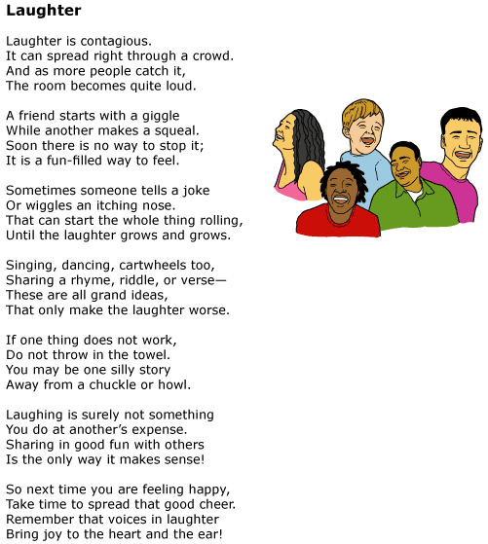

Based on the poem, how do people get others to laugh with them?
 |  | A. | When one person starts laughing, it makes others want to join in.
 |  | B. | When a person tickles others, it makes them laugh.
 |  | C. | When someone tells a joke, people may think it is funny.
 |  | D. | When everyone laughs, the room can become quite noisy.

Question 4 of 8
A lion and an alligator were friends. One day they were walking along the beach. The alligator decided to go swimming. He was doing back flips, swirling around, and making whirlpools. He turned back to the lion and said, "Do you want to come do some tricks? It's really fun!" The lion said, "Sure." He jumped right into the water. The lion started sinking to the bottom. He couldn't swim. A dolphin swam under him, and the lion rode on his back all the way back to shore.
In the passage above, what is the author's message to the reader?
 |  | A. | It is easier to do flips in the water.
 |  | B. | Lions and alligators can be friends.
 |  | C. | Dolphins are very good swimmers.
 |  | D. | You should think before you do things.

Question 5 of 8
Which one of these is an opinion?
 |  | A. | Some space stations contain shower stalls.
 |  | B. | Tim takes dance class on Monday afternoons.
 |  | C. | Mother vacuums the floor everyday.
 |  | D. | The astronaut always likes his job.

Question 6 of 8
A First Sign of Spring
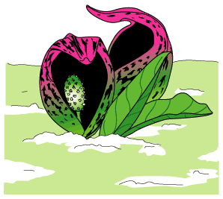
1 The skunk cabbage is a strange plant. It can grow in freezing weather. Its blooms do not look like flowers. And it stinks!
2 Most kinds of plants wait for the warm weather of spring before their flowers bloom. But the skunk cabbage does not seem to mind the winter's cold. As spring approaches, this plant begins growing underneath the snow. As the skunk cabbage grows, it makes its own heat to keep warm. The temperature of the plant may be as much as thirty degrees warmer than the outside air. The skunk cabbage uses the heat to melt its way through the snow's icy surface.
3 The skunk cabbage is one of the first signs of spring. This hardy plant can be found in moist places throughout North America. Its pointed blossoms look like tiny purple pitchers. Skunk cabbage grows in swampy ground and in low places where water gathers.
4 A skunk cabbage is often first noticed because of its smell. This plant got its name because of the strong, skunk-like scent that makes it so easily detected. Many people think that the smell of the skunk cabbage is unpleasant, but many insects find it inviting. Flies and beetles visit the flowers. They crawl down inside the pitchers to drink the nectar at the bottom. Their bodies brush against the inside of the plant and pick up grains of pollen.
5 Like other plants, skunk cabbages use pollen to make seeds. As insects move from plant to plant, they carry pollen from one skunk cabbage flower to another. By doing this, the insects help the skunk cabbage to reproduce or create new plants. In late summer, after seeds have formed and ripened, they fall from the plant and become buried in the earth. Over time they will grow into new plants. At the end of the next winter, new skunk cabbages will poke their heads through the snow. They will tell us that spring is coming soon.

Which would be the best place to look for a fully grown skunk cabbage?
 |  | A. | Around wet areas
 |  | B. | In a desert
 |  | C. | Where a skunk lives
 |  | D. | Under the snow

Question 7 of 8
Timmy Johnson spent two weeks at basketball camp again this summer. The coach wanted Timmy to spend his time at camp working on offense and defense. Timmy's coach told him that he would make a good guard for his school team. A guard is someone who dribbles down the court and passes the ball to other teammates. Timmy worked hard at basketball camp and plans to attend basketball camp next summer.
Choose the sentence from the paragraph that states an opinion.
 |  | A. | A guard is someone who dribbles down the court and passes the ball to other teammates.
 |  | B. | Timmy Johnson spent two weeks at basketball camp again this summer.
 |  | C. | Timmy's coach told him that he would make a good guard for his school team.
 |  | D. | Timmy plans to attend basketball camp next summer.

Question 8 of 8
Andy the ant worked hard all day to get his food back to his home. Mickey the grasshopper wanted Andy to play with him. Andy told him he could not because it would soon be winter and he would need the food.
Mickey went on his way. He played and had fun while Andy worked.
Winter did come and it got very cold. Mickey knocked on Andy's door to see if he could have some food.
What is the message in this story?
 |  | A. | Andy was an ant and Mickey was a grasshopper.
 |  | B. | Animals have fun playing together.
 |  | C. | You need to work hard so you can be prepared.
 |  | D. | Winters can be very cold.

Copyright © Discovery Education Assessment 2012. Proprietary Information. All rights reserved.
Discovery Education Page

