Progress Probe #1660439: 3rd Grade TCAP Coach Chapter 2 Lesson 16 (Grade 03 RE)
Teacher Key with Answers
Ques | Answer | Level | Skill | Subskill | Item #
1 | C | Moderate | Informational Text | SPI 0301.6.1 Focus and Clarify Thinking [69065] | U52279
2 | D | Hard | Informational Text | SPI 0301.6.1 Focus and Clarify Thinking [69065] | D97432
3 | D | Hard | Informational Text | SPI 0301.6.1 Focus and Clarify Thinking [69065] | D61397
4 | B | Moderate | Informational Text | SPI 0301.6.1 Focus and Clarify Thinking [69065] | U53054
5 | B | Hard | Informational Text | SPI 0301.6.1 Focus and Clarify Thinking [69065] | D59239

Name: Date:
3rd Grade TCAP Coach Chapter 2 Lesson 16
Question 1 of 5
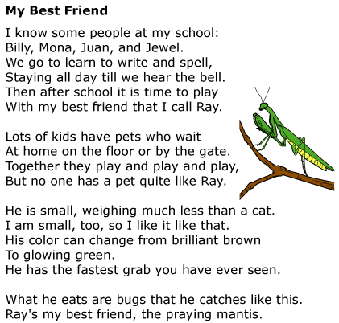

Which of these would best help you check your understanding of the poem?
 |  | A. | Read the poem out loud
 |  | B. | Think about a pet you know
 |  | C. | Ask yourself questions as you read
 |  | D. | Read the title and the first line again

Question 2 of 5
Ana was looking forward to Groundhog Day. She was so tired of winter, and having to stay inside all day. She couldn't wait for spring to come. She knew that today was the day that Goober the Groundhog popped out of his burrow. If he saw his shadow, there would be six more weeks of winter. If there was no shadow, spring would come early. Ana hurried to Goober's burrow. She waited with all of the other people who had come to find out if Goober would see his shadow. Goober poked his nose out of his hole, and then crawled out. As he stood up, the crowd shouted, "Hurrah! No more winter!" Ana was thrilled. She hurried home and pulled her catcher's mitt and softball from the back of her closet. Spring training was about to begin!
Which of the following questions can you ask yourself to help you understand what the groundhog's shadow means?
 |  | A. | Where does Goober the Gopher live during the springtime?
 |  | B. | Why is it that Ana likes spring so much more than winter?
 |  | C. | Why did so many people come to see Goober's shadow?
 |  | D. | What does it mean when the groundhog casts a shadow?

Question 3 of 5
I have a friend who is an author. Mr. Farley likes to write books about animals. He has written stories about monkeys, goats, and horses. His last book was about a mouse that moved to the city.
My teacher asked the class to write a story in our journals. I wrote a story about my pet dog. I wrote about the time we went to the park to play fetch with his ball.
How are these two stories alike?
 |  | A. | They are both about things that could not really happen.
 |  | B. | They are both going to be read at the spring play.
 |  | C. | They are both about people that cook a lot.
 |  | D. | They are both about writing stories about animals.

Question 4 of 5
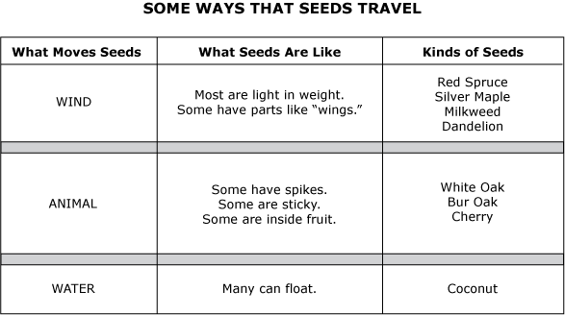

How Seeds Travel
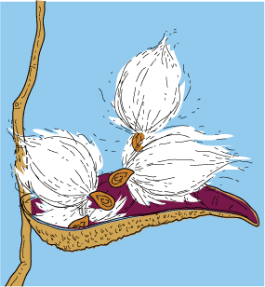
1 Plants make seeds at the end of the growing season each year. Seeds grow into new trees, vegetables, fruits, and flowers. People love to see these plants grow!
2 The seeds of some trees are heavy and fall to the ground. Pinecones fall to the ground from pine trees. They hold big seeds concealed inside. It is fun to try to see the seeds in pinecones. The seeds inside the cones grow right where they fall.
3 Acorns are seeds that fall to the ground from oak trees. Squirrels bury the acorns in the fall. During the winter, the squirrels don't find all the acorns they buried. Some of the covered acorns grow into new oak trees. People enjoy the shade of big oak trees.
4 Apple, pear, and cherry trees drop their fruit to the ground with the seeds still inside them. Small animals and insects sometimes eat the fruit that falls to the ground. People like the fruit too. The seeds that are left on the ground grow into new trees.
5 Some seeds travel far away from the plant. These seeds are so light that they float in the air when the wind blows. Milkweed plants have pods that break open. The seeds come out of the pods and float away. Dandelion seeds are also very light. They move like spinning tops when the wind lifts them into the air. It's fun to watch them travel with the wind. Other plants and trees produce light seeds that look very different. The seeds of some elm trees look as if they have tiny airplane wings. When the wind stops blowing, the light seeds fall to the ground. In the spring, the seeds from all these plants begin to grow in the spots where they fell.
6 Sometimes the wind ceases blowing when the seeds are over a river or a lake. Then the seeds begin to fall into the water. Some seeds float until they reach land. Then they begin to grow.
7 Some seeds cling to animal fur. The seeds fall to the ground when an animal rubs its fur against the trunk of a tree or a rock. Seeds also stick to people's clothing when they walk through the woods. People are usually surprised to see seeds sticking to their clothes. The seeds fall to the ground and begin to grow where people brush the seeds off their clothes.
8 People help seeds travel in another way too. Farmers and gardeners buy seeds that they plant in the ground. That's how people grow trees, vegetables, fruits, and flowers right where they want them. People are really glad they can take seeds with them.
9 Seeds can travel a long way or a short way. Animals, people, wind, and water help seeds find new places to grow. Seeds that travel are amazing!

What is the article mainly about?
 |  | A. | One kind of heavy seed is found in pinecones.
 |  | B. | Seeds are scattered in many ways so they can grow in new places.
 |  | C. | Blowing seeds can travel far before they land on the ground.
 |  | D. | Animals and insects sometimes eat fruit with seeds inside.

Question 5 of 5
Alice and the Pig, from Alice in Wonderland
The thing she held was a baby. It grunted again, and Alice looked into its face to see what was wrong with it. It had a very turned-up nose that looked more like a snout than a nose. Its eyes were too small for a baby. Alice did not like the looks of the thing at all. "Maybe it was just crying," she thought and looked into its eyes again to see if there were any tears.
No, there were no tears. "If you're going to turn into a pig, my dear," said Alice, "I'll have nothing more to do with you." The poor little thing cried again, (or grunted—no one could tell which).
Alice did not want to leave the creature in the woods. "But what am I to do with this thing when I get it home," she wondered. It grunted again even louder than before. This time she was sure that it was a pig. She set the creature down and was happy to see it trot away quietly into the wood.
"If it had grown up," she said to herself, "it would have made an ugly child. But it does make a handsome pig, I think."
Which question could be asked in order to clarify thinking while reading this story?
 |  | A. | Why is Alice in the woods?
 |  | B. | Why does Alice not like the looks of the creature?
 |  | C. | What is the pig's name?
 |  | D. | How old is Alice?

Copyright © Discovery Education Assessment 2012. Proprietary Information. All rights reserved.
Discovery Education Page

