Progress Probe #1660345: 3rd Grade TCAP Coach Chapter 1 lesson 9 and 10 (Grade 03 RE)
Teacher Key with Answers
Ques | Answer | Level | Skill | Subskill | Item #
1 | C | Moderate | Language & Vocabulary | SPI 0301.1.15 Root Words [68608] | U52516
2 | B | Hard | Language & Vocabulary | SPI 0301.1.16 Word Meanings [68611] | D569
3 | C | Hard | Language & Vocabulary | SPI 0301.1.15 Root Words [68608] | D51634
4 | D | Moderate | Language & Vocabulary | SPI 0301.1.15 Root Words [68608] | U52520
5 | D | Moderate | Language & Vocabulary | SPI 0301.1.15 Root Words [68608] | U52518
6 | C | Hard | Language & Vocabulary | SPI 0301.1.16 Word Meanings [68611] | D2458
7 | A | Moderate | Language & Vocabulary | SPI 0301.1.16 Word Meanings [68611] | U43766
8 | A | Moderate | Language & Vocabulary | SPI 0301.1.16 Word Meanings [68611] | U52117
9 | C | Hard | Language & Vocabulary | SPI 0301.1.15 Root Words [68608] | D2665
10 | D | Hard | Language & Vocabulary | SPI 0301.1.15 Root Words [68608] | D16517
11 | A | Hard | Language & Vocabulary | SPI 0301.1.16 Word Meanings [68611] | D574

Name: Date:
3rd Grade TCAP Coach Chapter 1 lesson 9 and 10
Question 1 of 11
The Fastest Mile
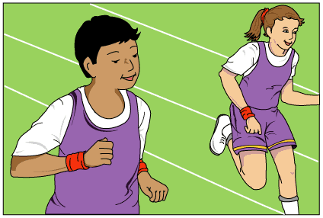
1 'Aunt Rosa! Look at this!' Danny shouted as he ran through the front door. 'Miss Williams wants the third graders to stay after school and practice. May I stay?' Aunt Rosa wondered what the school principal had sent home with the students.
2 'Hold on, hold on! Let me look at it,' Aunt Rosa laughed as she took the paper from Danny's excited hands.
Maple Grove Running Club
Come join your classmates!
Improve your health and
have fun exercising at the same time!
Who: Third-grade students
When: Mondays after school 3:00 p.m. to 4:00 p.m.
Where: The school playground
Goal: To run one mile
*Special Note: Miss Williams will be there to practice running with you!
3 'What is a goal?' Danny asked as they read the note together.
4 'A goal is something you work to complete. You set your mind to do something, and you practice hard until you can do it. Miss Williams wants you kids to practice running because a mile is a long way,' Aunt Rosa explained.
5 Miss Williams was a nice principal. The kids at Maple Grove respected her very much. She would often eat lunch with them in the cafeteria. She even talked to the kids during recess whenever she could. Every so often, she would give the students a new challenge. She liked for them to try something new.
6 'Oh, we can do it!' Danny said out loud, even though he was a little nervous inside. Danny's friend Kara was the best runner in the class. He knew she would be able to reach the goal. Would he ever be able to run a whole mile?
7 'Please, can I at least try it?' he asked his aunt again.
8 'Sure. I'll arrange to pick you up from school on Mondays so you can stay after and practice,' she said.
9 The third graders at Maple Grove practiced and practiced. Miss Williams set out orange cones on the playground. At each practice, they ran a little farther to the next cone. They ran and ran and ran. Miss Williams told them they had determination. This meant that they were moving toward their goal.
10 After practicing for three weeks, everyone could reach the last cone. They could all run a mile even if they ran slowly. As Danny expected, Kara was the fastest. Miss Williams said to the group, 'You have all amazed me with your hard work. I am so proud of you! I would like all of you to take part in the Race for Education run this weekend.'
11 Danny, Kara, and the rest of the class were proud and excited. They would support their school and even get a T-shirt! But that night, Danny twisted his ankle on the stairs. He was heartbroken. Would he be able to run in the Race for Education? Danny soaked his ankle in warm salt water. His aunt rubbed something that smelled like mint on his ankle. As Danny lay in bed, he asked Aunt Rosa, 'Will you be disappointed in me if I can't run?'
12 Aunt Rosa looked at Danny very seriously and replied, 'Danny, I've seen what you have been able to accomplish in the past three weeks. I would never be disappointed in someone who worked so hard. I want you to know that I am proud of you no matter what.'
13 Danny fell asleep smiling. The next day his ankle was much better! By Saturday, he was running without any problem. When Danny came in third at the race, he knew his hard work had paid off. He had run his fastest mile ever!

What is the root word in fastest?
 |  | A. | est
 |  | B. | fas
 |  | C. | fast
 |  | D. | test

Question 2 of 11
There were many undecided voters in the last presidential election.
What is the meaning of the word in bold?
 |  | A. | very sure
 |  | B. | not sure
 |  | C. | kind of sure
 |  | D. | sure again

Question 3 of 11
Karen was attractive.
Choose the suffix in the word attractive.
 |  | A. | attract
 |  | B. | att
 |  | C. | ive
 |  | D. | tract

Question 4 of 11
Life on the Farm
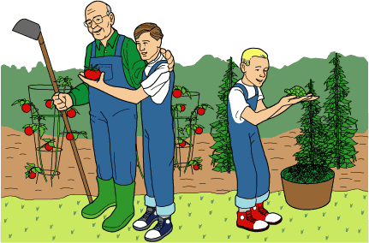
1 In 1950 many people lived on small farms. Kevin lived on such a farm with his family.
2 One day Kevin and his grandpa were in the garden picking green beans for dinner. They had been having trouble in the garden. Box turtles were eating the green bean plants. Just one bite, and a plant was ruined. This was a big deal for the family since the majority of their food was grown in the garden.
3 On that same day, Kevin found a cute baby turtle. He was determined to keep it as a pet. He knew if his brother saw it, he would take it away. So he hid the little turtle by putting it in the bottom of a bucket. Then he covered the small animal with green beans.
4 When the boys finished their tasks, they went to play. Grandpa took the bucket of green beans and the other vegetables to the house.
5 After working and playing, Kevin was hungry. Grandma had cooked chicken and green beans. Kevin was about to eat some green beans when he remembered something. 'Oh, no!' he thought. 'The baby turtle!' What had happened to it? He was afraid to say anything!
6 'May I be excused?' he asked. 'I forgot to wash my hands.'
7 He headed for the kitchen where he found the bucket with the rest of the green beans. There the baby box turtle was at the bottom of the bucket. It was safe and sound. 'Whew!' he sighed. 'In the morning, you're going back to the river where you belong!'

What is the root word in finished?
 |  | A. | ed
 |  | B. | fin
 |  | C. | shed
 |  | D. | finish

Question 5 of 11
The Case of the Unhappy Horse
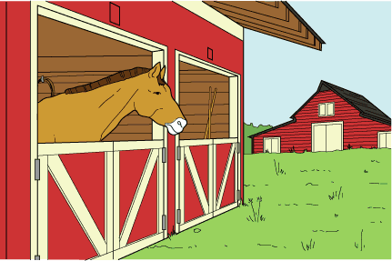
1 Every day after school, Dave went to Treeline Riding School to help feed and water the horses. A new horse named Mariah had just moved to the riding school. She was making a terrible noise in her stable. She snorted and kicked the sides of her stall as if she would break out any second.
2 Mr. Tom, owner of Treeline Riding School, jerked his head toward the stable.
3 'This morning I washed Mariah down with warm water to make her feel better.' Mr. Tom sighed. 'But as soon as I put her back in her stall, she started making a terrible clatter.'
4 Dave grinned. 'Sometimes I get tired of sitting at my desk all day. Maybe she's just tired of standing in her stall.'
5 'I don't dare let her out,' answered Mr. Tom. 'She has so much energy, she might run away. She might try to jump a fence and could get hurt.'
6 Dave said, 'Let me ride her for a while. The exercise might make her tired.'
7 'You're a fine rider, better than any of my other students,' admitted Mr. Tom. 'But I can't risk letting anyone ride her. Just go talk to her. She listens to you. You calm her down.'
8 Dave walked to Mariah's stall. In a low, quiet voice, he said, 'You're okay, girl. Everything's going to be all right.'
9 Mariah stuck her head over the stall door. Her wide, dark eyes held a curious look. Her feet moved in a restless shuffle.
10 Dave reached up and scratched her ears. She bobbed her head and cuddled into his shoulder.
11 Dave whispered, 'You're my new best friend, Mariah. Count on it.'
12 As he spoke, Mariah slowly relaxed and calmed down. Dave eased away from her stall. Before he was out the barn door, he heard her kicking and stamping her feet.
13 Dave went up to Mr. Tom and said, 'I have an idea. Mariah is quiet when I'm here. Let me sleep in another stall next to Mariah for a few nights. By then she might get used to her new home.'
14 Mr. Tom nodded. 'If it's okay with your folks and if one of your parents will stay the night with you, then it's okay with me.'
15 For three nights Dave and his dad slept on a pile of straw in the stall next to Mariah's. She made no fuss.
16 On the fourth night, Dave stayed home. The next morning when Dave came to the riding school, Mr. Tom looked serious. He said, 'Dave, last night Mariah made so much noise that she woke up my whole family. I don't know what to do.'
17 Dave put his hand to his chin and thought hard for a minute. At last he said, 'I think understand Mariah's problem. Now I know what to do.'
18 Mr. Tom smiled. 'Do what you have to do.'
19 That night Dave entered the barn and spoke softly to Mariah. When he left, she remained calm and quiet.
20 The next morning Dave caught up with Mr. Tom outside the barn.
21 Mr. Tom patted him on the shoulder. 'We didn't hear a sound from Mariah all night long. What did you do?'
22 Dave laughed. 'Come and see.'
23 Inside the barn, Dave opened the door to Mariah's stall. Mr. Tom said, 'Well, I'll be.'
24 At Mariah's side stood a small white goat. Mariah lowered her head and cuddled her new friend.
25 'Mariah was lonely,' Dave smiled. 'She's not lonely anymore.'

What is the root word in kicking?
 |  | A. | ing
 |  | B. | ick
 |  | C. | king
 |  | D. | kick

Question 6 of 11
The sinking of the Titanic was a terrible catastrophe.
What is the meaning of the word in bold?
 |  | A. | luck
 |  | B. | sadness
 |  | C. | disaster
 |  | D. | trouble

Question 7 of 11
The World's Best
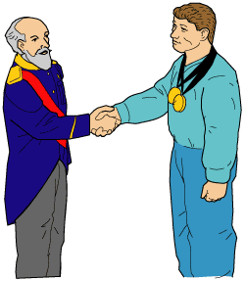
1 It was time to present the Olympic medals. A tall, important-looking man stood in front of the crowds. He was King Gustav V of Sweden. The 1912 Olympic Games were being held in his country. Many thousands of sports fans were there to see this event.
2 The crowd began cheering wildly. One of the men about to receive some of these medals had won first place in two of the Olympics' most difficult events.
3 King Gustav presented the man with the gold medals. He also gave him a beautiful statue and a cup shining with jewels. Then the king said something that will always be remembered. He said, 'Sir, you are the greatest athlete in the world.'
4 It is said that the man replied simply, 'Thanks, King.' Who was this Olympic champion?
5 James Thorpe was born on May 28, 1887, in Oklahoma. His parents were part Native American and had named him Wa-Tho-Huk, which means 'Bright Path.' Mostly, people called him 'Jim.'
6 In 1904, Jim went to Pennsylvania to study at the Carlisle Indian Industrial School. This was a school for Native Americans. Carlisle was famous for its fine sports teams. Jim quickly became a star. He had many natural sports skills. He was so strong and quick that he could play any sport and play it unusually well. Jim trained and practiced very hard.
7 Jim was especially good at football and track. He led the Carlisle teams to many exciting victories. Often they won against teams from much bigger schools.
8 People watching Jim play were astonished. It seemed that he could do anything. Jim Thorpe really was a 'super athlete'!
9 In the 1912 Olympics, Jim competed in several contests including two new ones in the modern Olympics: the pentathlon and the decathlon. The pentathlon is made up of five events and the decathlon is made up of ten events. These contests are considered two of the most difficult in the Olympics because athletes must compete in running, jumping, and throwing. Points are awarded for how well the athletes place in each event. The athlete with the highest total number of points after all of the events are finished wins the contest and the gold medal.
10 First, Jim won the pentathlon by placing first in four of the five events. Sports fans everywhere waited to see if he could win the decathlon too. Jim placed in the top four on all ten events in this contest. When all the points were added up, Jim had 8412. This was a new world record! Jim's score beat the previous world record by almost 998 points.
11 No wonder the crowds were cheering for Jim! The king was right about his skills. To this day, no other athlete has won both the pentathlon and decathlon in the same year. Jim Thorpe stands alone in the history of sports.

Read this entry from a thesaurus.
Which word is the best choice to replace the word quick in paragraph 6?
 |  | A. | swift
 |  | B. | hasty
 |  | C. | brief
 |  | D. | strong

Question 8 of 11
The Four Friends
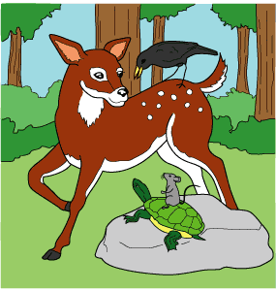
1 Once there were four animals who were very good friends. Deer was fast, graceful, and kind. Crow was clever, and he could fly quickly. Turtle moved slowly, but he was wise and understanding. Mouse was the smallest of the friends. She always had good ideas, though. The four friends had many adventures together in their forest home.
2 One day a hunter came to the forest. Crow flew off and soon was a black dot in the sky. Deer leaped into the bushes. Mouse scurried into her hole. Turtle tried to get back to his pond, but he was not fast enough. The hunter caught Turtle and tied him to his bow with a rope made of grass. Then the hunter started home. He licked his lips, thinking of the fine turtle stew he would have for supper.
3 As soon as the hunter was gone, Crow dropped from the sky. Deer and Mouse came out of their hiding places and met him. 'What shall we do?' Deer asked. 'We cannot let Turtle become that hunter's dinner!'
4 'We need a plan,' Mouse said. 'If only Turtle were here. He is so wise!'
5 'Don't forget that you have good ideas, too,' Crow reminded Mouse. 'Now, let's find a way to set Turtle free!'
6 After a few minutes of discussion, the friends had come up with a plan. Crow flew up into the sky and looked for the hunter. Deer followed Crow's directions. She ran ahead of the hunter. Then she lay down across the path. She lay very still and pretended to be dead.
7 Soon the hunter came along. When he saw Deer, the hunter put down his bow and his pack to take a closer look. Deer certainly seemed dead. He walked around Deer a few times. He pushed at Deer with his foot. Deer was afraid, but she lay absolutely still.
8 While the hunter was doing this, Mouse ran over to the bow.
9 'Be quiet, Turtle,' she whispered to her surprised friend. 'I need to get to work.'
10 Mouse began chewing on the rope of grass that was tied around Turtle. In just a few moments, Turtle was free. Mouse led him to a hiding place while the hunter looked at Deer.
11 'How lucky I am!' the hunter shouted. 'What a feast I will have tonight!' He went back to get his pack. It was then that he saw the empty bow and pieces of the chewed rope. 'Oh well,' he thought. 'I still have that fine deer.' The hunter turned around and started back to where Deer was lying. Suddenly, Deer jumped up and leaped into the forest. The hunter was left alone and went home empty-handed.
12 And so, the four friends were together again.

Read this sentence from paragraph 11.
The hunter was left alone and went home empty-handed.
Which sentence best explains what empty-handed means?
 |  | A. | The hunter had lost both animals.
 |  | B. | The hunter was not carrying his pack and bow.
 |  | C. | The hunter did not have any dinner.
 |  | D. | The hunter had empty hands.

Question 9 of 11
Choose the word that has the root word correctly underlined.
 |  | A. | ruined
 |  | B. | frantically
 |  | C. | tearing
 |  | D. | construction

Question 10 of 11
The house is ______________ out of wood and brick.
Choose the word below that can be made from the root word construct by adding a suffix.
 |  | A. | constructly
 |  | B. | constructful
 |  | C. | biconstruct
 |  | D. | constructed

Question 11 of 11
The powerful winds of the tornado demolished the houses.
What is the meaning of the underlined word?
 |  | A. | destroyed
 |  | B. | touched
 |  | C. | pushed
 |  | D. | twisted

