Progress Probe #1658680: 3rd Grade TCAP Coach Chapter 1 Lesson 1 and 2 (Grade 03 RE)
Teacher Key with Answers
Ques | Answer | Level | Skill | Subskill | Item #
1 | D | Moderate | Language & Vocabulary | SPI 0301.1.1 Use of Nouns [68579] | U53138
2 | A | Moderate | Language & Vocabulary | SPI 0301.1.1 Use of Nouns [68579] | U52612
3 | A | Moderate | Language & Vocabulary | SPI 0301.1.1 Use of Nouns [68579] | U52558
4 | B | Hard | Language & Vocabulary | SPI 0301.1.1 Use of Nouns [68579] | D85546
5 | D | Hard | Language & Vocabulary | SPI 0301.1.1 Use of Nouns [68579] | D1990
6 | C | Hard | Language & Vocabulary | SPI 0301.1.1 Use of Nouns [68579] | D3557
7 | C | Moderate | Language & Vocabulary | SPI 0301.1.11 Alphabetical Order [68598] | U52751
8 | A | Moderate | Language & Vocabulary | SPI 0301.1.11 Alphabetical Order [68598] | U53160
9 | C | Moderate | Language & Vocabulary | SPI 0301.1.11 Alphabetical Order [68598] | U53316
10 | C | Hard | Language & Vocabulary | SPI 0301.1.11 Alphabetical Order [68598] | D420
11 | B | Hard | Language & Vocabulary | SPI 0301.1.12 Spelled Words in Context [68600] | D50939
12 | A | Moderate | Language & Vocabulary | SPI 0301.1.18 Distinguish Sounds [68613] | U44604
13 | C | Hard | Language & Vocabulary | SPI 0301.1.18 Distinguish Sounds [68613] | D3271
14 | A | Hard | Language & Vocabulary | SPI 0301.1.18 Distinguish Sounds [68613] | D2461
15 | B | Moderate | Language & Vocabulary | SPI 0301.1.12 Spelled Words in Context [68600] | U52207

Name: Date:
3rd Grade TCAP Coach Chapter 1 Lesson 1 and 2
Question 1 of 15
Pandas
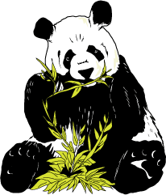
1 People love pandas. These fuzzy animals may look like cuddly clowns, but what are pandas really like?
2 There are two kinds of pandas. The red pandas look a lot like raccoons. Their tails are long and bushy, and they have reddish-brown fur. They are as big as large house cats. Their favorite food is bamboo, but they will eat only certain parts of the plant. Red pandas are fussy eaters!
3 The red pandas are losing their homes in the forests. People are cutting down the bamboo plants and building homes where the red pandas once lived. Zoos around the world are trying to save these pandas. Many red pandas have been born in zoos.
4 The pandas most people know about are the giant pandas. These pandas are very much like bears. They have short tails and thick fur. Their fur is black on their legs, ears, shoulders, and around their eyes. The fur on the rest of their bodies is white. Giant pandas grow to be about five feet long. They can weigh more than three hundred pounds. That's really big!
5 Giant pandas eat a large amount of food. They eat for about fourteen hours every day. Their favorite food is bamboo. They like the soft, leafy parts of the plant best, but the only part of the plant they will not eat is the roots. Pandas have strong teeth. They can bite through a stem as thick as your leg!
6 Giant pandas live in the bamboo forests of China. There are not many of these animals anymore. About one hundred giant pandas live in zoos around the world. Only about one thousand live in the wild.
7 Why are there so few giant pandas? The answer is people. At one time, people killed giant pandas and took their fur. Hunting pandas is against the law now. People also have cut down many bamboo forests to build farms and houses on the land. This destroys the pandas' food, and less food means fewer pandas.
8 Pandas are cute, furry animals that everyone loves. Even though there are many differences between the two kinds of pandas, both are in danger. Today, many people are trying to help pandas so there will be some for people to see in the future.

Reread paragraph 2.
Which word could replace They in the sentence 'They are as big as large house cats'?
 |  | A. | Raccoons
 |  | B. | Giant pandas
 |  | C. | Pandas' tails
 |  | D. | Red pandas

Question 2 of 15
Birthday Picnic
1 Last week, I had a great day! It was sunday, July 14, which is my birthday. My grandpa always takes me to a special place as his gift to me. “Where do you want to go this year?” he asked. I told him I would like to go on a picnic. Grandpa told me to wait while he went to his closet. Then he came back with a big smile on his face. He had a picnic basket in his hands.
2 First, we got things ready. Then we drove for an hour to Silver Lake. Grandpa took me to the store to buy food. Next we came home and made sandwiches. He also packed a bag of chips and other treats. My sister made us a big jar of fruit punch. Grandpa packed everything in the basket. We were ready to go.
3 When we got to the lake, we went for a swim. Then we ate our food. After we ate, I felt sleepy. The next thing I knew, Grandpa was shaking me gently. I had fallen asleep. Grandpa had carried me to the car. He had driven me home without even waking me. It was the most best birthday I ever had!

Read this sentence from the passage.
My grandpa always takes me to a special place as his gift to me.
Which is the simple subject of this sentence?
 |  | A. | grandpa
 |  | B. | takes
 |  | C. | me
 |  | D. | special

Question 3 of 15
Letter to Fran
10 maple avenue
springfield, tn
may 30, 2008
Dear Cousin Fran
1 I am so excited about coming to see you! I didn’t get no sleep last night. We will be there in less than too days. My mom and dad will take turns reading the map and driving our new truck. I hope your dad will cook us his famous barbecue beef. It tastes so __________!
2 When were in town, I hope we can go in your pool. Is it warm enough for swimming yet? I will bring my swimsuit and goggles. Our visit last year was the bestest time I have ever had. I’m sure this year will be even better.
3 I will seen you soon.
Love,
Cousin Benita

Read this sentence from the letter.
My mom and dad will take turns reading the map and driving our new truck.
What is the subject of this sentence?
 |  | A. | mom and dad
 |  | B. | will take turns
 |  | C. | reading and driving
 |  | D. | our new truck

Question 4 of 15
Which phrase means the same as "the shoes of the girls"?
 |  | A. | the girls shoes
 |  | B. | the girls' shoes
 |  | C. | the girl's shoes
 |  | D. | the girl shoes

Question 5 of 15
Choose the sentence that is written correctly.
 |  | A. | My friend house is on another street.
 |  | B. | My frien'ds house is on another street.
 |  | C. | My friends house is on another street.
 |  | D. | My friend's house is on another street.

Question 6 of 15
The other ______________ bicycles are parked in the driveway with mine.
Choose the correct word to fill in the blank.
 |  | A. | kidss'
 |  | B. | kids
 |  | C. | kids'
 |  | D. | kids's

Question 7 of 15
How Turtle Won the Race—A Native American Story
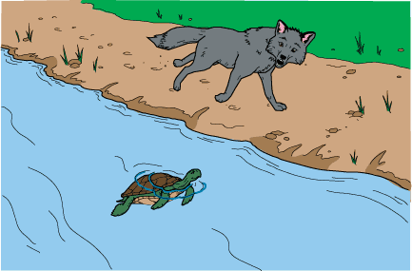
1 All the animals in the woods knew that Turtle was as slow as a stone and that Fox was as quick as the wind. One day, however, Turtle surprised them all. Turtle and Fox had a race, and Turtle won!
2 The story is told that Turtle was sitting on a log in the water. Fox came up to get a drink. 'Move aside! You are in my way!' said Fox.
3 'Why should I move?' asked Turtle.
4 'Because, silly, I am bigger than you!' Fox replied.
5 'Ha! I may not be big, but I can beat you at anything!' Turtle said. As soon as he spoke, Turtle was sorry about what he said. 'Oh, what have I done!' he whispered. But it was too late.
6 'Anything?' asked Fox with a smile. 'Then meet me here tomorrow for a race! I will show you!'
7 Turtle was worried. He went home and told his family. 'We will help you if we can,' they said.
8 'Maybe you can,' answered Turtle.
9 The next morning, Turtle was waiting on a log in the water.
10 'Come on out so we can race!' said Fox.
11 'Oh no,' answered Turtle. 'Turtles swim in the water. You run on the land.'
12 Fox didn't mind one bit. 'I can beat you on land or in the water!' he said. 'Ready, set, go!'
13 Turtle dipped down under the water and began to swim. Fox ran along the river bank. 'You cannot catch me!' Fox called over his shoulder.
14 'Oh, yes I can!' Turtle answered. But the voice didn't come from behind!
15 Fox looked up ahead. There, he saw Turtle poke his head up out of the water! Fox ran faster. 'You cannot catch me!' he called again.
16 'Oh, yes I can,' Turtle answered. Again, Fox saw Turtle poke his head out of the water, in front of where Fox ran.
17 Now Fox became quite nervous and began to scurry as fast as he could. But it was of no use! Again, Fox saw Turtle poke his head up, far ahead of where he ran. 'I give up! You win!' cried Fox, and he hurried away where no one could see him.
18 Later at home, Turtle thanked his family. 'I could not have done it without you!'
19 That was true. After Turtle had started the race, he hid while his family waited in different places under the water. When Fox ran near the first turtle, it poked its head up for a moment and then hid again. Then another turtle, farther ahead, poked its head out of the water. When Fox called out, each turtle answered, 'Oh, yes I can!' 'We surely fooled poor Fox,' the turtles agreed.
20 Every day after that, Turtle sat on a log in the water. All the animals still knew he was slow as a stone. All, that is, except Fox.

Which set of words from the story is in alphabetical (ABC) order?
 |  | A. | woods, worried, won
 |  | B. | cannot, catch, called
 |  | C. | animal, answered, anything
 |  | D. | tomorrow, told, too

Question 8 of 15
The Water Planet
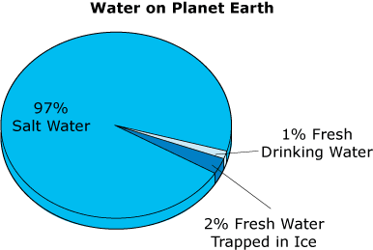
1 We live on a planet called Earth. Most of us live and play on solid ground. So why do some people call our home 'the water planet'?
2 Imagine that you are looking down on our planet from outer space. You would see that most of Earth is covered by water. Almost all of this water is found in Earth's four oceans. The Pacific is the largest ocean. It is so large that all of the land on our planet would fit inside this one ocean. In fact, many things found in Earth's oceans are huge. Oceans have tall mountains like those on land. They also have the deepest places on the planet. The oceans are all joined. The same water moves throughout each of them.
3 The oceans are very important to life on Earth. Ocean waters help keep the air from getting too hot. They also help keep the air from getting too cold. What would happen if the air became too hot or too cold? Life on Earth would not be possible. We also depend on the oceans for giving us much of the food we eat. Travel and play are also done on and in Earth's oceans.
4 A very small part of Earth's water is fresh water. It does not have salt in it. Most of the fresh water is frozen. Some of this water is trapped in glaciers. A glacier is a huge mass of ice that flows over land. Fresh water is also locked in the ice caps that have formed at Earth's North and South Poles. We cannot use this frozen water.
5 Some fresh water is not frozen. Many plants and animals must have this water in order to live. A person can live a long time without food but only a week without water. The water you drink probably comes from one of two places. It may be surface water that comes from lakes or rivers. Or it may be ground water that comes from wells.
6 Fresh water has important uses besides giving us something wonderful to drink when we are thirsty. We also use fresh water to clean our bodies and our clothes. Regular washing can remove germs that make us sick. We use fresh water to grow vegetables. We also cook many of our foods in fresh water.
7 Our bodies must have water to stay well. You might think you are just made of skin and bones, but most of your body is water. The human brain, blood, and lungs are made mostly of water. Water helps your body work as it should.
8 Some say that each person in the United States uses about 80 to 100 gallons of water a day. Every time you take a shower or water your lawn, you are using many gallons of water. So the next time you fill your glass with water, think about it. Remember the important part that water plays in our lives.

Read this alphabetical list of words from the passage.
frozen
mountains
ocean
planet
water
Where does the word glacier belong on this list?
 |  | A. | Between 'frozen' and 'mountains'
 |  | B. | Between 'mountains' and 'ocean'
 |  | C. | Between 'ocean' and 'planet'
 |  | D. | Between 'planet' and 'water'

Question 9 of 15
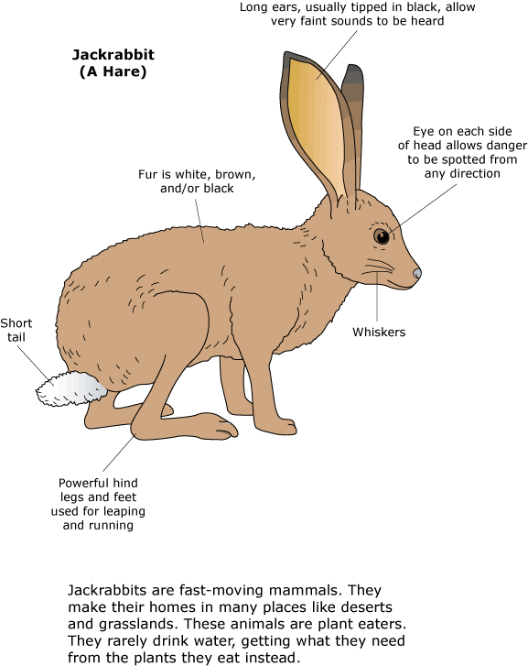

Oh, Dry Up!
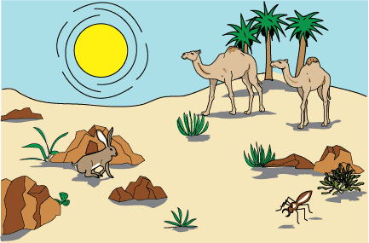
1 What comes to mind when you hear the word 'desert'? Do you think about sand and camels? Do you picture stinging insects? Maybe you imagine a certain kind of cactus. There are many kinds of deserts. Some are hot and sandy. Others are cold and rocky. One thing is true of all deserts: they are dry. A desert is a place that gets ten inches of rain or less each year. It is very difficult for animals and plants to live in a desert.
2 Plants manage to live in the desert in special ways. Some desert plants store water in their leaves. They have a waxy covering on their stems and leaves. This covering helps to hold water inside the plant. Other plants have long roots. These roots can reach down to water deep in the ground. Some plants have seeds that seem to rest for months or even years. When it rains, these seeds produce pretty wildflowers that bring color to the desert.
3 Animals in the desert also have developed ways to stay alive. Many animals have light-colored hair that covers their bodies. Light colors reflect the heat from the sun. This keeps some heat away from the animal's body and returns it to the air. The desert jackrabbit has huge ears. Heat leaves its body through its large ears. Most desert animals remain in holes or under rocks during the heat of day. They come out at night to hunt and eat. This is when the air is much cooler.
4 One insect has a special way of getting water. The long-legged beetle lives in the Namib Desert of Africa. During the night, a fog from the Atlantic Ocean moves over the desert. The beetle lowers its head toward the ground and raises its back into the breeze. Some of the fog's tiny water drops collect on the beetle's back. Then the droplets of water slide down the beetle's back and into its mouth.
5 Does a camel store water in its hump? A camel actually stores fat in its hump. It uses the fat as food when it travels a long way. The camel is able to hold a great deal of water, though. A camel can drink from 18 to 24 gallons at a time. The water passes through the camel's stomach to replace water used in other parts of the body. The camel keeps the water in its body because it does not sweat very much. It must get very hot before it starts to sweat and lose water. On a very hot day, a camel may rest facing the sun. That way only a small part of its body gets the direct rays of the sun. This helps the camel stay cooler.
6 Life in the desert can be difficult. Living things must often be protected from the hot daytime sun. Cold nights and little rain can also force animals and plants to develop amazing ways to stay alive. The desert is full of life, but you may need to look carefully to find it.

Read this alphabetical list of words from the passage.
beetle
desert
jackrabbit
sandy
wildflowers
Where does the word roots belong in this list?
 |  | A. | Between 'beetle' and 'desert'
 |  | B. | Between 'desert' and 'jackrabbit'
 |  | C. | Between 'jackrabbit' and 'sandy'
 |  | D. | Between 'sandy' and 'wildflowers'

Question 10 of 15
Put these words in alphabetical order:
thorn, thistle, those, theater
 |  | A. | thistle, theater, thorn, those
 |  | B. | theater, thorn, those, thistle
 |  | C. | theater, thistle, thorn, those
 |  | D. | those, thorn, thistle, theater

Question 11 of 15
Which sentence has the word in bold print spelled correctly?
 |  | A. | The man went on vakation to Hawaii.
 |  | B. | Four weeks ago we went on vacation.
 |  | C. | They came home for Easter vacasion.
 |  | D. | His vacatiun was last week.

Question 12 of 15
Hide-and-Seek
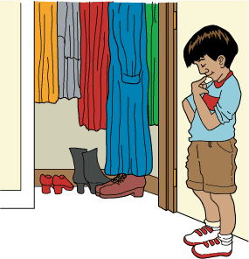
1 'No, Tina! You cannot come with us,' Daniel exclaimed.
2 'Please, can I go? I promise I won't annoy you,' Tina pleaded to her older brother. Tina longed to go to the park to play baseball with Daniel and his friends, but Daniel always said no whenever she asked if she could go. He would say, 'No, you are too young,' or 'No, you are too weak,' or 'No, you do not know how to play baseball.'
3 'No, Tina. You cannot come,' Daniel repeated.
4 'But why not?' she asked.
5 Daniel considered her question for a moment, and then he answered, 'Because you are not clever enough.' Daniel's friends laughed.
6 'Oh really?' Tina replied. 'If I can prove that I am clever, will you allow me to come to the park to play baseball with you?' she inquired.
7 Daniel was curious to hear more. 'All right,' he said. 'But how are you going to persuade me that you are clever?'
8 'I will hide somewhere in the house. If you and your friends cannot find me, then you have to take me to the park with you,' Tina replied.
9 'Well, what if we do find you?' Daniel asked.
10 'Then I will never ask you to take me with you again,' Tina answered.
11 'It's a deal!' Daniel exclaimed, certain that he and his friends would easily find her. The boys began to count, 'One Mississippi … two Mississippi … '
12 Tina knew that she could not select just any old hiding spot. Hoping to find the cleverest hiding spot of all, Tina ran into her parents' bedroom.
13 ' … six Mississippi … '
14 Tina suddenly recalled the long, blue dress that she had seen hanging in her mother's closet. She flung open the closet door. What luck! The dress was hanging exactly where she remembered it. Tina hurriedly went into the closet and closed the door. She ducked underneath the dress and stood up inside it. Even though she fit inside the dress perfectly, there was still one problem. Tina's two small feet were sticking out from under the dress!
15 ' …ten Mississippi. Here we come!' shouted the boys. When Tina heard the boys coming toward the bedroom, she knew they would surely see her feet sticking out from under the dress. Knowing that she had to act fast, Tina slipped her feet into her mother's brown snow boots just as the closet door swung open.
16 'We are going to find you!' yelled one of the boys.
17 Tina stayed very still.
18 'Come on, she is not in here,' Daniel said. Tina wanted to giggle. The boys attempted to find her for a very long time. They looked in the bathtub and under the beds. They even searched in absurd places, such as inside dresser drawers and down the drain. Daniel and his friends left no stone unturned.
19 Finally one of the boys said, 'If we don't give up soon, we won't have any time to play baseball.' Daniel agreed.
20 'All right. You can come out, Tina!' Daniel yelled.
21 'Can I come to the park with you?' asked a little voice from inside the blue dress.
22 'Yes,' Daniel answered.
23 Suddenly Tina pushed open the closet door and came out from under the dress. 'I was right here the entire time!' she exclaimed. The boys gazed down at the big, brown snow boots Tina was wearing and began to laugh.
24 'Well, I guess you really are pretty clever,' Daniel said.
25 'Yes, I am,' said Tina triumphantly. 'And I will show you how well I can play baseball too!'

What is the correct way to divide the word hurriedly in paragraph 14 into syllables?
 |  | A. | hur·ried·ly
 |  | B. | hu·rried·ly
 |  | C. | hurr·ie·dly
 |  | D. | hur·rie·dly

Question 13 of 15
Choose the word that has the same consonant blend as cheese.
 |  | A. | chaos
 |  | B. | straight
 |  | C. | channel
 |  | D. | school

Question 14 of 15
A volunteer shows ___________________ for others.
Choose a 5-syllable word to complete the sentence.
 |  | A. | consideration
 |  | B. | thoughtfulness
 |  | C. | assistance
 |  | D. | kindness

Question 15 of 15
Mr. Jefferson's Friend
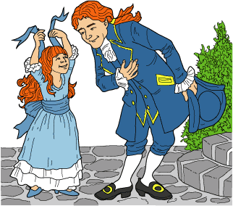
1 It was early evening on July 7, 1776. Martha was sitting on the front steps of her home in Philadelphia, Pennsylvania, when a tall man came out of the house next door. The man looked tired. Smiling at Martha, the man bowed and said, 'Good evening, young lady.'
2 Martha was watching an ant crawling alongside the sidewalk. 'Hello, sir,' Martha replied, lifting her eyes. Martha noticed that he had red hair just like she did.
3 Wiping his forehead with a handkerchief, the man walked over and sat next to Martha on the steps. 'You certainly have hot summers in Philadelphia,' the man said.
4 'Don't you live here, sir?' Martha asked.
5 'No,' the man answered. 'I live in Virginia, far south of here. I am renting a room in this house. I have work to do here, but it will be finished soon.'
6 'Will you go home then?' Martha asked.
7 'Yes,' the man answered. 'I have a wife and daughter in Virginia. I miss them very much.'
8 'I am ten,' Martha said. 'How old is your daughter?'
9 The man said, 'My daughter is three years old. She has red hair just like you and I do.' Just then Martha's mother called her inside for dinner. Martha stood up, and the man stood up, too. 'Thank you, young lady.'
10 'For what, sir?' Martha asked.
11 'Talking to you was like talking to my own daughter. You have made me feel less lonely,' the man said. 'May I ask your name?'
12 'My name is Martha.'
13 'That's strange,' the man said. 'My daughter's name is Martha. I am Thomas Jefferson.'
14 'Good night, Mr. Jefferson,' Martha said, smiling.
15 'Good night, Martha.'
16 The next day, people everywhere were talking. Americans did not think the King of England was fair. They had written him letters, but he did not answer. Now, they would no longer obey the king.
17 'We have declared our independence from England and the King, and from now on we shall be free,' Martha's father explained to her. 'Our leaders voted to approve a declaration on July 4, which will be read aloud today. The paper tells the King that from now on, we will be our own country.' Just then they heard a bell ring out. Martha and her parents walked to the town square. A huge crowd had gathered around. A speaker read the declaration. When the people heard what the speaker was saying, they cheered wildly.
18 On the way home, a neighbor asked, 'Who wrote that wonderful speech?'
19 'A man from Virginia,' Martha's mother answered. 'His name is Thomas Jefferson.' Martha's eyes widened in surprise. A few minutes later, Martha's family reached their home. Mr. Jefferson was standing on the steps.
20 'My work is finished, and I am going home,' Mr. Jefferson said. Martha hugged the tall man and gave him the blue ribbon from her hair.
21 'Please, take this ribbon. It is a present for your daughter,' she said.
22 Mr. Jefferson smiled. 'Thank you, Martha. She loves to wear ribbons in her hair, too,' he replied.
23 Martha's parents stared in disbelief. 'You know Thomas Jefferson?' her father cried.
24 'Yes,' Martha answered. 'He's a friend of mine. His daughter has red hair, too.'
25 Martha's parents were shocked. Martha's father shook hands with Mr. Jefferson. Then Mr. Jefferson got on his horse and rode away. Martha and her parents waved until he disappeared.

Read this sentence about the story.
Martha ____ that Mr. Jefferson's daughter ______ like _____ have the ribbon.
Which words make the sentence correct?
 |  | A. | new, wood, to
 |  | B. | knew, would, to
 |  | C. | new, wood, too
 |  | D. | knew, would, too

Copyright © Discovery Education Assessment 2012. Proprietary Information. All rights reserved.
Discovery Education Page

